

前 言

全国大学英语四、六级考试(以下简称四、六级考试)系教育部主办、教育部考试中心主持和实施的一项大规模标准化考试.自１９８７年开始实施以来,四、六级考试已走过近三十年的历程,其间经历了多次改革,顺应了我国 高等教育不断发展的新形势,推动了大学英语教学改革.

近年来,全国大学英语四、六级考试委员会(以下简称考试委员会)对 四、六级考试内容和题型作了进一步调整,并将口语能力的考核方式从面试 型转为计算机化考试,同时开发了大学英语四级口语考试,此前实施的大学英语口语考试转为大学英语六级口语考试.

四、六级考试(笔试)大纲历来分级成册,口试大纲单独成册. 现行的四、六级考试大纲为２００６年的修订版,共有三个单行本:«大学英语四级考试大纲»、«大学英语六级考试大纲»和«大学英语口语考试大纲».«全国大学英语四、六级考试大纲(２０１６ 年修订版)»在总体设计上更好地体现了四、六级考试体系的完整性,内容涵盖四级笔试、四级口试、六级笔试和六级口试, 并新增了四、六级考试词表.

公布«全国大学英语四、六级考试大纲(２０１６ 年修订版)»的目的是使广大师生和用人单位了解调整后的四、六级考试系列及各项考试的试卷结构、考试形式和考试内容. 考试委员会将对调整后的四、六级考试的效度和信度在实施过程中作进一步验证,不断完善考试,使四、六级考试不仅体现中

国特色,而且符合国际语言测试的发展趋势,使考试适应我国大学英语教学和测试的现状,更好地服务于我国大学英语教学的改革与发展.

本书所配听力音频和口试视频文件可在大学英语四、六级考试官网

(www．cet．edu．cn)下载.

著 者

目 录

考试系列介绍 １

１．考核的语言技能及要求 １

１．１ 听力理解 １

１．１．１ 考核的要求

１．１．２ 考核的技能

１

２

１．２ 阅读理解 ２

１．２．１ 考核的要求

１．２．２ 考核的技能

２

２

１．３ 写作

３

１．３．１ 考核的要求

１．３．２ 考核的技能

３

３

１．４ 翻译

４

１．４．１ 考核的要求

１．４．２ 考核的技能

４

４

１．５ 口头表达 ４

１．５．１ 考核的要求

１．５．２ 考核的技能

４

５

２．全国大学英语四级考试 ５

２．１ 四级笔试 ５

２．１．１ 试卷构成

２．１．２ 试卷分解

５

５

２．２ 四级口试 ６

２．２．１ 考试形式

２．２．２ 考试过程

６

６

３．全国大学英语六级考试 ７

３．１ 六级笔试 ７

３．１．１ 试卷构成

３．１．２ 试卷分解

７

８

３．２ 六级口试 ９

３．２．１ 考试形式

３．２．２ 考试过程

９

９

１

４．主观题评分 １０

４．１ 作文评分 １０

４．１．１ 评分方法 １０

４．１．２ 评分标准 １０

４．２ 翻译评分 １０

４．２．１ 评分方法 １０

４．２．２ 评分标准 １０

４．３ 口语考试评分 １１

４．３．１ 评分方法 １１

４．３．２ 评分标准 １１

５．分数解释及成绩报道 １２

５．１ 笔试

１２

５．１．１ 分数解释 １２

５．１．２ 成绩报道 １３

５．２ 口语考试 １３

５．２．１ 能力等级描述 １３

５．２．２ 成绩报道 １４

词表 １５

样卷 １４５

１．全国大学英语四级考试(笔试)样卷 １４５

２．全国大学英语四级考试(口试)样卷 １６４

３．全国大学英语六级考试(笔试)样卷 １６７

４．全国大学英语六级考试(口试)样卷 １８７

５．全国大学英语四级考试答题卡 １８９

６．全国大学英语六级考试答题卡 １９３

７．全国大学英语四级考试作文评分样卷 １９７

８．全国大学英语六级考试作文评分样卷 ２００

９．全国大学英语四级考试翻译评分样卷 ２０３

１０．全国大学英语六级考试翻译评分样卷 ２０５

１１．全国大学英语四级考试成绩报告单样张

１２．全国大学英语六级考试成绩报告单样张

２０７

２０９

２

# 考试系列介绍

四、六级考试对象是修完大学英语相应阶段课程的在校大学生.考试目的是参照«大学英语教学指南»(教育部高等学校大学外语教学指导委员会２０１５ 年制定)设定的教学目标对我国大学生英语综合运用能力进行科学的测量,同时也为用人单位了解我国大学生英语水 平提供参照依据.

四、六级考试系列分为大学英语四级考试(简称四级考试)和大学英语六级考试(简称六

级考试).四级考试包括四级笔试(CollegeEnglishTestBand４,简称 CETＧ４)和四级口试

(CETＧSpokenEnglish TestBand４,简 称 CETＧSET４);六 级 考 试 包 括 六 级 笔 试 (College

EnglishTestBand６,简称CETＧ６)和六级口试(CETＧSpokenEnglishTestBand６,简称CETＧ

SET６).笔试和口试每年各举行两次.

四、六级考试的命题语料(除主观题外)均选自英文原版材料,包括日常生活对话、广播 电视节目、讲座、报纸杂志、书籍、学术期刊等.选材原则包括:

内容健康,题材广泛,涵盖人文学科、社会科学、自然科学等领域,但所涉及的背景知 识为考生所了解或已在语料中提供;

体裁多样,包括记叙性、说明性、议论性文本等;

词汇范围参照本大纲所附的四、六级考试词表.超出该范围的词汇,如影响理解或答题,则标注汉语释义.

## １．考核的语言技能及要求

四、六级考试考核学生的英语综合运用能力,包括听力理解、阅读理解、写作、翻译和口 头表达能力.各项语言技能的考核要求参照«大学英语教学指南»中的“基础目标”和“提高目标”所设定的教学要求.

## １．１ 听力理解

１．１．１ 考核的要求

四级考试:要求考生能听懂语速较慢的短篇英语广播;能听懂就熟悉话题展开的多话轮简单英语会话;能听懂语速较慢、题材熟悉、篇幅较长的讲话和报道;能运用基本的听力

策略帮助理解.听力材料的语速为每分钟１２０－１４０词. 考

六级考试:要求考生能听懂就熟悉话题展开的多话轮英语会话;能听懂语速中等、题 试材熟悉、篇幅较长的英语广播;能听懂语速中等、题材熟悉的讲话、报道和内容浅显的学术讲 列座;能较好地运用听力策略帮助理解.听力材料的语速为每分钟１４０－１６０词. 介

系

绍

１

１．１．２ 考核的技能

听力理解部分考核学生获取口头信息的能力,包括理解主旨大意、重要事实和细节、隐 含意义,判断话语的交际功能、说话人的观点、态度等.听力理解部分考核的技能如下:

A．理解明示的信息

０１ 理解主旨大意

０２ 听懂重要信息或特定的细节

０３ 理解说话人明确表达的观点、态度等

B．理解隐含的信息

０４ 推论隐含的意义

０５ 判断话语的交际功能

０６ 推断说话人的观点、态度等

C．运用语言特征理解听力材料

０７ 辨别语音特征(如从连续的话语中辨别语音、理解重音和语调等)

０８ 理解句间关系(如因果、比较、条件等)

D．运用听力策略

０９ 运用合适的听力策略帮助理解

## １．２ 阅读理解

１．２．１ 考核的要求

四级考试:要求考生能读懂题材熟悉、语言难度较低的英语报刊文章和其他英语材 料;能读懂工作、生活中常见的应用文体的英语材料;能运用基本的阅读策略帮助理解. 仔细阅读速度达到每分钟７０词,快速阅读速度达到每分钟１００词.

六级考试:要求考生能读懂一般性题材的英语报刊文章和其他英语材料;能阅读题

材较熟悉的学术文章;能较好地运用阅读策略帮助理解.仔细阅读速度达到每分钟９０ 词,快速阅读速度达到每分钟１２０词.

１．２．２ 考核的技能

阅读理解部分考核学生通过阅读获取书面信息的能力,包括理解主旨大意、重要事实和 细节、隐含意义,判断作者的观点、态度等.阅读部分考核的技能如下:

A．理解明示的信息

０１ 理解主旨大意

０２ 理解细节信息

０３ 理解作者明确表达的观点、态度等

２

B．理解隐含的信息

０４ 概括主旨大意

０５ 推论隐含的意义

０６ 判断作者的观点、态度等

C．运用语言特征理解文章

０７ 根据上下文猜测词和短语的意思

０８ 理解句间关系(如因果、比较、条件等)

０９ 运用词汇及语法衔接手段理解篇章各部分之间的关系

D．运用阅读策略 １０ 运用合适的阅读策略帮助理解

## １．３ 写作

１．３．１ 考核的要求

四级考试:要求考生能用英语描述个人经历、观感、情感和发生的事件等;能描述简单的图表和图画;能就熟悉的主题发表个人观点;能写常见的应用文;能根据提纲、图表或图 画等提示信息作简短的讨论、解释和说明.中心思想明确,结构基本完整,用词较为恰当,语句通顺,语意连贯,能运用基本的写作策略.能在半小时内写出不少于１２０词的短文.

六级考试:要求考生能用英语就一般性的主题发表个人观点;能描述图表和图画;能

根据提纲、图表或图画等提示信息作较为深入的讨论、解释和说明.观点明确,结构清晰完整,用词贴切,语言表达流畅,语意连贯,能较好地运用写作策略.能在半小时内写出不少于

１５０词的短文.

１．３．２ 考核的技能

写作部分考核学生就熟悉的话题和情景用英语进行书面表达的能力,要求考生在规定 的时间内根据所给提示用英语写出一篇短文.写作部分考核的技能如下:

A．思想表达

０１ 表达中心思想

０２ 表达重要或特定的信息

０３ 表达观点、态度等

B．篇章组织

０４ 围绕所给的题目叙述、议论或描述,重点突出

０５ 连贯地组句成段,组段成篇

C．语言运用

０６ 运用恰当的词汇

０７ 运用正确的语法 考

０８ 运用合适的句子结构 试

系

０９ 使用正确的标点符号 列

１０ 运用衔接手段表达句间关系(如对比、原因、结果、程度、目的等) 介

绍

３

D．运用写作策略

１１ 运用合适的写作策略帮助表达

## １．４ 翻译

１．４．１ 考核的要求

四级考试:要求考生能将题材熟悉、语言难度较低的汉语段落译成英语. 段落的内容涉及中国的文化、历史及社会发展.译文基本准确地表达原文的意思,语句通顺,句式和用词较为恰当.能运用基本的翻译策略.能在半小时内将长度为１４０－１６０ 个汉字的段落译成英语.

六级考试:要求考生能将题材熟悉、语言难度中等的汉语段落译成英语. 段落的内

容涉及中国的文化、历史及社会发展.译文基本准确地表达原文的意思,语言流畅,句式运用恰当,用词贴切.能较好地运用翻译策略.能在半小时内将长度为１８０－２００ 个汉字的段落译成英语.

１．４．２ 考核的技能

翻译部分考核学生运用恰当的翻译策略和语言知识将主题熟悉、内容浅显、意思完整的汉语段落用英语表达出来的能力.翻译部分考核的技能如下:

A．将句子层面的汉语信息转换成英语

０１ 用合适的英语词汇准确表达汉语词汇的意思

０２ 用符合英语规范和表达习惯的句型准确表达汉语句子的含义

B．将语篇层面的汉语信息转换成英语

０３ 用英语准确、完整地表达汉语段落的信息

０４ 译文结构清晰,语篇连贯,语言通顺

C．运用翻译策略

０５ 运用合适的翻译策略帮助表达

## １．５ 口头表达

１．５．１ 考核的要求

四级考试:要求考生能用英语就熟悉的话题进行简短但多话轮的交谈;能对一般性事件和现象进行简单的叙述或描述;经准备后能就熟悉的话题作简短发言.语言表达较清楚,语音、语调和语法基本正确.能运用基本的口头表达与交流的策略.

六级考试:要求考生能用英语就一般性话题进行比较深入的多话轮交谈;能陈述事实、理由和描述事件、现象等;能表达个人意见、情感、观点等;能在对话中进行争辩、解释、比较、论证等.语言表达结构清晰,观点明确,语音、语调和语法正确.能较好地运用口头表达与交流的策略.

４

１．５．２ 考核的技能

口语部分考核学生就熟悉的话题用英语进行口头表达与交流的能力.口语部分考核的 技能如下:

A．口头阐述

０１ 陈述事实、理由、观点等

０２ 描述人物、事件、现象等

B．口头互动

０３ 交换意见、交流情感和观点等

０４ 争辩、解释、比较、论证等

C．运用口头交际策略

０５ 运用合适的口头表达与交流的策略帮助表达

## ２．全国大学英语四级考试

２．１ 四级笔试

２．１．１ 试卷构成

大学英语四级试卷由四个部分构成,依次为:１)写作;２)听力理解;３)阅读理解;４)翻译.各部分测试内容、题型和所占分值比例等如下表所示:

|  |  |  |  |  |  |
| --- | --- | --- | --- | --- | --- |
| 试卷结构 | 测试内容 | 测试题型 | 题目数量 | 分值比例 | 考试时间 |
| 写作 | 写作 | 短文写作 | １ | １５％ | ３０分钟 |
| 听力理解 | 短篇新闻 | 选择题(单选题) | ７ | ７％ | ２５分钟 |
| 长对话 | 选择题(单选题) | ８ | ８％ |
| 听力篇章 | 选择题(单选题) | １０ | ２０％ |
| 阅读理解 | 词汇理解 | 选词填空 | １０ | ５％ | ４０分钟 |
| 长篇阅读 | 匹配 | １０ | １０％ |
| 仔细阅读 | 选择题(单选题) | １０ | ２０％ |
| 翻译 | 汉译英 | 段落翻译 | １ | １５％ | ３０分钟 |
| 总计 | | | ５７ | １００％ | １２５分钟 |

２．１．２ 试卷分解

１)写作

考

作文题的提示形式包括提纲、情景、图画或图表等,每次考试采用其中的一种形式. 要 试

系

求考生根据所规定的题目及所给出的提示写出一篇短文,长度不少于１２０ 词. 写作部分的 列

分值比例为１５％.考试时间３０分钟. 介

绍

５

２)听力理解

听力理解部分由短篇新闻、长对话和听力篇章构成. 试题采用选择题(单选题)题型. 录音材料用标准的英式或美式英语朗读,语速约为每分钟１２０－１４０ 词.所有录音材料均播放一遍,每个问题后留有１５秒答题时间.听力理解部分的分值比例为３５％,其中短篇新闻占７％,长对话占８％,听力篇章占２０％.考试时间约２５分钟.

短篇新闻:３篇,总共４５０－５００词,每篇２－３题,共７题.

长对话:２篇,每篇２４０－２８０词,每篇４题,共８题.

听力篇章:３篇,每篇２２０－２４０词,每篇３－４题,共１０题.

３)阅读理解

阅读理解部分由词汇理解(１篇)、长篇阅读(１ 篇)和仔细阅读(２ 篇)构成.词汇理解的篇章长度为２００－２５０词;长篇阅读的篇章长度约１０００词;仔细阅读的每篇长度为３００－３５０词.阅读理解部分的分值比例为３５％,其中词汇理解占５％,长篇阅读占１０％,仔细阅读占

２０％.考试时间４０分钟.

词汇理解:采用选词填空题型,考核学生对篇章语境中词汇的理解和运用能力.篇章中删去了１０个词汇,并在篇章后提供１５ 个词汇选项.要求考生在对篇章理解的基础上从所给的词汇选项中选择正确的词汇填空,使篇章复原.

长篇阅读理解:采用段落匹配题型,考核学生运用略读和查读的技能从篇章中获取信息的能力.略读要求学生通过快速阅读获取文章主旨大意或中心思想;查读要求学生快速查找篇章中的特定信息.篇章后附有１０个句子,每句１题.每句所含的信息出自篇章中的某一段落,要求考生找出与每句所含信息相匹配的段落.有的段落可能对应两题,有的段落 可能不对应任何一题.

仔细阅读理解:采用选择题(单选题)题型,考核学生在不同层面上的阅读理解能力,

包括理解主旨大意和重要细节、综合分析、推测判断以及根据上下文推测词义等.每个篇章 后有５个问题,要求考生根据对篇章的理解从每题的四个选项中选择最佳答案.

４)翻译

试题所呈现的是一个或几个汉语段落,不含生僻的专业词汇或习语. 要求考生在规定的时间内将汉语段落译成英语.翻译部分的分值比例为１５％.考试时间３０分钟.

## ２．２ 四级口试

２．２．１ 考试形式

四级口试采用计算机化考试形式.模拟考官及试题呈现在计算机屏幕上,试题材料采用文字或画面提示(图画、图表、照片等).考生由计算机系统随机编排为两人一组.考生在计算机上进行考生与模拟考官、考生与考生之间的互动.考试包含四个任务,考试总时间约

１５分钟.

２．２．２ 考试过程

考试按以下步骤进行:

６

|  |  |  |  |
| --- | --- | --- | --- |
| 任务 | 任务名称 | 考 试 过 程 | 答题时间 |
| 热身 | 自我介绍 | 根据考官 指 令,每 位 考 生 作 一 个 简 短 的 自 我 介  绍.考试时间约１分钟. | 每位考生 ２０ 秒(两 位考生依次进行) |
| 任务 １ | 短文朗读 | 考生准备４５ 秒后朗读一篇１２０ 词左右的短文.  考试时间约２分钟. | 每位考生朗读 １ 分钟  (两位考生同步进行) |
| 任务 ２ | 简短回答 | 考生回答２ 个与短文有关的问题. 考试时间约  １分钟. | 每位考生 ４０ 秒(两 位考生同步进行) |
| 任务 ３ | 个人陈述 | 考生准备４５ 秒后,根据所给提示作陈述. 考试  时间约２分钟. | 每位考生１分钟(两位考生同步进行) |
| 任务 ４ | 双人互动 | 考生准备１分钟后,根据设定的情景和任务进行  交谈.考试时间约４分钟. | 两位考生互动３分钟 |

考生开始正式答题前先作一个简短的自我介绍,以进入良好的应考状态. 正式考试开始后,考生按下列顺序完成各项任务:

任务１:要求考生在经过一定准备后朗读一篇１２０ 词左右的短文. 考生的准备时间为４５秒,答题时间为１分钟.

任务２:要求考生回答模拟考官提出的２ 个问题,第１ 个问题与朗读短文的内容相

关,第２个问题与朗读短文的主题相关.每题的答题时间为２０秒.

任务３:要求考生经过准备后根据所给提示发言. 考生的准备时间为４５ 秒,答题时间为１分钟.

任务４:要求两位考生根据所给的情景和任务进行互动.考生的准备时间为１ 分钟,

双人互动时间为３分钟.

## ３．全国大学英语六级考试

３．１ 六级笔试

３．１．１ 试卷构成

大学英语六级试卷由四个部分构成,依次为:１)写作;２)听力理解;３)阅读理解;４)翻译.各部分测试内容、题型和所占分值比例等如下表所示:

|  |  |  |  |  |  |
| --- | --- | --- | --- | --- | --- |
| 试卷结构 | 测试内容 | 测试题型 | 题目数量 | 分值比例 | 考试时间 |
| 写作 | 写作 | 短文写作 | １ | １５％ | ３０分钟 |
| 听力理解 | 长对话 | 选择题(单选题) | ８ | ８％ | ３０分钟 |
| 听力篇章 | 选择题(单选题) | ７ | ７％ |
| 讲话/报道/讲座 | 选择题(单选题) | １０ | ２０％ |

考试

系

列介绍

７

(续表)

|  |  |  |  |  |  |
| --- | --- | --- | --- | --- | --- |
| 试卷结构 | 测试内容 | 测试题型 | 题目数量 | 分值比例 | 考试时间 |
| 阅读理解 | 词汇理解 | 选词填空 | １０ | ５％ | ４０分钟 |
| 长篇阅读 | 匹配 | １０ | １０％ |
| 仔细阅读 | 选择题(单选题) | １０ | ２０％ |
| 翻译 | 汉译英 | 段落翻译 | １ | １５％ | ３０分钟 |
| 总计 | | | ５７ | １００％ | １３０分钟 |

３．１．２ 试卷分解

１)写作

作文题的提示形式包括提纲、情景、图画或图表等,每次考试采用其中的一种形式. 要求考生根据所规定的题目及所给出的提示写出一篇短文,长度不少于１５０ 词. 写作部分的分值比例为１５％.考试时间３０分钟.

２)听力理解

听力理解部分由长对话、听力篇章和讲话/报道/讲座构成. 试题采用选择题(单选题) 题型.录音材料用标准的英式或美式英语朗读,语速约为每分钟１４０－１６０ 词.所有录音材料均播放一遍,每个问题后留有１３秒答题时间.听力理解部分的分值比例为３５％,其中长对话占８％,听力篇章占７％,讲话/报道/讲座占２０％.考试时间约３０分钟.

长对话:２篇,每篇２８０－３２０词,每篇４题,共８题.

听力篇章:２篇,每篇２４０－２６０词,每篇３－４题,共７题.

讲话/报道/讲座:３篇,总共约１２００词,每篇３－４题,共１０题.

３)阅读理解

阅读理解部分由词汇理解(１篇)、长篇阅读(１ 篇)和仔细阅读(２ 篇)构成.词汇理解的篇章长度为２５０－３００词;长篇阅读的篇章长度约１２００词;仔细阅读的每篇长度为４００－４５０词.阅读理解部分的分值比例为３５％,其中词汇理解占５％,长篇阅读占１０％,仔细阅读占

２０％.考试时间４０分钟.

词汇理解:采用选词填空题型,考核学生对篇章语境中词汇的理解和运用能力.篇章中删去了１０个词汇,并在篇章后提供１５ 个词汇选项.要求考生在对篇章理解的基础上从所给的词汇选项中选择正确的词汇答题,使篇章复原.

长篇阅读理解:采用段落匹配题型,考核考生运用略读和查读的技能从篇章中获取信息的能力.略读要求学生通过快速阅读获取文章主旨大意或中心思想;查读要求学生快速查找篇章中的特定信息.篇章后附有１０个句子,每句１题.每句所含的信息出自篇章中的某一段落,要求考生找出与每句所含信息相匹配的段落.有的段落可能对应两题,有的段落 可能不对应任何一题.

仔细阅读理解:采用选择题(单选题)题型,考核学生在不同层面上的阅读理解能力, 包括理解主旨大意和重要细节、综合分析、推测判断以及根据上下文推测词义等.每个篇章后有５个问题,要求考生根据对篇章的理解从每题的四个选项中选择最佳答案.

８

４)翻译

试题所呈现的是一个或几个汉语段落,不含生僻的专业词汇或习语. 试题内容的难度略高于四级. 要求考生在规定的时间内将汉语段落译成英语. 翻译部分的分值比例为

１５％.考试时间３０分钟.

## ３．２ 六级口试

３．２．１ 考试形式

六级口试采用计算机化考试形式.模拟考官及试题呈现在计算机屏幕上,试题材料采用文字或画面提示(图画、图表、照片等).考生由计算机系统随机编排为两人一组.考生在计算机上进行考生与模拟考官、考生与考生之间的互动.考试分为三个部分,考试总时间约

１８分钟.

３．２．２ 考试过程

考试按以下步骤进行:

|  |  |  |  |
| --- | --- | --- | --- |
| 部分 | 内容 | 考 试 过 程 | 答题时间 |
| 第一部分 | 自 我 介 绍 和问答 | 先由考生自我介绍,然后回答考官提问.考试时间约２分钟. | 自我介绍:每位考生２０ 秒(两位考生依次进行)  回答问题:每位考生３０ 秒(两位考生同步进行) |
| 第二部分 | 陈述和讨论 | 考生准备１ 分钟后,根据所给提示作个人陈述;两位考生就指定的话题讨  论.考试时间约８分钟. | 个人陈述:每位考生１ 分３０ 秒  (两位考生依次进行)  两人讨论:３分钟 |
| 第三部分 | 问答 | 考生回答考官的一个问题. 考试时间  约１分钟. | 每位考生４５ 秒(两位考生同步进行) |

第一部分:根据考官指令,两位考生分别作一个简短的自我介绍,每位考生答题２０秒;然后每位考生回答一个问题,答题时间３０秒.这部分主要用于“热身”目的,使考生进入良好的应考状态.

第二部分:根据考官指令和屏幕显示的文字或画面提示,考生准备１ 分钟,然后就所给提示依次作个人陈述,每位考生答题１分３０秒;此后两位考生就指定的话题展开讨论,讨论时间３分钟.这部分是考试的重点内容,检测考生用英语进行连贯的口头表达的能力,以 及传达信息、发表意见、参与讨论和进行辩论等口头交际能力.

第三部分:考生再次各自回答一个问题,每位考生答题４５ 秒.这部分给考生进一步

展示自己口头交际能力的机会.

考试系列介绍

９

## ４．主观题评分

４．１ 作文评分

４．１．１ 评分方法

四级和六级的作文评分均采用总体印象评分方式.作文满分为１５ 分,分为五个档次:

１４分档(１３－１５分)、１１分档(１０－１２分)、８分档(７－９分)、５分档(４－６ 分)和２ 分档(１－３分).四级和六级采用相同的档次描述.每次阅卷时,参照档次描述分别确定当次考试四级和六级各档次的评分样卷.阅卷员经过培训后参照评分样卷对考生的作文答卷进行评分.

４．１．２ 评分标准

四级和六级的写作测试难度不同,考核要求不同.相同档次的四级评分样卷和六级评分样卷具有级别上的差异.各档次描述如下:

|  |  |
| --- | --- |
| 档次 | 档 次 描 述 |
| １４分档 | 切题.表达思想清楚,文字通顺、连贯,基本上无语言错误,仅有个别小错. |
| １１分档 | 切题.表达思想清楚,文字连贯,但有少量语言错误. |
| ８分档 | 基本切题.有些地方表达思想不够清楚,文字勉强连贯,语言错误相当多,其中有一些是严重错误. |
| ５分档 | 基本切题.表达思想不清楚,连贯性差,有较多的严重语言错误. |
| ２分档 | 条理不清,思路紊乱,语言支离破碎或大部分句子均有错误,且多数为严重错误. |

## ４．２ 翻译评分

４．２．１ 评分方法

四级和六级的翻译评分均采用总体印象评分方式.翻译满分为１５ 分,分为五个档次:

１４分档(１３－１５分)、１１分档(１０－１２分)、８分档(７－９分)、５分档(４－６ 分)和２ 分档(１－３分).四级和六级采用相同的档次描述.每次阅卷时,参照档次描述分别确定当次考试四级和六级各档次的评分样卷.阅卷员经过培训后参照评分样卷对考生的翻译答卷进行评分.

４．２．２ 评分标准

四级和六级的翻译测试难度不同,考核要求不同.相同档次的四级评分样卷和六级评分样卷具有级别上的差异.各档次描述如下:

|  |  |
| --- | --- |
| 档次 | 档 次 描 述 |
| １４分档 | 译文准确表达了原文的意思.译文流畅,结构清晰,用词贴切,基本无语言错误,仅有个别 小错. |
| １１分档 | 译文基本表达了原文的意思.结构较清晰,语言通顺,但有少量语言错误. |

１０

(续表)

|  |  |
| --- | --- |
| 档次 | 档 次 描 述 |
| ８分档 | 译文勉强表达了原文的意思.译文勉强连贯,语言错误相当多,其中有一些是严重错误. |
| ５分档 | 译文仅表达了小部分原文的意思.译文连贯性差,有相当多的严重语言错误. |
| ２分档 | 除个别词语或句子,译文基本没有表达原文的意思. |

## ４．３ 口语考试评分

４．３．１ 评分方法

四级口语考试的评分分为人工评分部分和计算机自动评分部分.人工评分总分为１５分;计算机自动评分(朗读部分)总分为５ 分.人工评分的分值和计算机评分的分值合成后的考试总分为２０分,成绩报道时转换为A、B、C 和 D 四个等级.

六级口语考试全部采用人工评分,总分为１５ 分,成绩报道时转换为 A、B、C 和 D 四个

等级.

４．３．２ 评分标准

１)人工评分

四级人工评分和六级评分采用相同的评分标准.每次评分时,参照各项评分标准描述分别确定当次四级和六级口试各等级的标准样本.评分员经过培训后参照标准样本对考生 的答题表现进行评分.评分基于以下三项标准,每个单项满分为５分.评分标准描述如下: 准确性和范围:“准确性”指考生的语音、语调以及所使用的语法和词汇的准确程度;

“范围”指考生使用的词汇和语法结构的复杂度和丰富度.

话语长短和连贯性:“话语长短”指考生对整个考试中的交际所作的贡献、讲话的多少;“连贯性”指考生能进行较长时间的、语言连贯的发言.

灵活性和适切性:“灵活性”指考生应付不同场景和话题的能力;“适切性”指考生根据 不同场合选用适当确切的语言的能力.

|  |  |  |  |
| --- | --- | --- | --- |
|  | 准确性和范围 | 话语长短和连贯性 | 灵活性和适切性 |
| ５  分 | * 语法和词汇基本正确 * 表达过程中 词 汇 丰 富、语 法结构较为复杂 * 发音较好,但 允 许 有 一 些 不影响理解的母语口音 | * 能进行较长 时 间 的 发 言,语言连贯,组织思想和搜寻词语时偶尔出现停顿,但不影响交际 | * 能自如地应对不同场景和话题 * 能积极地参与讨论 * 语言的使用总体上能与语境、功能和目的相适应 |
| ４  分 | * 语法和词汇 有 一 些 错 误,但未严重影响交际 * 表达过程中词汇较丰富 * 发音尚可 | * 能进行较连 贯 的 发 言,但 多数发言较简短 * 组织思想和搜寻词语时频繁出现停顿,有时会影响交际 | * 能较自如地应对不同场景和话题 * 能较积极地参与讨论 * 语言的使用基本上能与语境、功能和目的相适应 |

考

试

系列介绍

１１

(续表)

|  |  |  |  |
| --- | --- | --- | --- |
|  | 准确性和范围 | 话语长短和连贯性 | 灵活性和适切性 |
| ３  分 | * 语法和词汇 有 错 误,且 有 时会影响交际 * 表达过程中 词 汇 不 丰 富,语法结构较简单 * 发音有缺陷,有时会影响交际 | * 发言简短 * 组织思想和搜寻词语时频繁出现较长时间且影响交际的停顿,但能基本完成交际任务 | * 不能积极参与讨论 * 有时不能适应话题或内容的转换 |
| ２  分 | * 语 法 和 词 汇 有 相 当 多 的 错误,以致交际时常中断 * 表达过程中因缺乏词汇和语法结构而严重影响交际 * 发音较差 | * 发言简短且 毫 无 连 贯 性,基本不能进行交际 | * 不能参与讨论 |
| １分 | 不描述 | 不描述 | 不描述 |

２)计算机自动评分

四级朗读任务采用计算机自动评分,基于准确性、流利度和完整性三项标准,满分为５

分.评分标准描述如下:

|  |  |
| --- | --- |
| 分数 | 标 准 描 述 |
| ５分 | * 意群停顿恰当,语音、语调正确 * 朗读流利,基本没有重复、自我更正 * 内容完整 |
| ４分 | * 有少量的意群停顿错误,语音、语调有一些错误,但未严重影响听者的理解 * 朗读较流利,有少量重复、自我更正 * 内容基本完整 |
| ３分 | * 有较多意群停顿错误,语音、语调也有较多错误,且有时会影响听者的理解 * 朗读不够流利,有较多停顿、重复、自我更正 * 内容不够完整 |
| ２分 | * 意群停顿完全混乱,语音、语调有大量错误,严重影响听者的理解 * 朗读有大量停顿、重复、自我更正 * 内容支离破碎 |
| １分 | 不描述 |

## ５．分数解释及成绩报道

５．１ 笔试

５．１．１ 分数解释

四、六级笔试是“标准相关―常模参照”的标准化考试.标准相关体现在试卷各部分的设

１２

计和命题参照了«大学英语教学指南»规定的技能和要求.常模参照体现在考后各部分的原始分转换成报道分时分别参照各部分的常模.因此,考试既是标准相关又具有常模参照的性质. 四、六级笔试的原始总分经过等值处理后参照总分常模转换成常模正态分,均值为５００、

标准差为７０,报道总分在２２０分至７１０分之间.各部分报道分的相加之和等于报道总分.

四、六级笔试成绩由三个单项分和总分构成.单项分依次为:听力、阅读、写作和翻译. 考生的四级笔试成绩达到４２５分及以上,表明其语言能力已达到«大学英语教学指南»中“基础目标”所设定的教学要求;考生的六级笔试成绩达到４２５ 分及以上,表明其语言能力已达到«大学英语教学指南»中“提高目标”所设定的教学要求. 考试委员会在其官网(http://

www．cet．edu．cn)公布了总分和各单项分的百分位对照表,每位考生均可在其所考级别的常

模中找到其成绩的百分位位置,即在其所考级别的常模群体中所处的相对位置. 这也为考试成绩使用者了解考生的相对能力水平提供了依据.

５．１．２ 成绩报道

四、六级笔试成绩总分达到２２０分及以上的考生将获得由教育部考试中心颁发的“全国大学英语四、六级考试成绩报告单”.

考试委员会每次考试后向实施考试的各个院校提供该校考生的成绩(总分和各部分单 项分)和有关该校的各种统计数据,以利于各院校的大学英语教学.

## ５．２ 口语考试

５．２．１ 能力等级描述

四级和六级的口语考试难度不同,考核要求不同.两个级别的能力等级描述见下表.

四级口试能力等级描述

|  |  |
| --- | --- |
| 等级 | 等 级 描 述 |
| A | 能用英语就熟悉的话题进行交谈,基本没有困难. 能就熟悉的话题连贯地发表意见和看法.  能清晰、流利地叙述或描述一般性事件和现象. |
| B | 能用英语就熟悉的话题进行交谈,虽有些困难,但不影响交际. 能就熟悉的话题作较连贯的发言.  能较清晰、流利地叙述或描述一般性事件和现象. |
| C | 能用英语就熟悉的话题进行简单的交谈. 能就熟悉的话题作简短的发言.  能简单地叙述或描述一般性事件和现象. |
| D | 尚不具备英语口头交际能力. |

考试系列介绍

１３

六级口试能力等级描述

|  |  |
| --- | --- |
| 等级 | 等 级 描 述 |
| A | 能用英语就一般性话题进行深入的交谈.  能清晰、流利地表达个人意见、情感、观点等. 能详细地陈述事实、理由和描述事件、现象等. |
| B | 能用英语就一般性话题进行较深入的交谈.  能较清晰、较连贯地表达个人意见、情感、观点等. 能较详细地陈述事实、理由和描述事件、现象等. |
| C | 能用英语就一般性话题进行简单的交谈. 能基本表达个人意见、情感、观点等.  能简单地陈述事实、理由和描述事件、现象等. |
| D | 尚不具备基本的英语口头交际能力. |

５．２．２ 成绩报道

参加四级口语考试的考生将获得同时含有笔试成绩和口试等级的“全国大学英语四级 考试成绩报告单”;参加六级口语考试的考生将获得同时含有笔试成绩和口试等级的“全国大学英语六级考试成绩报告单”.

１４

# 词 表

说明

本词表专为大学英语四、六级考试所制定.词目的选择遵循“以定量分析为主,定性分析为辅”的原则,参考了«大学英语教学大纲»(«大学英语教学大纲»修订工作组,１９９９)以及«大学英语课程教学要求»(教育部高等教育司,２００７)所 附 词 表;还 参 照 了 CollinsCobuild,BYU CorpusofAmerican

English 等词典及词库的词频统计,以及 AdvancedLearnersDictionaryof

CurrentEnglish,LongmanDictionaryofContemporaryEnglish 等常用的学习型词典列出的词汇.

随着社会的发展,近年来出现了大量新生词汇.因此,本词表还收录了少量出现频率较高的新词,如swipe,smartphone,podcast等.本词表还收录了１９８７年以来四、六级考试考核频率较高但未列入以前教学词表的词汇.本词表共收录词目５４１８ 个. 分四级和六级两个级别,其中六级词用

★号标出.本词表只列词形,不列词性,不给释义,不注读音.

词表中的同形异音异义词分列,如 minute,resume,lead,invalid等;同形异义词一般也予以分列,如just,mine,bound,patient等.

有两种拼法的词并列,如adviser/advisor;既有英式又有美式拼法的词

原则上以美式拼 法 为 主,如labo(u)r,skeptical/sceptical,judg(e)ment,

connection/connexion,special(i)ty.

派生词原则上不单列(特别常用的除外). 如列了serious,则不另列

seriously,seriousness.如果形式上是派生词,而实际上已不被看成派生词,则单独列出,如interesting,remarkable,realy,advanced,proceedings等.

词表

１５

a/an abandon abbreviation abide

★

★

able ability

★

abnormal aboard

abolish abolition

★

abort abortion about

above abreast abroad abrupt

★

★

absent absence

absolute

absorb absorption abstract

★

absurd absurdity

abundant abundance

abuse abusive

academy academic academician accelerate acceleration

accent

accept acceptance acceptable

access accessible accessory

★

accident accidental

★

acclaim

accommodate accommodation accompany

accomplish accomplishment accord

accordance accordingto accordingly

account accounting accountant accountancy accountable accountability

accumulate accumulation accumulative

accurate accuracy

accuse accusation

accustom accustomed

１６

ace ache

achieve achievement

acid acidity

acknowledge acknowledgement acquaint acquaintance

acquire acquisition acre

across

act action acting activate

★

active activity activist

actor actress

actual actually acupuncture

★

acute

adapt adaptation adaptive

add addition additional

addict addiction addictive address

adequate adequacy adequately adhere adherence

★

★

adjacent adjective

adjust adjustment

administer/administrate administration administrative admire admiration admirable

admit admission admittance admittedly adolescent adolescence

★

adopt adoption

★

adore adorable

adult adulthood

advance advancement advanced

advantage advantageous advent

★

adventure adventurer adventurous adverb

* adversary
* adverse adversity /

advertise advertisementad advertising advice

advise advisor/Ｇer advisory advisable 词

表

１７

advocate advocacy aerial

★

aesthetic aesthetics affair

affect

affection affectionate

★

affiliate affiliation

★

affirm affirmation affirmative

★

affix affixation

affluent affluence

afford affordable affordability afloat

★

afraid after aftermath afternoon

★

afterward(s)

again against

age aged ag(e)ing

agenda

agent agency

★

aggravate aggravation aggregate

★

aggressive aggression

★

agitate agitation ago

★

agony

agree agreement agreeable

agriculture agricultural ahead

aid aide AIDS

★

★

ail ailment

aim air

★

airborne

airＧconditioning airＧconditioner aircraft

airline airplane/aeroplane

１８

airport aisle akin alarm album

★

alcohol alcoholic ale

★

alert algebra

★

alien alienate alienation

★

align alignment alike

alive all

allege allegation alleged allegedly allergic allergy

★

★

alleviate alleviation

alley

★

allocate allocation

★

allot allotment allow

allowance alloy

★

★

allude allusion

★

allure allurement

ally alliance

★

almighty almost aloft alone along alongside aloud

★

alphabet alphabetic(al)

already also

alter alteration

★

alternate alternation alternately alternative

although altitude

altogether 词

表

１９

alumin(i)um always

am

★

amass amateur

amaze amazing amazement ambassador

★

ambiguous ambiguity

ambition ambitious ambulance

★

amend amendment amiable

★

amid(st)

★

ammunition among(st) amount ample

★

amplify amplification

amuse amusing amusement

★

analogue analogous analogy

★

analyze/Ｇyse analysis analytic(al) analyst

ancestor ancestry

anchor anchorage ancient

and

★

anecdote anecdotal anew

angel angle

angry anger anguish

★

animal

★

animate animated animation ankle

★

annex annexation anniversary

announce announcement

annoy annoyance annual

★

anonymous anonymity another

２０

answer ant

★

antagonism antagonist antagonistic antagonistically antenna

★

★

antibiotic

anticipate anticipation antique

★

antonym

anxious anxiety any

anybody/anyone

anyhow anything anyway anywhere apart

apartment/apt．

★ ape /

apology apologizeＧise apologetic app

★

appal(l) appalling

apparatus

apparent apparently

appeal appealing

appear appearance

★

appease appeasement appendix

★

appetite

applaud applause apple

appliance

apply application applicant applicable appoint appointment

★

appraise appraisal

appreciate appreciation appreciative apprentice

★

approach appropriate１

★

appropriate２ appropriation

approve approval

approximate approximately approximation

April 词

表

２１

apron

★

★

apt aptly

aptitude

arbitrary arbitrarily

★

arbitrate arbitration arc

★

★

arch architect architecture archive ardent area

★

★

★

arena

argue argument argumentation argumentative arguable arise

★

aristocrat aristocratic aristocracy arithmetic

arm armament armo(u)r

★

army around

arouse arousal

arrange arrangement array

★

arrest

arrive arrival

★

arrogant arrogance arrow

art artist artistic artistically artery

★

article

★

articulate articulation artifact

★

artificial artillery as

★

★

ascend ascendance ascertain

★

★

ascribe ash ashamed ashore

２２

aside ask asleep aspect

★

aspire aspiration ass

★

assassinate assassination assassin assault

★

assemble assembly

★

assert assertion assertive

assess assessment asset

assign assignment

★

assimilate assimilation

assist assistance assistant

associate association assorted

★

★

assortment

assume assumption

assure assurance

astonish astonishment astray

★

astronaut

astronomy astronomer astronomical asylum

★

at

athlete athletic atlas

★

atmosphere atmospheric

atom atomic

atop

★

atrocity atrocious

attach attachment attack

attain attainment attempt

attend attendance attendant

attention attentive attic

attitude attorney

attract attraction attractive 词

表

２３

attribute attributable attributive

★

auction auctioneer audience

audio

★

audit auditing auditor auditorium

★

augment augmentation August

aunt auntie

authentic authenticity author

authority authoritative authorize/Ｇise authorization/Ｇsation auto(mobile)

★

autobiography autobiographic(al)

automate automation automatic automatically autonomous autonomy

★

autumn

★

auxiliary avail

★

available availability avenge

★

avenue

average

★

avert aversion aviation

avoid avoidance await

awake award

aware awareness away

awe

awesome awful awkward ax(e) axis baby

babyboom babyboomer

bachelor back

２４

background backup

backward backwards

backyard bacon bacteria bad badge badly badminton baffle bag baggage bail

★

bait

bake bakery

balance balcony bald ball ballet balloon ballot bamboo ban banana band bandage bang

★

bank１ banking banker bank２

banknote

bankrupt bankruptcy banner

banquet bar

barbecue/BBQ

barber

bare barely

bargain barge

★

bark 词

表

２５

barn barometer barracks barrel barren barrier base baseball basement

★

★

★

★

basic basically basin

basis basket basketball bass

★

bat batch bath bathe bathroom battalion batter battery battle bay

★

be beach bead beak beam bean bear beard bearing beast beat

★

★

beauty beautiful beautify because

★

beckon become

bed bedding

bee

２６

beef beer beetle before

★

beforehand

beg beggar

begin beginning behalf

behave behavio(u)r behavio(u)ral

behind being belief believe bell belly

belong belongings beloved

below belt bench bend beneath

benefit beneficial beneficiary

★

benevolent benevolence benign

★

berry beset beside besides

★

★

besiege best

bestＧseller bestＧselling bet

betray betrayal better

between beverage beware

★

★

bewilder bewilderment beyond

bias

Bible Biblical/biblical 词

表

２７

bibliography bicycle/bike bid

★

big bilateral bill

★

billion billionaire bin

bind binoculars

★

biochemistry biochemical biochemist biography biographical biographer biology biological biologist biotechnology

bird

birth birthday biscuit bishop bit bitch bite bitter bizarre black

★

★

blackboard blackmail blade blame blank blanket blast blaze bleach bleak bleed blend

★

★

★

★

bless blessing blind

★

blink bloc block

★

２８

blog blond(e)

blood bloody bloom

blossom blouse blow blue blueprint bluff blunder blunt blur blush board

★

★

★

★

boast boastful boat

body bodily

boil boiler

bold bolster bolt bomb

★

bond bondage

bone bony

bonus book boom boost boot booth border

bore１ boring

bore２ born borrow boss

★

botany botanical both

bother bottle

bottom 词

表

２９

bounce bound１ bound２ bound３ boundary bouquet bout bow１ bow２ bowel bowl box１

★

★

box２ boxing boy boycott brace bracket brag brain brake branch brand brandＧnew brandy brass

★

★

brave bravery

★

breach bread break breakdown breakfast

breakthrough breast breath breathe breed breeze

★

brew brewery

bribe bribery brick

bride

３０

bridegroom bridge

brief briefing briefcase

★

brigade

bright brighten

brilliant brilliance bring

★

brink

★

brisk

broad broaden breadth broadcast

brochure broke broker bronze brood broom brother brow brown

★

★

browse browser bruise

★

brunch brush

brutal brutality bubble

buck bucket buckle bud buddy

★

Buddhism Buddhist

budget budgetary buffalo

★

★

buffer buffet bug

build building bulb

bulk bulky

bull 词

表

３１

bullet bulletin bully bump bumper bunch bundle burden bureau

★

bureaucrat bureaucratic bureaucracy burglar burglary

★

burn

burst

bury burial

bus

bush bushy

business businessman bust

★

busy but butcher butt butter butterfly button

★

buy buyer

★

buzz by bypass

bystander cab

cabbage cabin cabinet cable cafe cafeteria cage cake calcium

★

calculate calculation calculator calculating

３２

calendar calf call calling calm calorie camel camera camp

campaign campus can１

can２ canal

cancel cancellation cancer

candidate candidacy candle

candy cane cannon canoe canteen canvas cap

★

★

★

capable capability capacity

★

cape

capital capitalist capitalism capsule

★

captain caption captive capture car caravan

★

★

★

★

carbohydrate carbon

card cardboard cardinal

★

care careful careless 词

表

３３

career cargo carpenter carpet carriage carrier carrot carry cart carton

★

cartoon cartoonist

★

carve carving case

cash cashier casino cast castle casual casualty cat

★

★

catalog(ue)

★

catastrophe catastrophic catch

category cater cathedral Catholic cattle cauliflower cause

★

★

★

caution cautious cave

★

cavity cease ceiling

celebrate celebration

★

celebrity cell cellar cellＧphone

Celsius/Ｇcius

３４

cement cemetery

★

★

censor censorship census

★

cent

center/Ｇtre central centralize/Ｇise centigrade

centimeter/Ｇtre

century ceramic cereal

★

ceremony ceremonial

certain certainly certainty certificate

★

certify certification chain

chair chairman/chairperson chalk

challenge challenging chamber

★

champagne

champion championship chance

★

chancellor change channel chant

★

chaos chaotic chapel

★

chapter

character characteristic characterize/Ｇise charge

charity charitable

charm charming chart

charter chase chat cheap cheat

check１ 词

表

３５

check２/cheque cheek

cheer cheerful cheese

chef

chemistry chemical chemist cherish

chess chest chew chicken chief

child childish

chill chilly

chimney chin china chip chocolate choice choir choke

★

cholesterol

choose choosy chop

chopstick chord chore chorus

★

Christ Christmas Christian Christianity chronic chronically

★

★

chronicle

★

chunk church cigar cigaret(te) cinema

circle circular circuit

circulate circulation circumstance

circus

３６

cite citation

citizen citizenship

city

★ civic / /

civil civilizeＧise civilizationＧsation civilian

claim clamp clan clap

★

★

clarity clarify clarification clash

★

clasp class

classic classical

classify classification classified classmate

classroom clause claw clay clean cleanse

★

clear clearly clearance

★

clearＧcut clearing clench clergy

★

★

★

clerk clerical

clever cliché click client cliff

★

climate climatic climax

climb cling

clinic clinical

clip

★

cloak 词

表

３７

clock clockwise clog clone close closet cloth

★

★

clothe clothing clothes

cloud cloudy clown

club clue clumsy cluster clutch coach coal coalition coarse

★

★

★

coast coastal coat

★

cocaine cock cockpit cocktail coconut code

★

★

★

★

coexist coexistence coffee

★

cognitive cognition

coherent coherence

cohesion cohesive coil

coin coinage

★

coincide coincidence cold

collaborate collaboration collaborative collapse

collar

colleague

collect collection

３８

collective college

★

collide collision

colon semiＧcolon

★ colonel /

colony colonial colonialism colonizeＧise colo(u)r colo(u)rful

column columnist comb

combat combative

combine combination come

comedy comet

★

comfort comfortable comic

★

comma

command commander commemorate commemoration commence commencement

★

★

commend commendation

comment commentary commentator commerce commercial commercialize/Ｇise commission

commit commitment committee

commodity common commonplace commonwealth

★

communicate communication communicative commune communist communism community

commute commuter

compact

companion companionship company

compare comparison comparative comparable compartment

★

compass

★

compassion compassionate

compatible compatibility 词

表

３９

competitor

|  |  |  |
| --- | --- | --- |
| compel | compelling |  |
| compensate | compensation | compensatory |
| compete | competition | competitive |
| competent | competence |  |

compile compilation

★

★

complacent complacency

complain complaint complement complementary complete completion

★

complex complexity

★

complexion

complicate complicated complication compliment complimentary

★

comply compliance component

compose composition composer composite

★

compound１ compound２

comprehend comprehension comprehensive

★

compress compression comprise

compromise

compulsory

compute computer computerize/Ｇise computation comrade

conceal concealment

★

concede concession

★

conceit conceited

★

conceive conception

concentrate concentration

concept conceptual

concern concerned concerning

concert concerted concise

★

conclude conclusion conclusive concrete

★ concurrent

|  |  |  |
| --- | --- | --- |
| condemn condense condition | condemnation condensation conditional | conditioner |
| ４０ |  |  |

condolence conducive

★

★

conduct conductor confederation confederate confer

★

★

conference

confess confession confide

★

confidence confident confidential configuration

★

confine confinement

confirm confirmation conflict

conform conformity

confront confrontation

Confucian Confucianism

confuse confusion

congratulate congratulation congratulatory congregate congregation

★

congress congressional conjunction

connect connection/Ｇxion

* connotation

|  |  |  |
| --- | --- | --- |
| conquer | conqueror | conquest |
| conscience |  |  |
| conscientious |  |  |
| conscious | consciousness |  |

* consecutive

|  |  |  |
| --- | --- | --- |
| consensus |  | |
| consent |
| consequence | consequent | consequently |
| conservative |  |  |

* conserve conservation

|  |  |  |
| --- | --- | --- |
| consider | consideration | considering |
| considerable |  |  |
| considerate |  |  |
| consist |  |  |
| consistent | consistency |  |

console consolation

★

consolidate consolidation conspicuous

★

★

conspire conspiracy 词

表

４１

constant

★

constituent constituency constitute

constitution constitutional

★

constrain constraint

construct construction

★ consulate consul

|  |  |  |
| --- | --- | --- |
| consult | consultation | consultative |
| consume | consumer | consumption |
| contact |  |  |

consultant

contagious

★

contain container containment contaminate contamination

★

contemplate contemplation contemplative contemporary

contempt contemptible

contend contention contentious content１

content２ contented

contest contestant

context contextual

continent continental contingent

★

continue continuation continual continuous continuity contract１ contractor

contract２ contraction

contradict contradiction contradictory contrary

contrast

contribute contribution contributor contrive

★

control

controversy controversial convene

★

convenient convenience

convention conventional

★

converge convergence

converse１ conversation

★ converse２

|  |  |  |
| --- | --- | --- |
| convert convey  ★ convict | conversion conveyance | convertible |
| ４２ |  |  |

conviction

convince convincing

★ convoy

|  |  |  |
| --- | --- | --- |
| cook | cooker |  |
| cookie |  |
| cool |  |
| cooperate | cooperation | cooperative |
| coordinate | coordination | coordinator |
| cop |  | |
| cope |
| copper |
| copy |
| copyright |

coral cord

★

★

cordial cordiality core

★

cork corn corner

cornerstone corporal

★

corporation corporate corps

★

corpse

correct correction corrective correlate correlation correlative

★

correspond correspondence correspondent corresponding corridor

★

corrode corrosion

corrupt corruption cosmetic

★

★

cosmopolitan

cosmos cosmic

cost costly

costume cottage cotton couch cough could

council council(l)or

counsel counsel(l)or 词

表

４３

count countdown counter

★

counteract counteraction counterfeit

★

counterpart country countryside county

★

coup (détat)

couple coupon

courage courageous course

court１ court２ courtesy courtyard cousin

★

cover coverage cow

coward cowardly cowardice cowboy

★

cozy/Ｇsy

crab crack crackdown cracker cradle craft cram crane crash crate crave crawl

★

★

★

★

★

crazy craze

cream creamy

create creation creative creator creature

* credential
* credible credibility

４４

credit creditable creep

crew

★

cricket

crime criminal cripple

★

crisis

★

crisp criterion

criticize/Ｇise criticism critic critical

crocodile crop

cross crossing crouch

★

★

crow

crowd crowded crown

crucial crude

★

cruel cruelty

cruise cruiser crumble

★

★

crunch crush crust cry crystal cub

★

★

cube cubic

cucumber cue cuisine

★

★

culminate culmination cult

★

cultivate cultivation

culture cultural cumulative

★

★

cunning cup cupboard curb

cure curable 词

表

４５

curfew

★

curious curiosity curl

currency

current currently curriculum

curse curtail curtain curve cushion custody

★

★

custom customary customer

customs cut cute

cyberspace

cycle cycling cyclist cylinder

★

★

cynical cynicism dad(dy)

daily

dairy dam damage damn

damp dampen dance

danger dangerous

dare daring

dark darkness darken darling

★

dart

dash

data datum

database

date１ dating

date２ daughter dawn

day daily

４６

daylight dazzle dead deadline

★

★ deadlock

|  |  |  |
| --- | --- | --- |
| deadly |  | |
| deaf |
| deal１ | dealer | dealing |
| deal２ |  | |
| dean |
| dear |
| death |
| debate |

debris

★

debt debtor

★

debut decade decay

deceive deceit deception deceptive December

decent

decide decision decisive decimal

★

deck

declare declaration declarative decline

decorate decoration decorative decrease

★

decree

★

dedicate dedication

★

deduce deducible

★

deduct deduction deductive deductible deed

deem

deep deeply depth deer

★

default defeat

defect１ defective

defect２ defection

defend defense/Ｇce defensive defendant

★

defer 词

表

４７

deficient deficiency deficit

define definition

definite definitely

defy defiance defiant

★

degenerate degeneration

★

degrade degradation degree

delay

delegate delegation

delete deletion

deliberate deliberation delicacy

★

delicate

delicious

delight delightful

deliver delivery

★

delude delusion

demand demanding

democracy democratic democrat

★ demographic /

demonstrate demonstrationdemo demonstrative denote denotation

★

★

denounce denunciation

dense density dent

dental dentist

deny denial

depart departure department

depend dependent dependence dependable depict depiction

★

★

deplete depletion deplore

★

★

deploy deployment

★

deport deportation deposit

★

depot

★

depreciate depreciation

depress depression

deprive deprivation

４８

depth deputy

★

derail derailment

★

deregulate deregulation

derive derivative derivation

descend descent descendant

describe description descriptive desert１

desert２ desertion deserve

design designer

★

designate designation

desire desirable desirability desirous desk

desktop desolate

★

despair desperate despatch

★

despise despite dessert destination

★

destiny destined

destroy destruction destructive

★

detach detached detachment

detail detailed

★

detain detention

detect detection detective

★

deter deterrent detergent

★

deteriorate deterioration

determine determination determined detriment detrimental

★

★

devastate devastating devastation

develop development developmental developer deviate deviation

★

device devil devise

devote devotion devour

★

dew 词

表

４９

diabetes

diagnose diagnosis diagram

dial

dialect dialog(ue) diameter diamond diary

dictate dictation dictator

dictionary

die dying

★

diesel

diet dietary

differ difference different differentiate differentiation

★

difficult difficulty

★

diffuse diffusion dig

|  |  |  |
| --- | --- | --- |
| digest | digestion | digestive |
| digit | digital |  |
| dignity | dignify |  |
| dilemma |  |  |
| diligent | diligence |  |

dilute dilution dim

★

dime

dimension dimensional diminish

★

dine diner

dinner dinosaur dioxide dip diploma

★

|  |  |  |
| --- | --- | --- |
| diplomat | diplomatic | diplomacy |
| direct | direction | director |
| ★ directory  disable disagree disappear | dirty disabled disagreement disappearance | disability |
| ５０ |  |  |

dirt

disappoint disappointment disappointing disapprove disapproval

★

disarm disarmament

disaster disastrous discard

★

discern discharge

discipline disciplined disciplinary disclose disclosure

★

disco discord discount discourage discourse

★

★

discover discovery discreet

★

★

discrepancy

discriminate discrimination discriminatory discuss discussion

disease disguise

disgust disgusting dish

disintegrate disintegration disk/disc

dislike dismantle dismay

★

★

dismiss dismissal

disorder dispatch/despatch dispense disperse

★

★

★

★

displace displacement

display

dispose disposal disposition

★

dispute disputable disregard

★

disrupt disruptive disruption dissent

★

★

dissertation 词

表

５１

dissident dissolve

★

distance distant distil(l)

★

distinct distinction distinctive

distinguish distinguishable

★ distort distortion

|  |  |  |
| --- | --- | --- |
| distract | distraction |  |
| distress | distressful |
| distribute | distribution | distributive |
| district |  |  |
| disturb | disturbance |  |
| ditch |  |  |
| dive |  |  |
| diverse | diversify | diversity |

divert diversion

★

divide division divisive dividend

★

★

divine divorce dizzy do dock

doctor doctorate doctoral doctrine

★

document documentary dodge

★

dog dogma dole doll dollar dolphin

★

★

* domain
* dome

|  |  |  |
| --- | --- | --- |
| domestic |  | |
| dominate | domination | dominance dominant |
| donate | donation | donor |
| donkey |  | |
| doom |
| door |
| dormitory/dorm  ５２ |

dose dosage

dot double

doubt doubtful doubtless dough

★

dove

down downgrade download downstairs downtown

★

downward downwards doze

★

dozen draft drag dragon

drain drainage

drama dramatic dramatically

drastic drastically

draw drawing drawback

★

drawer

★

dread dreadful

dream dreamy dress

★

dressing drift drill drink drip

drive driver

drop dropout drought drown drug drum

drunk drunken drunkard

dry dryer

dual

★

dub 词

表

５３

dubious duck

★

due duly

dull dumb dump

★

duplicate duplication

durable durability duration

during dusk

dust dusty

duty dwarf

★

★

dwell dweller dwelling dye

dynamic dynamics dynasty

each

eager eagle ear early

earn earnings earnest

earth earthquake ease

east eastern

★

Easter

easy easily

easyＧgoing eat eccentric echo eclipse

★

★

ecology ecological

economics economist

economy economic economical ecosystem

★

edge

★ edible

５４

|  |  |  |
| --- | --- | --- |
| edit | editor | edition |
| editorial |  |  |
| educate | education | educational educator |
| effect | effective |  |
| efficient | efficiency |  |
| effort |  |  |
| egg |  |  |

eggplant

★

ego egoism egoist eight

eighteen eighth eighty either

★

eject ejection

★

elaborate elaboration elapse

★

★

elastic elasticity elbow

elder elderly

elect election elective

★ electoral electorate

|  |  |  |
| --- | --- | --- |
| electricity | electric(al) | electrician |
| electron | electronic | electronically |
| elegant | elegance |  |
| element |  |  |
| elementary |  |  |

elephant

elevate elevation elevator eleven

★

elicit

★

eligible eligibility

eliminate elimination elite

★

eloquent eloquence else

elsewhere email

★

emancipate emancipation embargo

★

★

embark

embarrass embarrassment

electronics

词表

５５

embassy embed

★

★

embody embodiment embrace

★

embroidery

emerge emergence emergency

★

emigrate emigration emigrant

★

eminent eminence

emit emission

emotion emotional

emperor empress

emphasis emphasize/Ｇise emphatic empire

★

empirical

employ employment employer employee empty emptiness

★

emulate emulation

enable

★

enact enactment

★

enclose enclosure encounter

encourage encouragement encouraging encyclop(a)edia

★

end ending endless

endanger endeavo(u)r

★

★

endorse endorsement

★

endow endowment

endure endurance enemy

energy energetic energetically

enforce enforcement

engage engagement engine

engineer engineering

enhance enhancement

enjoy enjoyable enjoyment enlarge

enlighten enlightenment enlightening enlist

★

enormous

５６

enough

enquire enquiry enrich

enrol(l) enrol(l)ment

★

ensue ensure entail

★

enter entrance entry

enterprise enterprising

|  |  |  |
| --- | --- | --- |
| entertain | entertainment | entertaining |
| enthusiasm | enthusiastic | enthusiastically |
| entire | entirety |  |
| entitle |  |  |

entity

★

entrepreneur entrepreneurial entrust

★

★

envelop envelope

environment environmental environmentalist

★

envisage envoy

★

envy envious epic

★

★

epidemic episode epoch

★

equal equally equality

★

equate equation equator

★

equip equipment

★

equity equitable

equivalent equivalence era

★

eradicate eradication

erase eraser

★

erect erection

★

erode erosion erosive

err error erroneous errand

★

★

erupt eruption

★

escalate escalation escalator escape

enthusiast

词表

５７

escort especially

★

essay essayist

essence essential

establish establishment estate

★ esteem/ /

★

estheticaesthetic estheticsaesthetics estimate estimation

eternal eternity

ethic ethics

ethnic etiquette euro

★

★

evacuate evacuation

★

evade evasive evasion

evaluate evaluation

★

evaporate evaporation eve

even evenly

evening

event eventful

eventually eventual eventuality ever

every everybody everyday everyone everything everywhere

evident evidence

evil evoke

★

evolve evolution evolutionary exact

exaggerate exaggeration

|  |  |  |
| --- | --- | --- |
| examine | exam(ination) | examiner examinee |
| example | exemplary | exemplify |
| exceed | exceedingly |  |
| excel |  |  |
| excellent | excellence |  |
| except  ５８ |  |  |

exception exceptional excerpt

★

excess excessive

exchange

excite exciting excitement

exclaim exclamation exclamatory

exclude exclusion exclusive excursion

excuse

execute execution executive

★

exempt exemption exercise

exert exertion

exhaust exhaustion exhaustive

exhibit exhibition exile

exist existence existent existing exit

★

exotic

expand expansion expansive

expect expectation expectancy expedition

★

expel

expend expenditure

expense expensive

experience experienced

experiment experimental expert

expertise

★

expire expiration

explain explanation explanatory explicit

explode explosion explosive

exploit exploitation

explore exploration exponent

★

export exportation

expose exposure exposition

★

express expression expressive expressway

★

exquisite 词

表

５９

extend extension extensive extended extent

exterior external

★

extinct extinction extinguish

extra

★

extract extraction extraordinary

★

extravagant extravagance extreme extremity eye

eyebrow

eyesight fable fabric

★

fabricate fabrication fabulous

★

face facial

★

facet

facility facilitate facilitation

fact factual

★

faction factor factory faculty fade

fail failure

faint

fair１ fairly

fair２ fairy

faith faithful

fake fall１ fall２

false falsehood

fame famous

familiar familiarity familiarize/Ｇise family

famine

fan

６０

fancy

|  |  |  |
| --- | --- | --- |
| fantasy | fantastic |  |
| far |  |
| fare |  |
| farewell |  |
| farm | farmer | farming |
| farther |  |  |
| fascinate | fascinating | fascination |

fascist fascism

★

fashion fashionable fast

fasten fat

fatal fatality fate

father fatherly fatigue

fault faulty

favo(u)r favo(u)rable favo(u)rite fax

fear fearful

feasible feasibility feast

★

★

feat feather feature February federal federation fee feeble feed feedback

★

feel feeling

fellow fellowship female

★

feminine feminism feminist fence

ferry

fertile fertility fertilizer/Ｇiser festival

fetch 词

表

６１

fever feverish few

fiber/Ｇbre

fiction fictional field

fierce fifteen fifth fifty fight

figure figurative file

fill filling

film filter

final finally finalize/Ｇise

finance financial

find finding

fine１ fine２ finger

fingerprint finish finite

★

fire fireman fireplace fireworks firm１ firm２

first firstly

* fiscal

|  |  |  |
| --- | --- | --- |
| fish | fishing | fisherman |
| fist |  |  |
| fit |  |  |
| five |  |  |
| fix | fixed | fixture fixation |
| flag |  |  |
| flame |  |  |

* flank
* flap
* flare

６２

flash flat１ flat２

★

flatter flattery flavo(u)r

flaw flawless

flee fleet flesh

flexible flexibility fling

★

★

flip

★

flirt flirtation float

flock flood floor flour flourish flow flower

fluctuate fluctuation

fluent fluency fluid

★

flush flutter

★

fly１ flight

fly２ foam focus foe

★

★

fog foggy

★

foil fold folk folklore

★

follow following fond

food

fool foolish

foot

football 词

表

６３

footprint for forbid

force forceful forecast

forehead

foreign foreigner foremost

foresee foreseeable foresight

forest forestry foretell

★

forever forfeit

★

forge forgery

forget forgetful forgettable

forgive forgiving fork

form formation

formal formality format

former formidable formula

★

formulate formulation fort

★

forth forthcoming

★

fortify fortification fortnight

★

fortune fortunate

forty forum forward fossil foster foul

★

★

found founding founder foundation

fountain four fourteen

６４

fox fraction fracture

★

★

fragile fragility

fragment fragmentation fragmentary fragrant fragrance

★

frame

framework franchise frank

★

★

frantic frantically

★

fraud fraudulent

free freedom

freeway freeze freight

frequent frequency fresh

freshman friction Friday

★

friend friendly friendship

fright frighten fringe

★

frog from front frontier

frost frosty

★

frown

fruit fruitful

frustrate frustration frustrating fry

fuck

fuel

fulfil(l) fulfil(l)ment full

fun funny

function functional

fund funding fundamental

funeral 词

表

６５

fur furnace furnish furniture further furthermore

★

fury furious

★

fuse fusion fuss

★

★

futile futility future

gadget gadgetry gain

★

galaxy gallery gallon gamble game

gang gangster

gaol gap garage garbage

garden gardener gardening

★

garlic garment gas

gasoline/petrol

★

gasp gate

gather gathering gauge

★

gay

|  |  |  |
| --- | --- | --- |
| gaze |  | |
| gear |
| gender |
| gene | genetic | genetically |
| general | generally | generalize/Ｇise |
| generate | generator |  |
| generation |  |  |
| generous  ６６ | generosity |  |

genius genre gentle gentleman genuine

★

geography geographic geographically

geology geological geologically geometry geometric geometrically germ

gesture

get ghost

giant gigantic

gift gifted

★

giggle girl give given glacier glad

★

★

glamo(u)r glamo(u)rous

glance gland glare glass gleam

★

★

★

★

glide glider

glimpse

★ glitter /

globe global globalizeＧise

gloom gloomy

glory glorious glossary

★

glove glow glue go goal goat god

gold golden

golf 词

表

６７

good goodbye goodness goods goose gorge gorgeous gospel gossip

★

★

govern government governor

gown grab

grace graceful gracious grade

gradual gradually

graduate graduation grain

gram(me)

grammar grammatical grand

grandchild grandchildren grandson granddaughter grandparent grandfather grandmother

grant granted grape

graph graphic graphically grasp

grass grassy grateful

gratitude grave gravitation gravity gray/grey graze

★

★

grease greasy

great

★

greed greedy green

greenhouse

greet greeting grid

★

grief grieve grievous

６８

grill grim grin grind grip groan

★

★

★

grocer grocery

★

groove grope gross ground group

★

grow growth

guarantee

guard guardian guess

guest

guide guidance guideline

guilt guilty

guitar guitarist gulf

gum gun gut guy

gym(nasium)

habit habitual habitat

hack１ hacker

hack２ hail１ hail２

hair hairy

half halfway hall halt ham

hamburger/burger

hammer

★

hamper 词

表

６９

hand handful handbook

handicap handicapped handicraft

★

handle handsome handwriting handy hang happen

happy happiness happily

★

harass harassment harbo(u)r

hard harden

hardly hardship hardware hardy

★

harm harmful harmless

harmony harmonious harness

harsh harvest

haste hasty hasten hat

hatch

hate hatred hateful haul

haunt have haven havoc hawk hay

★

★

★

hazard hazardous

haze hazy

he head

headache heading headline

headmaster headmistress

７０

headquarters heal

health healthy healthful heap

|  |  |  |
| --- | --- | --- |
| hear | hearing |  |
| heart | hearty |  |
| heartfelt |  |  |
| heat | heated | heating |

heave heaven heavy hectare hectic hedge heel

★

★

height heighten

heir heiress

helicopter hell hello helmet

★

help helpful helpless helplessly hemisphere

★

hen

hence henceforth her herald

★

★

★

herb herbal

herd here hereby heritage

hero/heroine heroic heroism

★

heroin hers herself

hesitate hesitation hesitant hi

★

hibernate hibernation

hide hiding

★

hierarchy hierarchical 词

表

７１

★

|  |  |  |
| --- | --- | --- |
| high highlight highＧtech highway hijack | highly |  |
| hike  hill him himself hinder | hilly  hindrance |
| hinge  hint hip hire his  history | historic | historical historian |
| hit |  |  |

★

hitherto hive hobby hockey hoist hold hole holiday hollow

★

★

★

★

holy holiness

home homeless homely homeland

homework homogeneous homosexual/homo

★

honest honesty honey

honeymoon

|  |  |  |
| --- | --- | --- |
| hono(u)r hook | hono(u)rable | hono(u)rary |
| ★ hop  horizon horn horror | hopeful horizontal  horrible | hopeless  horrify |
| ７２ |  |  |

hope

horse horsepower hose

★

hospital hospitalize

hospitable hospitality

host１ hostess

host２ hostage

★

hostile hostility hot

hotdog hotel hound

★

hour hourly

house housing household

housewife housework hover how however howl huddle hug

★

★

★

huge

★

hum

human humanity

★

humane humanism humanist humanitarian humble humbly

★

humid humidity

★

humiliate humiliation

humo(u)r humo(u)rous hundred

hunger hungry

hunt hunting hunter hurdle

★

★

hurl hurricane

★

hurry hurriedly

hurt hurtful

husband

hut 词

表

７３

hybrid hydrogen

★

★

hygiene hygienic hyphen

★

hypocrisy hypocritical hypocrite hypothesis hypothetical

★

★

hysterical hysteria I

ice icy

★

iceberg iceＧcream

★ icon

|  |  |  |
| --- | --- | --- |
| idea |  | |
| ideal | idealistic | idealism |
| identify | identification |  |
| identity | identical |  |

ideology ideological

★

idiom idiomatic

★

idiot idiotic

idle idly

★

idol if

★

ignite ignition

ignorant ignorance ignore

ill illness

illegal illicit

★

★

illiterate illiteracy

★

illuminate illumination

illusion illusory

illustrate illustration illustrative image imaging

imagine imagination imaginative imaginary imitate imitation imitative

immediate immediately

immense immensely immensity immerse immersion

★

immigrate immigration immigrant

★ imminent /

immune immunity immunizeＧise impact

７４

impair impart

★

★

impatient impatience imperative

★

imperial imperialism imperialist impetus

★

implement１ implementation

implement２ implicit

imply implication

import importation

important importance

impose imposition imposing

impossible impossibility

impress impression impressive

★

imprison imprisonment impromptu

★

improve improvement

impulse impulsive in

★ inaugurate inauguration

★ inborn

|  |  |  |
| --- | --- | --- |
| incentive |  | |
| inch |
| incidence |
| incident | incidental | incidentally |
| incline | inclined | inclination |
| include | inclusion | inclusive including |
| income |  |  |

incorporate incorporation

★

increase increasingly

incredible incredibly incumbent

★

★

incur indebted indeed indefinite

★

★

independent independence index

indicate indication indicative indicator indict indictment

★

indifferent indifference 词

表

７５

indigenous

★

★

indignant indignation indispensable

individual individualism

indoor indoors

induce inducement

★ /

indulge indulgence indulgent

industry industrial industrializeＧise industrious

★ inertia

|  |  |  |
| --- | --- | --- |
| inevitable |  | |
| infant |
| infect | infection | infectious |
| infer | inference |  |
| inferior | inferiority |  |
| infinite | infinity | infinitive |
| inflate | inflation |  |

★ inflict infliction

|  |  |  |
| --- | --- | --- |
| influence | influential |  |
| influenza/flu |  |
| inform | information | informative informant |
| infrastructure |  |  |

infringe infringement

★

★

ingenious ingenuity ingredient

inhabit inhabitant

★

inherent

inherit inheritance

★

inhibit inhibition

initial initially

initiate initiation initiative

★

inject injection

injure injury injurious ink

inland inmate inn inner

★

innocent innocence

innovate innovation innovative innumerable

★

input

inquire/enquire inquiry/enquiry inquisitive

７６

insane insanity insect

insert insertion

inside insider

insight insightful

|  |  |  |
| --- | --- | --- |
| insist | insistence | insistent |
| inspect | inspection | inspector |
| inspire | inspiration | inspirational |
| instal(l) | instal(l)ation |  |
| instal(l)ment |  |  |
| instance |  |  |
| instant | instantaneous |  |
| instead |  |  |
| instinct | instinctive |  |
| institute |  |  |
| institution | institutional |  |
| instruct | instruction | instructor instructive |
| instrument | instrumental |  |

insulate insulation insulator insult

★

insure/ensure insurance

intact intake intangible integral

★

integrate integration integrity

★

intellect

intellectual

intelligent intelligence

★ intelligible

|  |  |  |
| --- | --- | --- |
| intend | intention | intent |
| intense | intensity | intensify |
| intensive |  |  |
| interact | interaction | interactive |

intercourse

★

interest interesting interested

interfere interference interim

★

interior

intermediate intermediary

★ intermittent

intentional

词表

７７

internal international Internet/internet

interpret interpretation interpreter interrogate interrogation

★

interrupt interruption interval

★

intervene intervention

interview interviewer interviewee intimate intimacy

★

intimidate intimidation

into

★

intricate intricacy intrigue

★

★

intrinsic intrinsically

introduce introduction introductory intrude intrusion intruder

★

intuition intuitive

invade invasion invader invasive invalid１

★

invalid２ invaluable invariably

invent invention inventor

★

inventory

★

invert inversion

invest investment investor investigate investigation investigator invisible

invite invitation inviting

involve involvement involved inward

iron

irony ironic(al) ironically irrational

irregular irrespective

★

irrigate irrigation

★

irritate irritation irritating irritable island

★

isle

isolate isolation

７８

issue it item its itself ivory jack jacket

★

★

jail/gaol

jam１ jam２ January jar１

jar２

★

jargon jaw jazz

jealous jealousy jeans

jeep

★ jelly /

★

jeopardizeＧise jeopardy jerk

★

jet jetlag

jewel jewel(l)ery

job jockey jog join joint joke jolly journal

★

★

journalism journalist

journey

joy joyous joyful

judge judg(e)ment judicial

★

★

judiciary

juice juicy

July 词

表

７９

jump junction June jungle junior junk jurisdiction

★

★

jury juror

just１ just２ justice

justify justification juvenile

★

keen

keep kettle key keyboard kick

kid

★

kidnap kidney kill

★

kilogram(me)/kilo kilometer/Ｇtre

kin

kind kindness kindergarten

king kingdom kiss kit kitchen kite

knee kneel knife knight knit knob knock

★

★

knot knotty

８０

know knowledge knowledgeable knowhow

label

labo(u)r laborious laboratory/lab

lace

lack lad ladder lady lag lake lamb lame lamp

★

land landing

landlord/landlady landmark landscape

★

lane

language lap laptop

large largely laser

★

lash lass

last lastly

late later

lately latitude latter

★

laugh laughter launch

laundry lavatory lavish

★

law lawful

lawn lawsuit lawyer

★

lay 词

表

８１

layer layman layoff layout

★

lazy laziness

lead１ leader leadership leading lead２

leaf leaflet league leak lean leap

★

learn learned learning learner lease

least leather leave

lecture lecturer

left leftist

leg

★ legacy /

legal legalizeＧise

legend legendary

legislate legislation legislative legislator legitimate legitimacy

★

leisure leisurely

lemon lemonade lend

★

lenient leniency lens

★

lesbian less lesson lest let letter level

★

lever leverage levy

★

liable liability liberal

８２

liberate liberation liberty

library librarian license/Ｇce

lick lid

lie１ liar

lie２ lieutenant life

★

lift

light１ lighting light２

lightning like１

like２ likely likelihood likewise

lily limb lime limelight

★

★

limit limitation limited

★

limp

line linear

★

linen liner linger

★

★

★

linguistic linguistics

link linkage

lion lioness

lip lipstick liquid liquor list

★

listen listener liter/Ｇtre

literal literally

literary literature literate literacy litter

little

live１ living 词

表

８３

live２ livelihood lively liver livestock livingＧroom load

★

loaf

loan

lobby lobbyist

local locality

locate location

lock locker

★

locomotive

lodge lodging lofty

★

log

logic logical

★

logistics logistic(al) logo

lonely loneliness

long１ length lengthy long２

★

longevity

★

longitude longitudinal look

★

loom loop loophole

★

loose loosen

★

loot lord lorry

lose loss

lot lotion lottery

★

★

loud loudly

★

lounge

love lovely lover

low lower

loyal loyalty

８４

lubricate lubrication

★

luck lucky

★

lucrative luggage luminous lump lunar

★

lunch luncheon lung

★

lure

luxury luxurious

★

lyric lyrical

machine machinery

mad madden

madam magazine

magic magical magistrate

★

magnet magnetic

magnificent magnificence magnify

★

★

magnitude maid maiden mail main mainland

mainstream

maintain maintenance

★

majesty majestic

major majority make

makeup male

★

malice malicious malignant

★

mall

★

malpractice mammal

man manly manhood

manage management manager managerial

★

mandate mandatory 词

表

８５

maneuver/manoeuvre

★

★

manifest manifestation

manipulate manipulation manipulative mankind

manner mansion manual

★

manufacture manufacturer manuscript

★

many map mar

★

marathon marble March march

★

margin marginal marine

★

maritime mark

market marketing

marry marriage marital marsh

marshal

★

martyr martyrdom

marvel marvel(l)ous

Marxism Marxist

★

masculine masculinity mask

mass massive

★

massacre massage

master mastery masterpiece

mat

match mate

material materialism materialist materialize/Ｇise

★

maternal maternity math(ematics)/maths mathematical matter

mature maturity

８６

★ meadow

|  |  |  |
| --- | --- | --- |
| maximum May may maybe mayor me | maximize/Ｇise | maximal |
| meal  mean１ | meaning | meaningful |
| mean２ mean３ means meantime meanwhile  measure | measurement | measurable |
| meat  mechanic | meaty  mechanical | mechanics mechanism |

mechanize/Ｇise mechanization/Ｇsation medal

★

mediate mediation mediator medical

Medicare medication

★

medicine medicinal medieval

★

medium media meet

meeting

★

melody melodious melon

melt

member membership memorandum/memo

memorial

memory memorize/Ｇise menace

★

mend

mental mentality mention

★

mentor menu

★

merchandise 词

表

８７

merchant mercury

★

mercy merciful

mere merely

★

merge merger

merit meritorious

merry merriment

mess messy

message messenger

★

metabolism metabolic

metal metallic

★

metaphor metaphorical

meter/Ｇtre metric

method methodical methodology meticulous

★

metro metropolitan microphone

★

microscope microscopic

microwave microwavable midday

middle

middleＧclass midnight midst midwife

★

★

might mighty

migrate migration migrant mild

mile mileage

★

milestone

★

militant militancy military

★

militia

milk milky

mill millimeter/Ｇtre

million millionaire mind

★

mindset mine１

mine２ mineral mining

８８

mine３

* mingle
* miniature /

minimum minimal minimizeＧise minister ministry ministerial

minor minority mint

★

minus minute１ minute２

miracle miraculous mirror

miserable misery misfortune

mislead misleading miss１

miss２ missile missing mission missionary

★

mist misty

mistake mistaken mister

mistress

misunderstand misunderstanding

mix mixture mixer moan

★

mobile

* mobilize/Ｇise
* mock

|  |  |  |
| --- | --- | --- |
| mode |  | |
| model |
| moderate | moderation | moderator |
| modern | modernize/Ｇise | modernization/Ｇsation |
| modest | modesty |  |
| modify | modification | modifier |
| moist | moisture |  |
| mo(u)ld | mo(u)ldy |  |

molecule molecular mom(my)

★

moment momentary momentarily 词

表

８９

momentum momentous

★

★

monarchy monarch Monday

money monetary monitor

monkey

★

monopoly monopolize/Ｇise

★

monotony monotonous

monster monstrous

month monthly

monument monumental

mood moody

moon mop

moral morality morale

★

more moreover morning

★

mortal mortality mortgage

★

mosquito

most mostly

motel

mother motherly motion

motivate motivation motive

motor motorway

mount１ mounting mount２

mountain mountainous

★

mourn mourning mouse

mouth mouthful

move movement movie

★

mow much

mud muddy

mug

９０

mule multilateral

★

multiple multiply multiplication multitude

★

municipal municipality

murder murderous murmur

★

muscle muscular museum

mushroom

music musical musician must

★

mute mutter mutual my myself

★

mystery mysterious

myth mythical mythology nail

★

naive naivety naked

name namely nap napkin

narrate narration narrative narrator

narrow narrowly nasty

nation national nationality nationalist nationalism nationwide

native

nature natural naturally naughty

★

navigate navigation

navy naval

near nearly

nearby neat

necessary necessarily

necessity necessitate

neck 词

表

９１

necklace

need needy

needle

negate negation negative

neglect neglectful

★

negligent negligence negligible

★

negotiate negotiation negotiable neighbo(u)r neighbo(u)rhood

neither

nephew

nerve nervous nest

net

network networking

neutral neutrality neutralize/Ｇise never

nevertheless new

news newspaper next

nice nicety

nickel nickname niece

★

night nightly nightmare

★

nil

nine nineteen ninety ninth nitrogen no

★

noble nobility nobody

nod

noise noisy

★

nominal

★

nominate nomination nominee none

９２

nonetheless nonsense noodle noon

★

nor norm

|  |  |  |
| --- | --- | --- |
| normal | normally | normalize/Ｇise normalization/Ｇsation |
| north | northern |  |
| northeast | northeastern |  |
| northwest | northwestern |  |
| nose | nosy |  |
| not |  |  |
| note | notation | notable |
| notebook |  |  |

noteworthy nothing

★

notice noticeable

notify notification

notion notional

★

notorious notoriety notwithstanding

★

noun

nourish nourishment

novel１ novelist

novel２ novelty November

now nowadays nowhere

nuclear nucleus

nude nudity

nuisance numb number numerical numerous nurse nursery nurture nut

★

★

★

nutrition nutrient

★

oak 词

表

９３

oar oath

★

★

obese obesity

obey obedient obedience object１

object２ objection

objective

oblige obligation obliged obligatory obscene obscenity

★

★

obscure obscurity observatory

★

observe observation observer observant

★

obsess obsession obsessive obstacle

★ obstruct obstruction

|  |  |  |
| --- | --- | --- |
| obtain | obtainment |  |
| obvious | obviously |
| occasion | occasional | occasionally |
| occupation | occupational |  |

|  |  |  |
| --- | --- | --- |
| occupy | occupancy | occupant |
| occur | occurrence |  |
| ocean | oceanic |  |
| oclock |  |  |
| October |  |  |
| odd | oddity |  |
| odds |  |  |
| odo(u)r | odorous |  |
| of |  |  |
| off |  |  |
| offend | offense/Ｇce | offensive offender |
| offer | offering |  |
| office |  |  |
| officer |  |  |
| official |  |  |

offset offspring

★

★

often/oftentimes

oil oily

okay old

oldＧfashioned

★ olive

９４

Olympic Olympics Olympiad

omit omission on

once one oneself ongoing onion online only onset onto onward opaque

★

★

open opener opening openly opera

operate operation operational operator operative

★

opinion opportunity

oppose opposition opponent opposite

★

oppress oppression oppressive

opt option optional

★

optic optical

optimism optimistic optimist

★

optimum optimal or

oral orange

orbit orbital

orchestra ordeal

★

order orderly ordinary

ore

organ organic organism

organize/Ｇise organization/Ｇsation organizational/Ｇsational

orient１ orientation

orient２ oriental 词

表

９５

|  |  |  |  |
| --- | --- | --- | --- |
| origin | original | originality | originate |
| ornament | ornamental |  |  |
| orphan | orphanage |  |  |

orthodox other otherwise oughtto ounce our

★

ours ourselves out outbreak outcome outdated

outdoor outdoors outer

★

outfit outgoing outing outlaw outlet outline outlook output

★

★

outrage outrageous outset

outside outsider outskirts

outstanding

outward outwards oval

oven over overall overcoat overcome overdue overflow overhaul overhead overhear

★

★

９６

overlap overlook overnight override overseas oversee oversight overstate overt overtake overthrow overtime overturn

★

★

★

★

★

overwhelm overwhelming overwhelmingly owe owingto

★

owl

own owner ownership ox

★

oxide oxygen ozone pace pack package packet pact pad paddy page

★

pain painful

paint painting painter pair

palace pale palm pamphlet pan panda panel panic

★

★

panorama panoramic

★

pant 词

表

９７

pants paper paperback parachute parade paradigm paradise

★

★

★

paradox paradoxical

paragraph parallel

★

paralyze/Ｇyse paralysis

★

parameter parasite parcel pardon

★

parent parental parenting

★

parish park１

park２ parking

parliament parliamentary parole

★

★

parrot

part partial partially participate participation participant particle

particular particularly

★

partisan partition partly

★

partner partnership

party pass passage passenger passerby

★

passion passionate

passive passport password past pasta paste

★

９８

pastime pastry pasture pat patch patent path pathetic

★

★

★

patient１ patience

patient２

* patriot patriotic patriotism
* patrol /

★

patron patronizeＧise patronage pattern

pause

pave pavement paw

pay payment

payroll pea

peace peaceful peach

peak peanut pear pearl peasant peck

★

peculiar peculiarity

★

pedal peddle pedestrian peel peep peer

★

★

★

★

peg

pen

penalty penalize/Ｇise pencil

★

pending pendulum

★

penetrate penetration 词

表

９９

penguin peninsula penny

★

★

pension pensioner

people pepper per

perceive perception perceptive

percent percentage perch

★

perfect perfection

perform performance performer perfume

★

perhaps

peril perilous

period periodic periodical perish

★

permanent permanence

★

permeate permeation

permit permission permissible permissive perpetual perpetuate

★

★

perplex perplexity

★

persecute persecution

persevere perseverance

persist persistent persistence

person personal personally personality personnel

perspective

persuade persuasion persuasive pessimism pessimistic pessimist pest

★

★

pesticide

pet

★

petition petitioner petrochemical

★

petrol petroleum petty

★

pharmacy pharmaceutical

phase phenomenon

philosophy philosophical philosopher

１００

photo(graph) photographic photographer photography phrase phrasal

physical physician

physics physicist physiological

★

piano pianist

pick picky

picnic

picture picturesque pie

piece pierce pig pigeon pile

★

pilgrim pilgrimage

pill pillar pillow pilot pin pinch pine pink pint pioneer pipe

pirate piracy

pistol pit pitch pity pizza

place placement

plague plain plaintiff

★

plan planning planner

plane

planet planetary

plant plantation

词表

１０１

plastic plate plateau platform plausible

★

★

play player

playground plaza

★

★

plea plead

★

please pleasure pleasant pleasing pledge

plenty plentiful plight

★

plot plough/plow plug plumber plumbing plunge plural

★

★

plus

pocket podcast

poem poetry

poet poetic

point pointless

★

poise poised

poison poisonous poke

★

pole polar

police policeman policy

polish

|  |  |  |
| --- | --- | --- |
| polite | politeness |  |
| politics | political | politician |
| poll | pollster |  |
| pollute | pollution | pollutant |

polytechnic pond ponder pool

★

★

１０２

poor poverty

pop

popular popularity

population populous populate porcelain

★

★

porch pork porridge

★

port portable porter

★

portfolio portion

★

portray portrayal portrait

pose posture

position positive

possess possession possessive

possible possibility possibly

post１ postage postman post２

postcard poster

postpone postponement pot

potato potent

★

potential potentiality pottery

★

★

poultry pound１ pound２ pour powder

power powerful practise/Ｇice practicable

practical practicality

★

practitioner praise

pray prayer１ prayer２

preach preacher

precaution precautionary

★

precede preceding precedent precious

词表

１０３

★ predecessor preface

|  |  |  |
| --- | --- | --- |
| precise | precision | precisely |
| ★ predator | predatory |  |
| predict | prediction | predictable |
| ★ predominate predominance predominant | | |
| prefer | preferable | preference preferential |
| pregnant | pregnancy |  |
| prejudice |  |  |
| preliminary |  |  |

premature premier premise premium

★

★

★

★

preoccupy preoccupied

prepare preparation preparatory preposition

★

prerequisite

prescribe prescription

present１ presence

present２ presentation

present３ presently

preserve preservation preservative preside

★

president presidency presidential press１

press２ pressure pressing

★

prestige prestigious

★

presume presumption presumably

pretend pretense/Ｇce pretext

★

pretty

|  |  |  |
| --- | --- | --- |
| prevail | prevalence | prevalent |
| prevent | prevention | preventive |
| preview |  |  |
| previous |  |  |

prey

★

price priceless

pride proud

priest

primary primarily prime

１０４

primitive prince/princess principal principle

print printer printing

prior priority

prison prisoner

private privacy privatize/Ｇise privatization/Ｇsation privilege privileged

prize

probable probability probably probe

★

problem problematic procedure

proceed proceedings

process processor procession

proclaim proclamation

produce production productive productivity product

profession professional professor

proficient proficiency profile

★

profit profitable profound

program(me)

progress progressive progression prohibit prohibition prohibitive project１

project２ projector projection

★

prolong

prominent prominence

promise promising

promote promotion prompt

★

prone pronoun

pronounce pronunciation proof

* proofread
* prop

词表

１０５

propaganda

★

★

propagate propagation

★

propel propeller proper

property

proportion proportional

propose proposal proposition prose

★

prosecute prosecution

prospect prospective

★

prosper prosperity prosperous

protect protection protective protein

protest protocol prototype prove

★

★

proverb proverbial

provide provision provided

province provincial

provoke provocation provocative

★

proximate proximity

★

psychiatry psychiatric psychiatrist psychology psychological psychologist pub

public publicize/Ｇise publicity publicly

publish publication pudding

★

pull pulse pump pumpkin punch

★

|  |  |  |
| --- | --- | --- |
| punctual | punctuality |  |
| punish | punishment |
| pupil |  |
| purchase |  |
| pure | purity | purify |
| purple |  |  |
| purpose | purposeful |  |
| purse  １０６ |  |  |

pursue pursuit

push pushy

put

puzzle puzzlement pyramid

★

quake

qualify qualification

quality qualitative

quantify quantification

quantity quantitative

quarrel quarrelsome quart

★

quarter quarterly queen

★

query quest

★

question questionnaire queue

quick quiet quit quite quiver quiz quota

★

quote quotation

rabbit

race１ racial racism racist race２

rack radar

★

radiate radiation radiator radiant radical

radio

★

radioactive radioactivity

rag ragged raggedly

rage raging

raid rail

railway/railroad

rain rainy

rainbow

词表

１０７

raincoat raise rally ranch random range rank rap rape

★

★

★

★

rapid rapidity

rare rarely rarity rash

★

rat

rate rating

rather

★

ratify ratification ratio

★

ration rational

★ rattle

|  |  |  |
| --- | --- | --- |
| raw |  | |
| ray |
| reach |
| react | reaction | reactionary |
| read | reading | reader |
| ready | readily |  |

real really reality

realistic realism realize/Ｇise realization/Ｇsation realm

reap rear

reason reasonable

★

reassure reassurance

rebel rebellion rebellious recall

★

recede

receive receipt recipient receptive receiver recent recently

reception receptionist recession

★ recipe

１０８

reciprocal

★

recite recitation reckless

★

reckon

recognize/Ｇise recognition recommend recommendation

★ reconcile reconciliation reconciliatory

|  |  |  |
| --- | --- | --- |
| record | recorder | recording |
| recover | recovery |  |
| recreation | recreational |  |
| recruit | recruitment |  |

rectify rectification

★

★

recur recurrence

recycle recyclable red

reduce reduction

★

redundant redundancy reel

★

refer reference referee

★

★

referendum

refine refinery refinement

reflect reflection reflective

reform reformation reformist refrain

refresh refreshment

refrigerator/fridge refrigeration

★

refuge refugee refund

★

refuse refusal

★

refute refutation regard

regarding regardless regime

★

★

regiment regimental

region regional

register registration registrar

regret regrettable regretful

regular regularity

regulate regulation regulatory regulator

词表

１０９

rehabilitate rehabilitation

★

★

rehearse rehearsal reign

★

★

rein

reinforce reinforcement

reject rejection

★

rejoice rejoicing

relate relation relationship

relative relativity

relax relaxation relay

release

★

relentless

relevant relevance relic

★

relieve relief

religion religious relish

★

reluctant reluctance

rely reliance reliable

remain remainder

remark remarkable

remedy remedial

remember remembrance

remind reminder reminiscent reminiscence remnant

★

★

remote

remove removal

★ renaissance

|  |  |  |
| --- | --- | --- |
| render | rendering |  |
| renew | renewal | renewable |
| renovate | renovation |  |

renown renowned

★

rent rental

repair reparable

repay repayment

repeat repetition repetitive repeatedly repel

★

★

repertoire

replace replacement reply

１１０

report reporter

represent representation representative repress repression repressive reproach

★

★

reproduce reproduction reproductive

republic republican reputation

★

repute reputable request

require requirement rescue

research researcher

resemble resemblance

resent resentment

reserve reservation reserved reservoir

★

★

reshuffle

reside residence resident residential resign resignation

resist resistance resistant

resolve resolution resolute resort１

resort２

resource resourceful

respect respectable respectful

respective respectively

respond response responsive respondent responsible responsibility

rest１

rest２ restaurant restless

★

restore restoration

restrain restraint

restrict restriction restrictive

result resultant

resume resumption résumé

retail retailer

retain retention

* retaliate retaliation
* retarded

词表

１１１

retell retelling

retire retirement retired retort

★

retreat

★

retrieve retrieval

★

retrospect retrospective return

reunite reunification reunion

reveal revelation

★

revenge revengeful revenue

reverse reversal reversible

review reviewer

revise revision

★

revive revival revolt

★

revolution revolutionary revolve

reward rewarding

★

rhetoric rhetorical

rhythm rhythmic rib

ribbon rice rich rid riddle

ride rider

★

ridge

ridicule ridiculous rifle

★

rig right

★

rigid rigidity

★

rigo(u)r rigorous rim

★

ring

riot riotous

rip

ripe ripen

rise

risk risky

１１２

ritual

★

rival rivalry

river road roar roast

rob robbery

robot robotic robust

★

rock rocky

rocket rod role

roll roller

romance romantic roof

room root rope

rose rosy

★

rot rotten

★

rotate rotation

rough roughly round

rouse route routine row１ row２

royal royalty rub

rubber rubbish rude rug

ruin ruinous

rule ruler ruling rumo(u)r

run runner running runway

rural

rush

词表

１１３

rust rusty

★

★

ruthless sack sacred

★

sacrifice sacrificial

sad sadness sadden saddle

★

safe safety

★ safeguard

|  |  |  |
| --- | --- | --- |
| sail | sailing | sailor |
| saint |  |  |
| sake |  |  |
| salad |  |  |
| salary |  |  |
| sale |  |  |
| salesman |  |  |

salmon salon

★

★

salt salty

★

salute salutation salvage

★

★

salvation

same sample sanction sanctuary sand sandwich

★

★

★

sanitation sanitary

★

sarcasm sarcastic satellite

★

satire satirical satirist

satisfy satisfaction satisfactory

★

saturate saturation Saturday

sauce

sausage savage

★

save saving

say saying

scale

scan scanner

１１４

scene

|  |  |  |
| --- | --- | --- |
| scandal | scandalous |  |
| scar |  |
| scarce | scarcity | scarcely |
| scare | scary |  |
| scatter |  |  |
| ★ scenario | scenery | scenic |
| scent |  |  |
| schedule |  |  |
| scheme |  |  |
| scholar | scholarly | scholarship scholastic |
| school | schooling |  |
| science | scientific | scientist |
| scissors |  |  |
| scold |  |  |
| scope |  |  |
| score |  |  |
| ★ scorn | scornful |  |

scout scramble scrap scrape scratch scream screen screw

★

★

★

script scripture

★ scrub /

★

scrutiny scrutinizeＧise sculpture

★

sea

seal search

season seasonal seat

second１ second２ secondary secondＧhand

secret secrecy secretive

secretary secretarial section

词表

１１５

sector secular

★

secure security

★

seduce seduction seductive see

seed seedling seek

seem seeming seemingly

segment segmental

★

segregate segregation

seize seizure seldom

select selection selective

self selfish selfless sell

semester seminar

senate senator send

senior seniority

★

sensation sensational

sense sensible sensor

sensitive sensitivity sentence

★

sentiment sentimental

separate separation separatist September

sequence sequential sergeant

★

★

serial

series serious servant

serve service serving session

set setback setting

settle settlement

seven seventeen seventy

１１６

★

|  |  |  |
| --- | --- | --- |
| several severe sew sex | severity sexy | sexual |
| shabby  shade shadow | shady |  |
| shaft  shake shall shallow  shame | shaky  shameful | shameless |
| shape share |  |  |
| shark  sharp | sharpen |  |
| shatter  shave she shed sheep sheer sheet shelf shell  shelter | shaver |  |

★

★

★

shepherd shield shift

★

★

shine shiny

ship shipping shipment shipyard

★

shirt

shit shiver shock shoe shoot

shop shopping shore

short shortage shorts shortcoming

词表

１１７

shorthand shortly shot should shoulder shout shove

★

★

show showy

★

showcase shower shred shrewd shrimp shrink

★

★

★

shrub shrubbery shrug

shut

shuttle

shy shyness shyly

sick sicken

side sideways siege sigh sight

sightseeing

sign signature signal

significant significance signify

★

silent silence

silicon

silk silky

silver silvery

similar similarity

simple simplicity simplify simply simulate simulation

★

★

simultaneous sin

since

sincere sincerity

sing singer

１１８

single

singular singularity sinister

★

sink sip sir sister

sit sitting

site situation situate six sixteen sixty

size sizable

skate skating skeleton

★

skeptical/sceptical skeptic/sceptic skepticism/scepticism

sketch sketchy

ski skiing

skill skil(l)ful skilled skim

★

skin skinny

skip skirt skull sky skyline

★

skyscraper slack

★

★

slam slap slash slaughter

★

★

slave slavery

sleep sleepy sleepiness sleeve

slender slice slide

slight slightly slim

词表

１１９

slip slippery slipper slogan

slope slot slow slum slump small smart

★

★

★

smartphone smash

smell smelly smile

smog smoggy

smoke smoky smooth

★

smuggle smuggling smuggler snack

★

snail snake snap snatch sneak sniff

★

★

★

★

★

snob snobbish

snow snowy

so soak soap soar

★ sob /

★ soberＧre

soＧcalled soccer

society social socialize/Ｇise sociable

socialism socialist

sociology sociologist sock

★

socket soda sodium sofa

★

１２０

soft soften

software soil solar soldier

sole solely

solemn solemnity

★

solicit solicitor

solid solidity solidify solidarity

★

★

solitary solitude solo

★

solve solution solvent soluble some

somebody somehow someone something sometime sometimes somewhat somewhere son

song soon soothe

★

sophisticated sophistication sore

sorrow sorrowful sorry

sort

soul sound１ sound２ soup sour source

south southern

southeast southeastern

southwest southwestern souvenir

★ sovereign sovereignty

词表

１２１

sow

space spacious spatial spaceship/spacecraft

spade

★

spaghetti span

spare sparingly spark

sparkle

speak speaker

★ spear / /

special specializeＧise specializationＧsation specialist specialty/speciality

★

species

specific specifically

specify specification specimen

★

spectacle spectacular spectator

★

★

spectrum

speculate speculation speculative speech speechless

speed speedy speeding

spell spelling

spend spending

sphere spherical

★

spice spicy

★

spider spill spin

★

spine spinal

★

spiral

spirit spiritual spit

spite splash

splendid splendo(u)r

split spoil

spokesman/spokeswoman spokesperson

★

sponge spongy

sponsor sponsorship

１２２

spontaneous spontaneity

spoon spoonful sport sportsman/sportswoman spot

★

spotlight

spouse sprawl spray spread spring sprinkle spur spy squad square squeeze

★

★

★

★ stab /

stable stability stabilizeＧise

stack stadium staff stage stagger

★

★

stagnate stagnation stagnant

stain stainless stair

staircase stake stale stalk stall stammer stamp１ stamp２ stance stand

★

★

★

★

standard standardize/Ｇise standardization/Ｇsation

★

standby standpoint staple１

★ staple２ stapler

词表

１２３

star starry

stare stark

★

start starter startle

starve starvation

state statement statesman

★

static

station stationary stationery

★

statistic statistical

statue status

★

statute statutory stay

steady steadily steak

steal

steam steamy steamer steel

steep steer stem１ stem２ step

* stereotype
* stern ( )

★

stewardess stick１

stick２ sticky

stiff stiffen

★

stifle stigma still１ still２

★

stimulate stimulation stimulus stimulant sting

★

stipulate stipulation stir

★

stitch stock

１２４

stocking stomach

stone stony

stool stoop

★

stop stoppage store１

store２ storage

storm stormy story１

stor(e)y２

★

stout stove

straight straighten straightforward

strain１ strain２ strait strand

★

★

strange stranger strangle

★

strap

strategy strategic straw

★

stray streak stream streamline street

★

★

stress stressful stretch

strict stride

strike striking string

strip stripe strive stroke１ stroke２ stroll

★

strong strength strengthen

词表

１２５

structure structural struggle

★

stubborn

student studio study

stuff stuffy stuffing stumble

★

★

stump

★

stun stunning

stupid stupidity sturdy

★

style stylish

subject１ subject２ subjective submarine submerge

★

★

submit submission submissive

★

subordinate subordination

★

subscribe subscription subscriber subsequent

★

subsidy subsidize/Ｇise

★

subsistence

substance substantial

substitute substitution

★

subtle subtlety

subtract subtraction

suburb suburban subway

|  |  |  |
| --- | --- | --- |
| succeed | successor | succession successive |
| success | successful |  |
| such |  |  |
| suck |  |  |
| sudden | suddenly |  |

sue

★

suffer suffering suffice

★

sufficient sugar

suggest suggestion suggestive

★ suicide suicidal

１２６

suit１ suitable

suit２ suitcase suite

★

★

sulfur/sulphur

sum

summary summarize/Ｇise summer

summit summon

★

sun sunny

Sunday sunlight sunrise sunset sunshine super superb superficial

★

superintendent

superior superiority supermarket

★

superstition superstitious

supervise supervision supervisor supper

supplement supplementary

supply supplier

support supportive supporter

suppose supposition supposedly suppress suppression suppressive supreme supremacy

★

sure

surf surfing

surface surge

surgery surgical surgeon surname

★

surpass surplus surprise surrender

surround surroundings

词表

１２７

surveillance survey

★

survive survival survivor

★

susceptible suspect

suspend suspension suspense

suspicion suspicious

sustain sustainable sustainability swallow１

swallow２ swamp swap sway swear

★

★

sweat sweater

sweep sweet swell swift

swim swimming swimmer swing

swipe switch sword

symbol symbolic(al)

* symmetry symmetric(al) /

sympathy sympathetic sympathizeＧise symphony

★

★

symposium symptom

* syndicate
* syndrome
* synonym /

★

synthesis synthetic synthesizeＧise system systematic systematically table

tablet taboo tack tackle

★

★

* tact tactful
* tactic

１２８

tag tail tailor take takeoff tale

talent talented

talk talkative

tall tame tan tangible tangle tank tanker tap tape target tariff task

★

★

★

★

taste tasty

tax taxation

taxi tea

teach teacher teaching team

tear１ tear２ tease

★

technical technician technique

technology/tech technological

tedious teen teenager

telecommunications telephone/phone

telescope telescopic television/TV

tell telling

teller temper

词表

１２９

temperament temperature temple tempo temporal

★

★

★

temporary temporarily

★

tempt temptation ten

★

tenant

tend tendency tender

tennis

tense１ tension tense２

tent tentative tenure term terminal

★

★

★

terminate termination terrace

★

★

terrain

terrible terribly terrific

territory territorial

terror terrify terrorism terrorist tertiary

★

test

★

testify testimony text textbook textile texture than

★

★

thank thankful

Thanksgiving that

the

theater/Ｇtre theatrical theft

their

１３０

theirs them theme themselves then

theory theoretical

therapy therapist therapeutic(al) there

thereby therefore thermal thermometer these

★

thesis they thick thief thigh thin thing

★

think thinking third

thirst thirsty thirteen

thirty this

★

thorn thorny thorough

those

though

thought thoughtful thousand

thread

threat threaten three

★

threshold

★

thrift thrifty

★

thrill thriller thrive

throat throne through

★

词表

１３１

throughout throw thrust thumb

thunder thunderous Thursday

thus

tick ticket tickle

★

tide tidal

tidy tie

tiger tigress

tight tighten tile

★

till tilt timber

★

time timely timing timid

★

tin tiny tip

tire tired tiring tireless tiresome tissue

title to toast tobacco today toe

together toil toilet token

★

tolerate tolerance tolerant tolerable toll

tomato tomorrow

ton tonnage

tone

１３２

tongue tonight too tool tooth top

topic topical

★

topple torch tornado torture toss total touch tough

★

tour tourism tourist

* tournament
* tow ()

towards towel tower

town township toxic

★

toy trace track tract tractor

★

|  |  |  |
| --- | --- | --- |
| trade |  |  |
| trademark |  |
| tradition | traditional |
| traffic | trafficking |
| tragedy | tragic | tragically |
| trail | trailer |  |
| train | trainer | trainee training |

trait tram

★

★

tranquil tranquility transaction

★

transcend transcript

transfer transference

词表

１３３

transform transformation transient

★

★

transistor transit

★

transition transitional

translate translation translator transmit transmission transmitter transparent transparency

transplant transplantation

transport transportation trap

trash

★

trauma traumatic travel

tray tread treasure

★

★

treasury treasurer

treat treatment treaty

tree

★

trek tremble tremendous trench trend

★

trial

triangle triangular

★

tribe tribal

★

tribune tribute

★

trick tricky

★

trickle trifle trigger trillion trim trip triple

★

★

triumph triumphant trivial

★

trolley

１３４

troop trophy

★

★

tropic tropical

trouble troublesome trousers

truck

true truly

★

trumpet trunk

trust trustee

truth truthful

try trial trying tub

★

tube tuck Tuesday tug tuition tumble tumo(u)r tune tunnel

★

★

★

★

turbulent turbulence turkey

★

turmoil

turn turnout turnover turtle

★

★

★

tutor tutorial

twelve twelfth

twenty twentieth twice

twin twist two

type typist

typewriter typical tyre/tire

ugly ugliness

ultimate ultimately

词表

１３５

ultra umbrella unanimous

★

★

uncertain uncertainty uncle

uncover under

underdeveloped underestimate undergo undergraduate underground

★

underlie underlying underline

undermine underneath

understand understanding

undertake undertaking underwear

undo undoubtedly uneasy

unemployed unemployment unfold

★

uniform uniformity

★

unify unification unilateral

★

union unique unit

unite unity

universe universal university

★

unleash

unless unprecedented until

★

★

unveil up update upgrade

★ uphold

１３６

upload upon upper upright uprising upset upstairs upＧtoＧdate

★

upward upwards

★ uranium / /

urban urbanizeＧise urbanizationＧsation urge

urgent urgency

★

urine urinate us

usage

use user useful useless used

usual usually utility

utilize/Ｇise utilization/Ｇsation

utmost utter１

utter２ utterly

vacant vacancy vacation

★

vaccine vaccinate vaccination vacuum

vague

vain vanity

valid validate validity valley

value valuable

★

valve van vanish vapo(u)r

|  |  |  |
| --- | --- | --- |
| various | variety |  |
| vary | variation | variable variant |
| vast |  |  |
| vegetable | vegetarian |  |

★ vegetation

词表

１３７

vehicle veil vein velocity velvet vendor vent

★

★

★

★

★

ventilate ventilation venture

★

venue

verb verbal

★

verdict verge

★

verify verification versatile

★

★

verse version versus vertical very vessel vest veteran veto via viable

★

★

★

vibrate vibration vice

★

★

vicinity vicious

★

victim victimize

victory victorious video

view viewpoint

vigor vigorous

village villager vinegar

violate violation

violent violence

violin violinist

★ virgin virginity

１３８

virtual virtually

virtue virtuous virus

visa

visible visibility

vision visionary

visit visitor

visual visualize/Ｇise

vital vitality

vitamin vivid vocabulary vocal

★

vocation vocational vogue

★

voice

★

void

★

volatile volatility

volcano volcanic volleyball

volt voltage

volume voluminous

volunteer voluntary

vote voter

★

voucher vow voyage vulgar

★

★

vulnerable vulnerability wage

wag(g)on

waist

wait waiter/waitress

★

waive waiver

wake waken

walk wall wallet wander want war ward

词表

１３９

wardrobe ware warehouse warfare

★

warm warmth

warn warning warrant

★

★

warranty warrior wary

wash washing

waste wasteful

watch watchful water

waterproof watertight watt

★

wave wavy

wax way we

weak weaken weakness

wealth wealthy weapon

wear

★

weary weariness weather

weave web webcast website

wed wedding

★

wedge Wednesday weed

week weekly

weekday weekend weep

weigh weight weird

welcome

１４０

welfare well１ well２

wellＧbeing wellＧknown wellＧoff

west western westerner wet

whale wharf

★

what whatever whatsoever wheat

wheel

when whenever

where wherever whereabouts

★

whereas whereby whether

★

which whichever while/whilst

whip whirl whisky whisper whistle white

★

who whoever

whole wholly wholesale

★

★

wholesome whom whose why wicked

★

wide width widen widespread

widow widower

★

wield wife wild

wilderness

词表

１４１

wildlife

will willing willingness willpower

win winner

wind１ windy

wind２ window

wine winery

wing wink winter wipe

★

wire wireless

wise wisdom

wish

wit witty

★

witch with

withdraw withdrawal wither

★

★

withhold within without withstand witness wolf woman

wonder wonderful

wood wooden

wool wool(l)en

word wording

work worker

workforce workout workshop world worldwide worm

worry worried worse

worship worst

１４２

worth worthless worthwhile

worthy worthiness would

wound

wrap wrapping

wreck wreckage wrench

★

★

wrestle wrestling wretched

★

wrinkle wrist

write writer writing wrong

xＧray yacht yard yawn

★

★

year yearly

★

yearn yearning yell

yellow

yes yeah

yesterday yet yield yoga yoghurt you young

youngster

your yours

yourself yourselves

youth youthful

★

zeal zealous

zero zigzag

★

★

zip zipper

zone zoo

zoology zoological

词表

１４３

★ zoom

５４１８ ２５５１

１４４

# 样 卷

## １．全国大学英语四级考试(笔试)样卷

PartI

Writing

(３０minutes)

Directions:Forthispart,youareallowed３０ minutestowriteanessaybasedonthe picturebelow．Youshouldstartyouressaywithabriefdescriptionofthepictureand commentonthekidsunderstandingofgoingtoschool．Youshould writeatleast１２０ wordsbutnomorethan１８０words．WriteyouressayonAnswerSheet１．

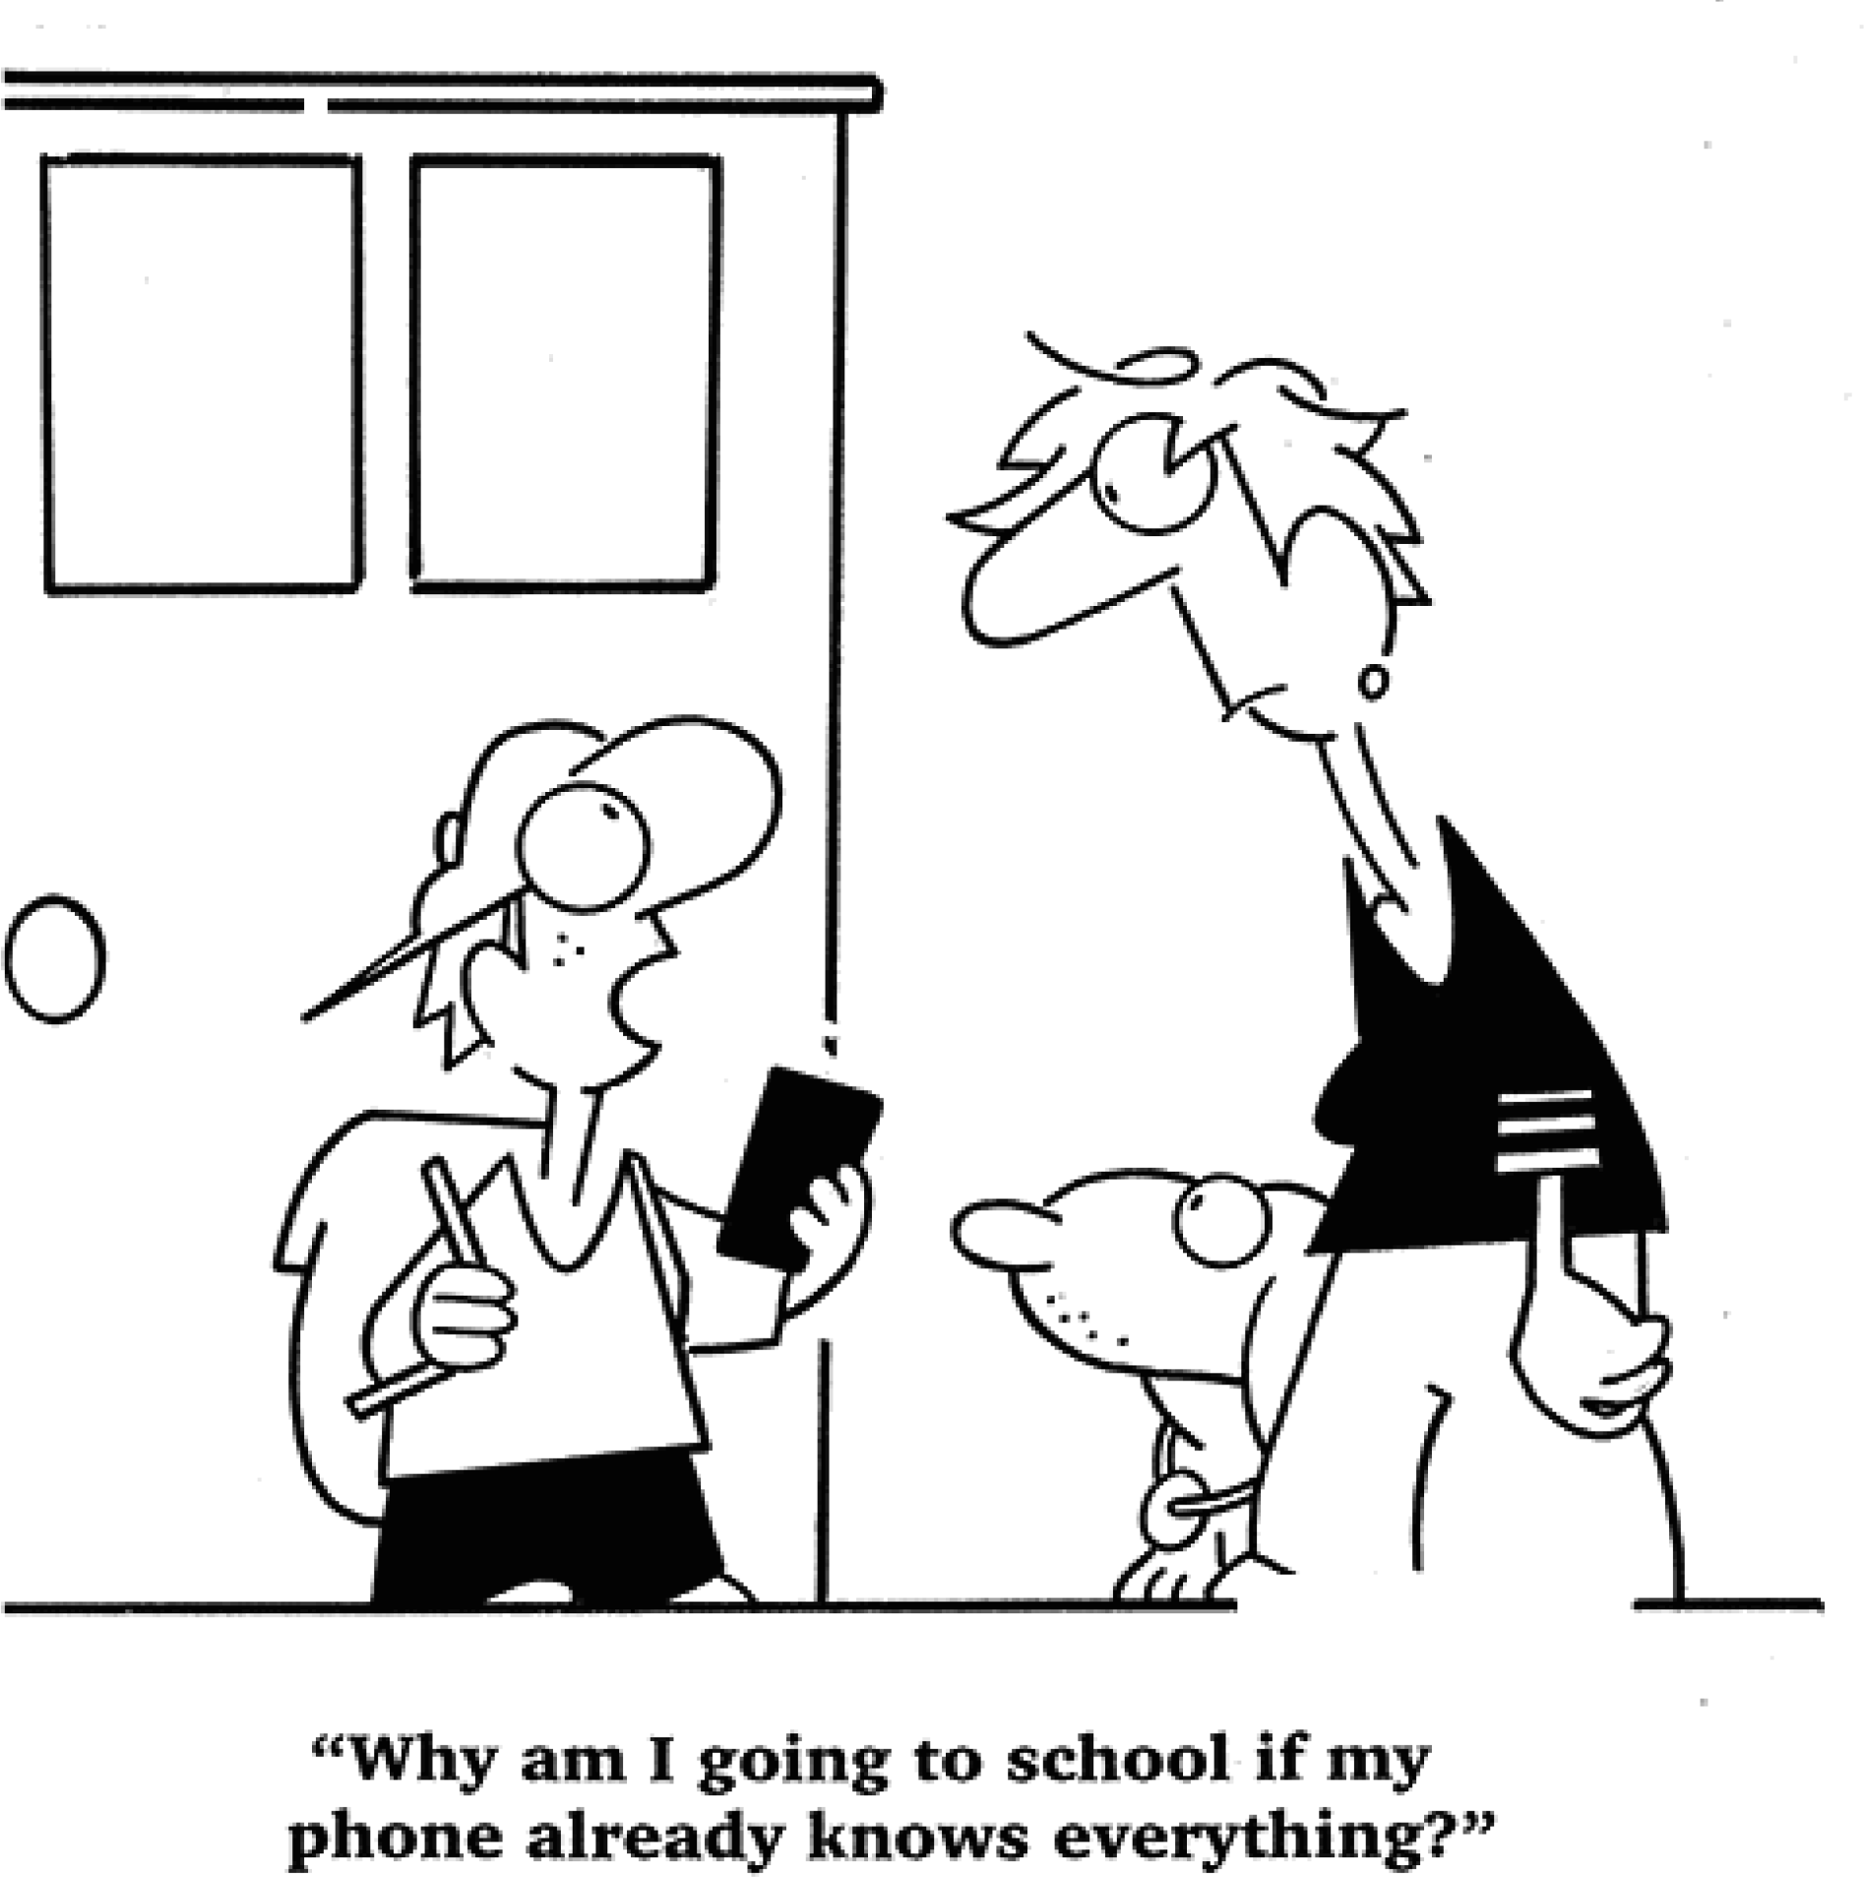

PartII

ListeningComprehension

(２５minutes)

SectionA

Directions:Inthissection,you willhearthreenewsreports．Attheendofeachnews report,youwillheartwoorthreequestions．Boththenewsreportandthequestions

样卷

１４５

willbespokenonlyonce．Afteryouhearaquestion,you mustchoosethebestanswer fromthefourchoicesmarkedA),B),C)andD)．Then markthecorrespondingletter onAnswerSheet１withasinglelinethroughthecentre．

Questions１and２arebasedonthenewsreportyouhavejustheard．

１．A)ChristmasＧtimeattacksmadebySomalirebels． B)AnexplosionatabusstationincentralNairobi． C)Thekillingofmorethan７０UgandansinKampala． D)BlastssetoffbyaSomaligroupinUgandascapital．

２．A)OnChristmasEve． C)Duringasecuritycheck． B)Justbeforemidnight． D)Inthesmallhoursofthemorning．

Questions３and４arebasedonthenewsreportyouhavejustheard．

３．A)Itislikelytoclosemanyofitsstores． B)Itisknownforthequalityofitsgoods． C)Itremainscompetitiveintherecession． D)Itwillexpanditsonlineretailbusiness．

４．A)Expanditsbusinessbeyondgroceries． B)Fire２５,０００ofitscurrentemployees． C)CutitsDVDpublishingbusiness． D)Sellthebusinessforonepound．

Questions５to７arebasedonthenewsreportyouhavejustheard．

５．A)Alltaxisbegantousemeters． B)Alltaxisgotairconditioning． C)Advertisementswereallowedontaxis． D)Oldtaxiswerereplacedwithnewcabs．

６．A)Alowinterestloanscheme． C)Taxipassengerscomplaints． B)Environmentalistsprotests． D)Permissionforcaradvertising．

７．A)Therearenomoreirregularpractices． B)AllnewcabsprovideairＧconditioning． C)Newcabsareallequippedwithmeters． D)Newlegislationprotectsconsumerrights．

１４６

SectionB

Directions:Inthissection,you willheartwolongconversations．Attheendofeach conversation,you willhearfourquestions．Boththeconversation andthequestions willbespokenonlyonce．Afteryouhearaquestion,you mustchoosethebestanswer fromthefourchoicesmarkedA),B),C)andD)．Then markthecorrespondingletter onAnswerSheet１withasinglelinethroughthecentre．

Questions８to１１arebasedontheconversationyouhavejustheard．

８．A)IthasapartnershipwithLCP． C)Itspecializesinsafetyfromleaks． B)ItisheadquarteredinLondon． D)Ithasachemicalprocessingplant．

９．A)Heisachemist． C)Heisasafetyinspector．

B)Heisasalesman． D)HeisMr．Grandsfriend．

１０．A)Thepublicrelationsofficer． C)Directorofthesafetydepartment． B)Mr．Grandspersonalassistant． D)Headofthepersonneldepartment．

１１．A)WaitforMr．Grandtocallback． B)LeaveamessageforMr．Grand． C)Providedetailsoftheirproductsandservices． D)Sendacomprehensivedescriptionoftheirwork．

Questions１２to１５arebasedontheconversationyouhavejustheard．

１２．A)Teacher． B)Journalist． C)Editor． D)Typist．

１３．A)Somenewlydiscoveredscenicspot． B)BigchangesintheAmazonvalley． C)Anewrailwayunderconstruction． D)ThebeautifulAmazonrainforests．

１４．A)Innewsweeklies． C)InnewspapersSundayeditions． B)Inalocaleveningpaper． D)InoverseaseditionsofU．S．magazines．

１５．A)Tobecomeaprofessionalwriter．C)Togetherlifestorypublishedsoon． B)Tobeemployedbyanewspaper．D)Tosellherarticlestoanewsservice．

SectionC

Directions:Inthissection,you willhearthreepassages．Attheendofeachpassage,

you willhearthreeorfourquestions．Boththepassageandthequestionswillbespoken

样卷

１４７

onlyonce．Afteryouhearaquestion,you mustchoosethebestanswerfrom thefour choicesmarkedA),B),C)and D)．Then markthecorrespondingletteron Answer Sheet１withasinglelinethroughthecentre．

Questions１６to１８arebasedonthepassageyouhavejustheard．

１６．A)Sheisbothapopularandahighlyrespectedauthor． B)Sheisthefirstwritertofocusonthefateofslaves． C)SheisthemostlovedAfricannovelistofalltimes． D)Sheisthemostinfluentialauthorsincethe１９３０s．

１７．A)TheBookCriticsCircleAward． C)ThePulitzerPrizeforfiction． B)TheNobelPrizeforliterature． D)TheNationalBookAward．

１８．A)SheisarelativeofMorrisons． C)Sheisaskilledstoryteller． B)Sheisaslavefrom Africa． D)Sheisablackwoman．

１４８

Questions１９to２１arebasedonthepassageyouhavejustheard．

１９．A)Theyareverygenerousingivinggifts． B)Theyrefusegiftswhendoingbusiness． C)Theyregardgiftsasatokenoffriendship． D)Theygivegiftsonlyonspecialoccasions．

２０．A)Theyenjoygivinggiftstootherpeople． B)Theyspendalotoftimechoosinggifts． C)Theyhavetofollow manyspecificrules． D)Theypayattentiontothequalityofgifts．

２１．A)GiftＧgivingplaysanimportantroleinhumanrelationships． B)Wemustbeawareofculturaldifferencesingivinggifts． C)Wemustlearnhowtogivegiftsbeforegoingabroad． D)ReadingextensivelycanmakeoneabettergiftＧgiver．

Questions２２to２５arebasedonthepassageyouhavejustheard．

２２．A)Shetenderlylookedafterhersickmother． B)Shedevelopedastronginterestinfinance． C)Shelearnedtowriteforfinancialnewspapers． D)Sheinvestedinstocksandshareson WallStreet．

２３．A)Sheinheritedabigfortunefromherfather．

B)Shesoldherrestaurantwithasubstantialprofit． C)Shegot７．５milliondollarsfromherexＧhusband． D)Shemadeawiseinvestmentinrealestate．

２４．A)Shewasdishonestinbusinessdealings． B)ShefrequentlyillＧtreatedheremployees． C)Sheabusedanimalsincludingherpetdog． D)Shewasextremelymeanwithhermoney．

２５．A)Shecarriedonherfamilystradition． B)Shemadehugedonationstocharities． C)Shebuiltahospitalwithhermothersmoney． D)Shemadeabigfortunefrom wiseinvestments．

PartIII

ReadingComprehension

(４０minutes)

SectionA Directions:Inthissection,thereisapassagewithtenblanks．Youarerequiredtoselect onewordforeachblankfrom alistofchoicesgivenin a wordbankfollowingthe passage．Readthepassagethroughcarefullybeforemakingyourchoices．Eachchoicein thebankisidentifiedbyaletter．Pleasemarkthecorrespondingletterforeachitemon AnswerSheet２withasinglelinethroughthecentre．You maynotuseanyofthewords inthebank morethanonce．

TheU．S．DepartmentofEducationismakingeffortstoensurethatallstudentshave equalaccesstoaqualityeducation．Todayitis ２６ thelaunchoftheExcellentEducators forAllInitiative．Theinitiativewillhelpstatesandschooldistrictssupportgreateducators forthestudentswhoneedthem most．

“Allchildrenare ２７ toahighＧqualityeducationregardlessoftheirrace,zipcodeor

familyincome．Itis ２８ importantthatweprovideteachersandprincipalsthesupport theyneedtohelpstudentsreachtheirfull ２９ ,”U．S．SecretaryofEducation Arne Duncansaid．“Despitetheexcellentworkanddeep ３０ ofournationsteachersand principals,studentsinhighＧpoverty,highＧminorityschoolsareunfairlytreatedacrossour country．Wehavetodobetter．Localleadersandeducatorswill ３１ theirowncreative solutions,butwemustworktogetherto ３２ ourfocusonhowtobetterrecruit,support and ３３ effectiveteachersandprincipalsforallstudents,especiallythekidswhoneed them most．”

Todaysannouncementisanotherimportantstepforwardinimproving accesstoa

样卷

１４９

qualityeducation,a ３４ ofPresidentObamasyearofaction．Latertoday,Secretary Duncanwillleadaroundtablediscussionwithprincipalsandschoolteachersfromacrossthe countryaboutthe ３５ of workingin highＧneedschoolsandhow toadoptpromising practicesforsupportinggreateducatorsintheseschools．

I)distributing J)enhance K)entitled L)potential M)properly N)qualified

O)retain

A)announcing B)beneficial C)challenges D)commitment E)component F)contests G)critically

H)develop

SectionB Directions:Inthissection,youaregoingtoreadapassagewithtenstatementsattached toit．Eachstatementcontainsinformationgiveninoneoftheparagraphs．Identifythe paragraphfrom whichtheinformationisderived．You maychooseaparagraph more thanonce．Eachparagraphismarkedwithaletter．Answerthequestionsby marking thecorrespondingletteronAnswerSheet２．

１５０

TheChangesFacingFastFood

1. FastＧfoodfirmshavetobeathickＧskinnedbunch．Healthexpertsregularlycriticise them severely for selling food that makes people fat．Critics even complain that McDonalds,whoselogosymbolisescalorie excess,should nothave been allowedto sponsortheWorldCup．ThesearethingsfastＧfoodfirmshavelearnttocopewith．Butnot perhapsformuchlonger．Theburgerbusinessfacesmorepressurefromregulatorsata timewhenitisalreadyadaptingstrategiesinresponsetoshiftsintheglobaleconomy．
2. Fastfood wasoncethoughtto be recessionＧproof．When consumers needto cut

spending,thelogicgoes,cheap mealslikeBig Macsand Whoppersbecomeeven more attractive．Such “tradingdown”provedtrueformuchofthelatestrecession,whenfastＧ foodcompanies picked up customers who could no longer afford to eat at casual restaurants．TrafficwasboostedinAmerica,thehomeoffastfood,withdiscountsand promotions,suchas＄１menusandcheapcombinationmeals．

1. Asaresult,fastＧfoodchainshave weatheredtherecessionbetterthantheir more

expensivecompetitors．In２００９salesatfullＧservicerestaurantsinAmericafellby more

than６％,buttotalsalesremainedaboutthesameatfastＧfoodchains．Insomemarkets, suchasJapan,FranceandBritain,totalspendingonfastfoodincreased．SameＧstoresales in America at McDonalds,the worldslargestfastＧfood company,did not decline throughoutthedownturn．PaneraBread,anAmericanfastＧfoodchainknownforitsfresh ingredients,performed well,too,becauseitoffershigherＧqualityfoodatlowerprices thanrestaurants．

1. ButnotallfastＧfoodcompanieshavebeenasfortunate．Many,suchasBurgerKing,

haveseensalesfall．Inasevererecession,whilesomepeopletradedowntofastfood, manyotherseatathome morefrequentlytosave money．DavidPalmer,ananalystat UBS,abank,sayssmallerfastＧfoodchainsinAmerica,suchasJackintheBoxandCarls Jr．,havebeenhitparticularlyhardinthisdownturnbecausetheyarecompetingwiththe globalgiantMcDonalds,whichincreasedspendingonadvertisingby morethan７％ last yearasotherscutback．

1. SomefastＧfoodcompaniesalsosacrificedtheirownprofitsbytryingtogivecustomers

bettervalue．Duringtherecessioncompaniessetpriceslow,hopingthatoncetheyhad temptedcustomersthroughthedoorthey wouldbepersuadedtoorder moreexpensive items．Butinmanycasesthatstrategydidnotwork．LastyearBurgerKingfranchisees

(特许 经 营 人 )sued (起 诉 )thecompany overitsdoubleＧcheeseburgerpromotion,

claimingitwasunfairforthemtoberequiredtosellthesefor＄１whentheycost＄１．１０ tomake．InMayajudgeruledinfavourofBurgerKing．Nevertheless,thecompanymay stillbecursingitsdecisiontopromotecheapchoicesovermoreexpensiveonesbecause itemsonits “value menu”nowaccountforaround２０％ ofallsales,upfrom １２％ last October．

1. AnalystsexpectthefastＧfoodindustrytogrow modestlythisyear．Butthedownturnis

makingcompaniesrethinktheirstrategies．ManyarenowintroducinghigherＧpriceditems toentice (引诱)consumersawayfrom ＄１specials．KFC,adivisionofYum! Brands, whichalsoownsTacoBellandPizzaHut,haslaunchedachickensandwichthatcosts around ＄５．AndinMayBurgerKingintroducedbarbecueporkribsat＄７foreight．

1. Companiesarealsotryingtogetcustomerstobuynew and moreitems,including

drinks．McDonaldsstartedsellingbettercoffeeasachallengetoStarbucks．Its“McCafé” linenowaccountsforanestimated６％ ofsalesinAmerica．Starbuckshassoldrightstoits SeattlesBestcoffeebrandtoBurgerKing,whichwillstartsellingitlaterthisyear．

1. AsfastＧfoodcompaniesshiftfrom “supersize”to “morebuys”,theyneedtokeep

customertraffichighthroughouttheday．Manyseebreakfastasabigopportunity,and notjustforfattyfood．McDonaldswillstartsellingporridge (粥)inAmericanextyear． Breakfasthasthepotentialtobeveryprofitable,saysSaraSenatoreofBernstein,a researchfirm,becausethe marginscanbehigh．FastＧfoodcompaniesarealsoadding middayandlateＧnightsnacks,suchasblendeddrinksand wraps．Theideaisthatby havingagreaterrangeofthingsonthemenu,“wecanselltoconsumersproductsthey

样卷

１５１

wantallday,”saysRickCarucci,thechieffinancialofficerofYum! Brands．

I) Butwhataboutthosegrowingwaistlines? Sofar,fastＧfoodfirmshavecleverlyavoided government regulation．By providing healthy options,like salads and lowＧcalorie sandwiches,theyhaveatleastgiventheimpressionofdoingsomethingabouthelpingto fightobesity．Theseofferingsarenotnecessarilylossleaders,astheybroadentheappeal ofoutletstogroupsofdinersthatincludesomepeoplewhodontwanttoeataburger．But customerscannotbeforcedtoordersaladsinsteadoffries．

1. Inthefuture,simply offeringahealthy option may notbe goodenough．“Every

packagedＧfoodandrestaurantcompanyIknowisconcernedaboutregulationrightnow,” saysMr．PalmerofUBS．Americashealthreformbill,whichCongresspassedthisyear, requiresrestaurantchainswith２０ormoreoutletstoputthecaloriecontentofitemsthey serveonthemenu．AstudybytheNationalBureauofEconomicResearch,whichtracked theeffectsonStarbucksofasimilarcalorieＧpostinglawinNewYorkCityin２００７,found thattheaveragecaloriecountpertransactionfell６％ andrevenueincreased３％ at StarbucksstoreswhereaDunkinDonutsoutletwasnearby—asign,itissaid,thatmenu labellingcouldfavourchainsthathavemorehealthyofferings．

1. InordertoavoidotherlegislationinAmericaandelsewhere,fastＧfoodcompanieswill

havetocontinueinnovating．WaltRikerofMcDonaldsclaimsthechangeithasmadeinits menumeansitoffersmorehealthyitemsthanitdidafewyearsago．“Weprobablysell morevegetables,more milk,moresalads,moreapplesthananyrestaurantbusinessin theworld,”hesays．ButtherecentproposalbyacountyinCaliforniatoban McDonalds fromincludingtoysinitshighＧcalorie “Happy Meals”,becauselegislatorsbelieveit attractschildrentounhealthyfood,suggeststhereisalotmorelefttodo．

３６．Somepeopleproposelawsbe madetostop McDonaldsfrom attachingtoystoitsfood specialsforchildren．

３７．FastＧfoodfirmsmaynotbeabletocopewithpressuresfromfoodregulationinthenear future．

３８．BurgerKingwillstarttosellSeattlesBestcoffeetoincreasesales． ３９．SomefastＧfoodfirmsprovidehealthyfoodtogivetheimpressiontheyarehelpingto

tackletheobesityproblem．

４０．Duringtherecession,manycustomersturnedtofastfoodtosavemoney． ４１．Manypeopleeatoutlessoftentosavemoneyintimesofrecession．

１５２

４２．Duringtherecession,BurgerKingspromotionalstrategyofofferinglowＧpriceditems oftenprovedineffective．

４３．FastＧfoodrestaurantscanmakealotofmoneybysellingbreakfast． ４４．ManyfastＧfoodcompaniesnowexpecttoincreasetheirrevenuebyintroducinghigherＧ

priceditems．

４５．AnewlyＧpassedlawrequiresbigfastＧfoodchainsspecifythecaloriecountofwhatthey serveonthemenu．

SectionC

Directions:Thereare２ passagesin thissection．Each passageisfollowed bysome questionsorunfinishedstatements．ForeachofthemtherearefourchoicesmarkedA), B),C)andD)．Youshoulddecideonthebestchoiceandmarkthecorrespondingletter onAnswerSheet２withasinglelinethroughthecentre．

PassageOne Questions４６to５０arebasedonthefolowingpassage．

IfyouthinkahighＧfactorsunscreen (防晒霜)keepsyousafefromharmfulrays,you

maybe wrong．Researchinthis weeks Nature showsthatwhilefactor５０reducesthe numberof melanomas (黑 瘤 )and delaystheir occurrence,it cant preventthem． Melanomasarethemostaggressiveskincancers．Youhaveahigherriskifyouhaveredor blondhair,fairskin,blueorgreeneyes,orsunburneasily,orifacloserelativehashad one．Melanomasaremorecommonifyouhaveperiodicintenseexposuretothesun．Other skincancersareincreasinglylikelywithlongＧtermexposure．

Thereiscontinuingdebateastohoweffectivesunscreenisinreducing melanomas —

theevidenceisweakerthanitisforpreventingothertypesofskincancer．A２０１１Australian studyof１,６２１peoplefoundthatpeoplerandomlyselectedtoapplysunscreendailyhadhalf therateofmelanomasofpeoplewhousedcreamasneeded．Asecondstudy,comparing１, １６７peoplewithmelanomasto１,１０１whodidnthavethecancer,foundthatusingsunscreen routinely,alongsideotherprotectionsuchashats,longsleevesorstayingintheshade,did givesomeprotection．Thisstudysaidotherformsofsunprotection — notsunscreen — seemedmostbeneficial．Thestudyreliedonpeoplerememberingwhattheyhaddoneover eachdecadeoftheirlives,soitsnotentirelyreliable．Butitseemsreasonabletothink sunscreengivespeopleafalsesenseofsecurityinthesun．

Manypeoplealsodontusesunscreenproperly — applyinginsufficientamounts,failing

toreapplyafteracoupleofhoursandstayinginthesuntoolong．Itissunburnthatismost worrying — recentresearchshowsfiveepisodesofsunburnintheteenageyearsincreases

样卷

１５３

１５４

theriskofallskincancers． Thegoodnewsisthatacombinationofsunscreenandcoveringupcanreducemelanoma

rates,asshownbyAustralianfiguresfromtheirslipＧslopＧslapcampaign．Soifthereisaheat

wavethissummer,itwouldbebestforus,too,tosliponashirt,slopon (抹上)sunscreen andslaponahat．

４６．WhatispeoplescommonexpectationofahighＧfactorsunscreen?

A)Itwilldelaytheoccurrenceofskincancer． B)Itwillprotectthemfromsunburn． C)Itwillkeeptheirskinsmoothandfair． D)Itwillprotectpeopleofanyskincolor．

４７．WhatdoestheresearchinNaturesayaboutahighＧfactorsunscreen?

A)Itisineffectiveinpreventingmelanomas． B)Itisineffectiveincaseofintensesunlight． C)ItisineffectivewithlongＧtermexposure． D)Itisineffectiveforpeoplewithfairskin．

４８．Whatdowelearnfromthe２０１１Australianstudyof１,６２１people?

A)Sunscreenshouldbeappliedalongsideotherprotectionmeasures． B)HighＧriskpeoplebenefitthemostfromtheapplicationofsunscreen． C)Irregularapplicationofsunscreendoeswomenmoreharmthangood． D)Dailyapplicationofsunscreenhelpsreducetheincidenceofmelanomas．

４９．WhatdoestheauthorsayaboutthesecondAustralianstudy? A)Itmisleadspeopletorelyonsunscreenforprotection． B)Ithelpspeopletoselectthemosteffectivesunscreen． C)Itisnotbasedondirectobservationofthesubjects． D)ItconfirmstheresultsofthefirstAustralianstudy．

５０．Whatdoestheauthorsuggesttoreducemelanomarates?

A)Usingbothcoveringupandsunscreen． B)Stayingintheshadewheneverpossible． C)Usingcoveringupinsteadofsunscreen． D)Applyingtherightamountofsunscreen．

PassageTwo Questions５１to５５arebasedonthefolowingpassage．

Acrosstherich world,wellＧeducatedpeopleincreasingly worklongerthanthelessＧ

skilled．Some６５％ ofAmerican men aged６２Ｇ７４ withaprofessionaldegreeareinthe workforce,comparedwith３２％ ofmenwithonlyahighＧschoolcertificate．Thisgapispart ofadeepening dividebetweenthe wellＧeducated wellＧoffandthe unskilled poor．Rapid technologicaladvancehasraisedtheincomesofthehighlyskilledwhilesqueezingthoseof theunskilled．Theconsequences,forindividualsandsociety,areprofound．

Theworldisfacinganastonishingriseinthenumberofoldpeople,andtheywilllive

longerthaneverbefore．Overthenext２０yearstheglobalpopulationofthoseaged６５or morewillalmostdouble,from６００millionto１．１billion．Theexperienceofthe２０thcentury, whengreaterlongevity (长寿)translatedinto moreyearsinretirementratherthan more yearsatwork,haspersuaded manyobserversthatthisshiftwillleadtoslowereconomic growth,whiletheswellingranksofpensionerswillcreategovernmentbudgetproblems．

Butthenotionofasharpdivisionbetweentheworkingyoungandtheidleoldmissesa

newtrend,thegrowinggapbetweentheskilledandtheunskilled．Employmentratesare fallingamongyoungerunskilledpeople,whereasolderskilledfolkareworkinglonger．The divideis mostextremein America,where wellＧeducated babyＧboomersare putting off retirementwhilemanylessＧskilledyoungerpeoplehavedroppedoutoftheworkforce．

Policyispartlyresponsible．ManyEuropeangovernmentshaveabandonedpoliciesthat usedto encourage people to retire early．Rising life expectancy,combined with the replacement of generous definedＧbenefit pension plans with less generous definedＧ contributionones,meansthateventhebetterＧoffmustworklongertohaveacomfortable retirement．Butthechangingnatureofworkalsoplaysabigrole．Payhasrisensharplyfor thehighlyeducated,andthosepeoplecontinuetoreaprichrewardsintooldagebecause these days the educated elderly are more productive than the preceding generation． Technologicalchangemaywellreinforcethatshift:theskillsthatcomplementcomputers, from managementknowhowtocreativity,donotnecessarilydeclinewithage．

５１．Whatishappeningintheworkforceinrichcountries?

A)Youngerpeoplearereplacingtheelderly． B)WellＧeducatedpeopletendtoworklonger． C)Unemploymentratesarerisingyearafteryear． D)Peoplewithnocollegedegreedonoteasilyfindwork．

５２．WhathashelpeddeepenthedividebetweenthewellＧoffandthepoor?

A)Longerlifeexpectancies． C)Profoundchangesintheworkforce． B)Arapidtechnologicaladvance． D)AgrowingnumberofthewellＧeducated．

５３．Whatdomanyobserverspredictinviewoftheexperienceofthe２０thcentury?

A)Economicgrowthwillslowdown． B)Governmentbudgetswillincrease．

样卷

１５５

C)Morepeoplewilltrytopursuehighereducation． D)Therewillbemorecompetitioninthejobmarket．

５４．WhatistheresultofpolicychangesinEuropeancountries?

A)Unskilledworkersmaychoosetoretireearly． B)MorepeoplehavetoreceiveinＧservicetraining． C)Evenwealthypeoplemustworklongertolivecomfortablyinretirement． D)PeoplemaybeabletoenjoygenerousdefinedＧbenefitsfrompensionplans．

５５．Whatischaracteristicofworkinthe２１stcentury?

A)Computerswilldomorecomplicatedwork． B)Morewillbetakenbytheeducatedyoung． C)Mostjobstobedonewillbecreativeones． D)Skillsarehighlyvaluedregardlessofage．

PartIV

Translation

(３０minutes)

Directions:Forthispart,you areallowed３０ minutestotranslatea passagefrom ChineseintoEnglish．YoushouldwriteyouransweronAnswerSheet２．

据报道,今年中国快递服务(courierservices)将递送大约１２０亿件包裹.这将使中国有可能超越美国成为世界上最大的快递市场.大多数包裹里装着网上订购的物品.中国给数百万在线零售商以极具竞争力的价格销售商品的机会.仅在１１ 月１１ 日,中国消费者就从国内最大的购物平台购买了价值９０亿美元的商品.中国有不少这样的特殊购物日.因此,快递业在中国扩展就不足为奇了.

１５６

### 【听力文字稿】

SectionA

Directions:Inthissection,you willhearthreenewsreports．Attheendofeachnews report,youwillheartwoorthreequestions．Boththenewsreportandthequestions willbespokenonlyonce．Afteryouhearaquestion,you mustchoosethebestanswer fromthefourchoicesmarkedA),B),C)andD)．Then markthecorrespondingletter onAnswerSheet１withasinglelinethroughthecentre．

NewsReportOne

Kenyanpolicesayonepersonwaskilledand２６injuredinanexplosionatabusstation incentralNairobi．TheblasthitabusabouttosetofffortheUgandancapitalKampala．Last July,theSomaligroupalＧShababsaiditwasbehindtheblastsintheUgandancapitalwhich killedmorethan７０people．WillRossreportsfromtheKenyancapital．

Theexplosionhappenedbesideabuswhichwasabouttosetoffforanovernightjourney from NairobitotheUgandancapitalKampala．Someeyewitnessesreportthatabagwasabout tobeloadedonboard,butitexplodedduringasecuritycheck．Windowsoftheredbuswere leftsmashed,andbloodcouldbeseenonthegroundbesidethevehicle．Justhoursearlier, UgandaspolicechiefhadwarnedofpossibleChristmasＧtimeattacksbySomalirebels．

Questions１and２arebasedonthenewsreportyouhavejustheard．

１．Whatisthenewsreportmainlyabout? ２．Whendidtheincidentoccur?

NewsReportTwo

WoolworthsisoneofthebestknownnamesontheBritish HighStreet．Itsbeenin businessfornearlyacentury．Many ofits８００ storesarelikelytoclosefollowingthe companysdecisiontocallinadministratorsafteranattempttosellthebusinessforatoken

￡１failed．

Thecompanyhashugedebts．TheimmediatecauseforthecollapsehasbeenBritains slidetowardrecession,whichhascutintoconsumerspending．However,thebusinesshad beenintroubleforyears．

Known for lowＧpriced general goods, Woolworths has struggled in the face of

competitionfromsupermarketsexpandingbeyondgroceriesandanewgenerationofinternet retailers．

Manyofthe store groups２５,０００ employeesarelikely tolosetheirjobs．Some

profitableareassuchastheDVDpublishingbusinesswillsurvive．

样卷

１５７

Questions３and４arebasedonthenewsreportyouhavejustheard．

３．WhatdowelearnaboutWoolworthsfromthenewsreport? ４．WhatdidWoolworthsattempttodorecently?

NewsReportThree

Cairoisknownnotonlyforitsovercrowdedroads,irregulardrivingpracticesandshaky oldvehicles,butalsoforitsairpollution．Inrecentmonths,though,environmentalstudies indicatetherehavebeensignsofimprovement．Thatsdueinparttotheremovalofmanyof thecapitalsoldＧfashionedblackandwhitetaxis．Mostofthesedatedbacktothe１９６０sand ７０sandwereinapoorstateofrepair．

Afternew legislation demandedtheirremovalfrom theroads,alow interestloan

scheme was set up with three Egyptian banks so drivers could buy new cars．The governmentpaysabout ＄９００foroldonestobediscardedandadvertising onthe new vehicleshelpscoverrepayments．

Theideahasprovedpopularwithcustomers— theycannowtravelinairＧconditioned

comfortandbecausethenewcabsaremetered,theydonthavetoargueoverfares．Banks andcarmanufacturersaregladfortheextrabusinessintougheconomictimes．Asforthe taxidrivers,mostaredelightedtobebehindthewheelofnewcars,althoughtherehave beenafewcomplaintsaboutswitchingfromblackandwhitetoaplainwhitecolour．

Questions５to７arebasedonthenewsreportyouhavejustheard．

５．WhatchangetookplaceinCairorecently? ６．Whathelpedbringaboutthechange?

７．Whydocustomersnolongerarguewithnewcabdrivers?

SectionB

Directions:Inthissection,you willheartwolongconversations．Attheendofeach conversation,you willhearfourquestions．Boththeconversation andthequestions willbespokenonlyonce．Afteryouhearaquestion,you mustchoosethebestanswer fromthefourchoicesmarkedA),B),C)andD)．Then markthecorrespondingletter onAnswerSheet１withasinglelinethroughthecentre．

１５８

ConversationOne

W:Morning,thisisTGC．

M:Goodmorning．WalterBarryhere,callingfrom London．CouldIspeakto Mr．Grand, please?

W:Whoscalling,please?

M:WalterBarry,from London． W:Whatisitabout,please?

M:Well,I understand that your company has a chemicalprocessing plant．My own company,LCP,LiquidControlProducts,isaleaderinsafetyfromleaksinthefieldof chemicalprocessing．Iwouldliketospeakto Mr．Grandtodiscusswaysin which we couldhelpTGCprotectitselffromsuchproblemsandsavemoneyatthesametime．

W:Yes,Isee．Well,Mr．Grandisnotavailableatthemoment．

M:CanyoutellmewhenIcouldreachhim?

W:Hesverybusyforthenextfewdays—thenhellbeawayinNewYork．Soitsdifficult togiveyouatime．

M:CouldIspeaktosomeoneelse,perhaps?

W:Whoinparticular? M:Acolleagueforexample?

W:Yourespeakingtohispersonalassistant．IcandealwithcallsforMr．Grand．

M:Yes,well,couldIringhimtomorrow?

W:No,Imsorryhewontbefreetomorrow．Listen,letmesuggestsomething．Yousend usdetailsofyourproductsandservices,togetherwithreferencesfromothercompanies andthenwellcontactyou．

M:Yes,thatsverykindofyou．Ihaveyouraddress．

W:Verygood,Mr．．．． M:Barry．WalterBarryfrom LCPinLondon． W:Right,Mr．Barry．Welookforwardtohearingfromyou． M:Thankyou．Goodbye．

W:Bye．

Questions８to１１arebasedontheconversationyouhavejustheard．

８．Whatdowelearnaboutthewomanscompany? ９．Whatdowelearnabouttheman?

１０．Whatisthewomanspositioninhercompany? １１．Whatdoesthewomansuggestthemando?

ConversationTwo M:Youregoingtowearoutthecomputerskeyboard! W:Oh,hi．

M:Doyouhaveanyideawhattimeitis?

W:AbouttenortenＧthirty? M:Itsnearlymidnight． W:Really?Ididntknowitwassolate．

M:Dontyouhaveanearlyclasstoteachtomorrow morning?

W:Yes,atsevenoclock．Mycommuterclass,thestudentswhogotoworkrightaftertheir lesson．

样卷

１５９

M:Thenyououghttogotobed．Whatareyouwriting,anyway? W:AnarticleIhopeIcansell． M:Oh,anotherofyournewspaperpieces? Whatsthisoneabout? W:DoyourememberthetripItooklastmonth?

M:TheoneuptotheAmazon?

W:Well,thatswhatIm writingabout—thenewhighwayandthechangesitsmakingin theAmazonvalley．

M:Itshouldbeinteresting．

W:Itis．IguessthatswhyIforgotallaboutthetime． M:How manyarticleshaveyousoldnow?

W:Aboutadozensofar．

M:Whatkindofnewspapersbuythem?

W:Thepapersthatcarryalotofforeignnews．TheyusuallyappearinthebigSunday editionswheretheyneedalotofbackgroundstoriestohelpfillupthespacebetween theads．

M:Isthereanyfutureinit? W:Ihopeso．TheresachanceImaysellthisarticletoanewsservice． M:Thenyourstorywouldbepublishedinseveralpapers,wouldntit?

W:Thatstheidea．AndImightevenbeabletodootherstoriesonaregularbasis．

M:Thatwouldbegreat．

Questions１２to１５arebasedontheconversationyouhavejustheard．

１２．Whatisthewomansoccupation? １３．Whatisthewomanwritingabout? １４．Wheredothewomansarticlesusuallyappear? １５．Whatdoesthewomanexpect?

SectionC

Directions:Inthissection,you willhearthreepassages．Attheendofeachpassage, you willhearthreeorfourquestions．Boththepassageandthequestionswillbespoken onlyonce．Afteryouhearaquestion,you mustchoosethebestanswerfrom thefour choicesmarkedA),B),C)and D)．Then markthecorrespondingletteron Answer Sheet１withasinglelinethroughthecentre．

１６０

PassageOne

Intodaysclass,welldiscussToniMorrisonsnovelBeloved．AsImsureyouallknow, Morrisonisbothapopularandahighlyrespectedauthor,anditsnoteasytobeboth．Born in１９３１,Morrison has writtensomeofthe mosttouchingandintelligent worksonthe AfricanＧAmericanexperienceever written by anyone,and yettocallheran “AfricanＧ

Americanwriter”doesntseemtodoherjustice．In manyways,shessimplyanAmerican writer—andcertainlyoneofourbest．

Beloved isatruly remarkable work．It wasrecommendedfor nearly every major literaryprize,includingthe NationalBook Awardandthe NationalBook Critics Circle Award,anditinfact won the Pulitzer Prizeforfictionin １９８８．Morrison herselfis distinguishedforhavingwontheNobelPrizeforliteraturein１９９３．

WhatmakesBeloveduniqueistheskillful,surewayinwhichMorrisonblendsintensely

personalstorytelling and American history,racial themes and gender themes,the experienceofBlackswiththeexperienceofallpeopleeverywhere,thedownＧtoＧearthreality ofslaverywithasenseofmysteriousspirituality．

Wellbe paying specialattention to these themes as we discuss this work．Im particularlyinterestedinyourviewsontherelativeimportanceofraceandgenderinthis book．IsitmoreimportantthatSethe,themaincharacter,isblackorthatshesawoman? Whichcontributesmoretoherbeing? WhatdoesMorrisontellusaboutboth?

Questions１６to１８arebasedonthepassageyouhavejustheard．

１６．WhatdowelearnaboutToniMorrison? １７．WhathonordidToniMorrisonreceivein１９９３? １８．WhatdoesthespeakertellusaboutSethe,the maincharacterin Morrisonsnovel

Beloved?

PassageTwo

ThetopicofmytalktodayisgiftＧgiving．Everybodylikestoreceivegifts,right? Soyou maythinkthatgiftＧgivingisauniversalcustom．Butactually,therulesofgiftＧgivingvary quitealot,andnotknowingthemcanresultingreatembarrassment．InNorthAmerica,the rulesarefairlysimple．Ifyoureinvitedtosomeoneshomefordinner,bringwineorflowers orasmallitem from yourcountry．Amongfriends,family,andbusinessassociates,we generallydontgivegiftsonotheroccasionsexceptonsomeonesbirthdayandChristmas． TheJapanese,ontheotherhand,givegiftsquitefrequently,oftentothanksomeonefor theirkindness．ThetraditionofgiftＧgivinginJapanisveryancient．Therearemanydetailed rulesfor everything from the color ofthe wrapping paper to the time ofthe gift presentation．AndwhileEuropeansdontgenerallyexchangebusinessgifts,theydofollow someformalcustomswhenvisitinghomes,suchasbringingflowers．Thetypeandcolorof flowers,however,cancarryspecialmeaning．

TodaywehaveseensomebroaddifferencesingiftＧgiving．Icouldgoonwithadditional

examples．Butletsnotmissthe mainpointhere:Ifwearenotawareofandsensitiveto culturaldifferences,the possibilitiesfor miscommunication and conflictare enormous． Whetherwelearnaboutthesedifferencesbyreadingabookorbylivingabroad,ourgoal mustbetorespectdifferencesamongpeopleinordertogetalongsuccessfully withour

样卷

１６１

globalneighbors．

Questions１９to２１arebasedonthepassageyouhavejustheard． １９．WhatdoesthespeakersayaboutgiftＧgivingofNorthAmericans? ２０．WhatdowelearnabouttheJapaneseconcerninggiftＧgiving?

２１．Whatpointdoesthespeakermakeattheendofthetalk?

PassageThree

HettyGreen wasaveryspoilt,onlychild．She wasbornin Massachusetts,USA,in １８３５．Herfatherwasamillionairebusinessman．Hermotherwasoftenill,andsofromthe ageoftwoherfathertookherwithhimtoworkandtaughtheraboutstocksandshares．At theageofsixshestartedreadingthedailyfinancialnewspapersandopenedherownbank account．

Herfatherdiedwhenshewas２１andsheinherited＄７．５million．ShewenttoNewYork andinvestedonWallStreet．Hettysavedeverypenny,eatinginthecheapestrestaurantsfor １５cents．Shebecameoneoftherichestand mosthated womeninthe world．At３３she marriedEdwardGreen,amultiＧmillionaire,andhadtwochildren,NedandSylvia．

Hettysmeannesswaswellknown．Shealwaysarguedaboutpricesinshops．Shewalked tothelocalgrocerystoretobuybrokenbiscuitswhichweremuchcheaper,andtogetafree boneforhermuchloveddog．OnceshelostatwoＧcentstampandspentthenightlookingfor it．Sheneverboughtclothesandalwaysworethesamelong,raggedblackskirt．Worstof all,whenhersonNedfellandinjuredhisknee,sherefusedtopayforadoctorandspent hourslookingforfreemedicalhelp．IntheendNedlosthisleg．

Whenshediedin１９１６sheleftherchildren ＄１００million．Herdaughterbuiltahospital

withhermoney．

Questions２２to２５arebasedonthepassageyouhavejustheard．

２２．WhatdowelearnaboutHettyGreenasachild? ２３．HowdidHettyGreenbecomerichovernight?

２４．WhywasHettyGreenmuchhated?

２５．WhatdowelearnaboutHettyGreensdaughter?

１６２

### 【参考答案】

PartI ListeningComprehension SectionA

１．B ２．C ３．A ４．D ５．D

６．A ７．C

SectionB

８．D ９．B １０．B １１．C １２．A

１３．B １４．C １５．D

SectionC

１６．A １７．B １８．D １９．D ２０．C

２１．B ２２．B ２３．A ２４．D ２５．C

PartII ReadingComprehension SectionA

２６．A ２７．K ２８．G ２９．L ３０．D

３１．H ３２．J ３３．O ３４．E ３５．C

SectionB

３６．K ３７．A ３８．G ３９．I ４０．B

４１．D ４２．E ４３．H ４４．F ４５．J

SectionC

４６．B ４７．A ４８．D ４９．C ５０．A

５１．B ５２．B ５３．A ５４．C ５５．D

PartIV Translation

ItisreportedthatChinesecourierserviceswilldeliverabout１２billionparcelsthisyear． ThiswillenableChinatoovertaketheUSandbecometheworldsbiggestdeliverymarket． Themajorityofcourierpackagescontainitemsorderedonline．Chinagivesmillionsofonline retailerstheopportunitytosellgoodsathighlycompetitiveprices．On１１Novemberalone, Chineseconsumersbought ＄９billion worthofproductsonthecountrysbiggestshopping platform．Chinahasmanyspecialshoppingholidayslikethis．So,itsnosurprisethecourier industryisexpandinginChina．

样卷

１６３

## ２．全国大学英语四级考试(口试)样卷

Topicarea:DailyLife Topic:Travel

Hello,welcometotheCETSpokenEnglishTest— BandFour．Wewishyoubothgood

lucktoday．Nowletsstartbyintroducingyourselves． CandidateA,wouldyoupleasegofirst? (时间２０秒)

Thankyou．CandidateB,nowitsyourturn．(时间２０秒)

Thankyou．OK,nowthatweknoweachother,letsmoveon．

Task１ ReadAloud

Inthistask,youwillreadaloudashortpassage．Youwillhave４５secondstogooverthe passageandoneminutetoreaditaloud．Hereisthepassage．

(屏幕显示以下文字)

ManypeoplewouldlistSanFranciscoasoneofthemostdelightfulcitiesintheworld． SittingonthePacificcoast,itgivesyouafeelingofthesea．Theseabreezeswakeyouup andmakeyoueatwellandsleepwell．Thecitywasplannedwithstraightroads,andthese roadscrosseachotheratrightangles,makingsquaresastheydoin manyAmericancities． Veryoftenyoucanfindyourselfontopofahillinthecity,lookingdownoneofthese straightroadsasitrisesandfallsonitsjourneythroughthetown．Agoodwaytotravelthese roadsisbycablecar．Thesearebusesthatrunonrailsinthegroundupanddownthesteep hills．

(考生准备时间４５秒)

Whenyouhearthebeep,pleasestarttoread．

(考生A 和B 同时回答,时间１分钟)

１６４

Task２ QuestionandAnswer

Inthistask,you willanswertwo questions．Foreach question,you willhave２０ secondstorespond．Whenyouhearthebeep,pleasestarttospeak．

(问题文字不显示在屏幕上)

Question１:

WhatwouldmanypeoplethinkofSanFranciscoaccordingtothepassage?

(考生A 和B 同时回答,时间２０秒)

Question２:

WhichcoastalcityinChinadoyoulikemost? Andwhy?

(考生A 和B 同时回答,时间２０秒)

Task３ IndividualPresentation

Inthistask,youwilltalkaboutthepicturedisplayedonthescreen．Youwillhave４５ secondstoprepareandoneminutetotalkaboutit．Nowhereisthepicture．

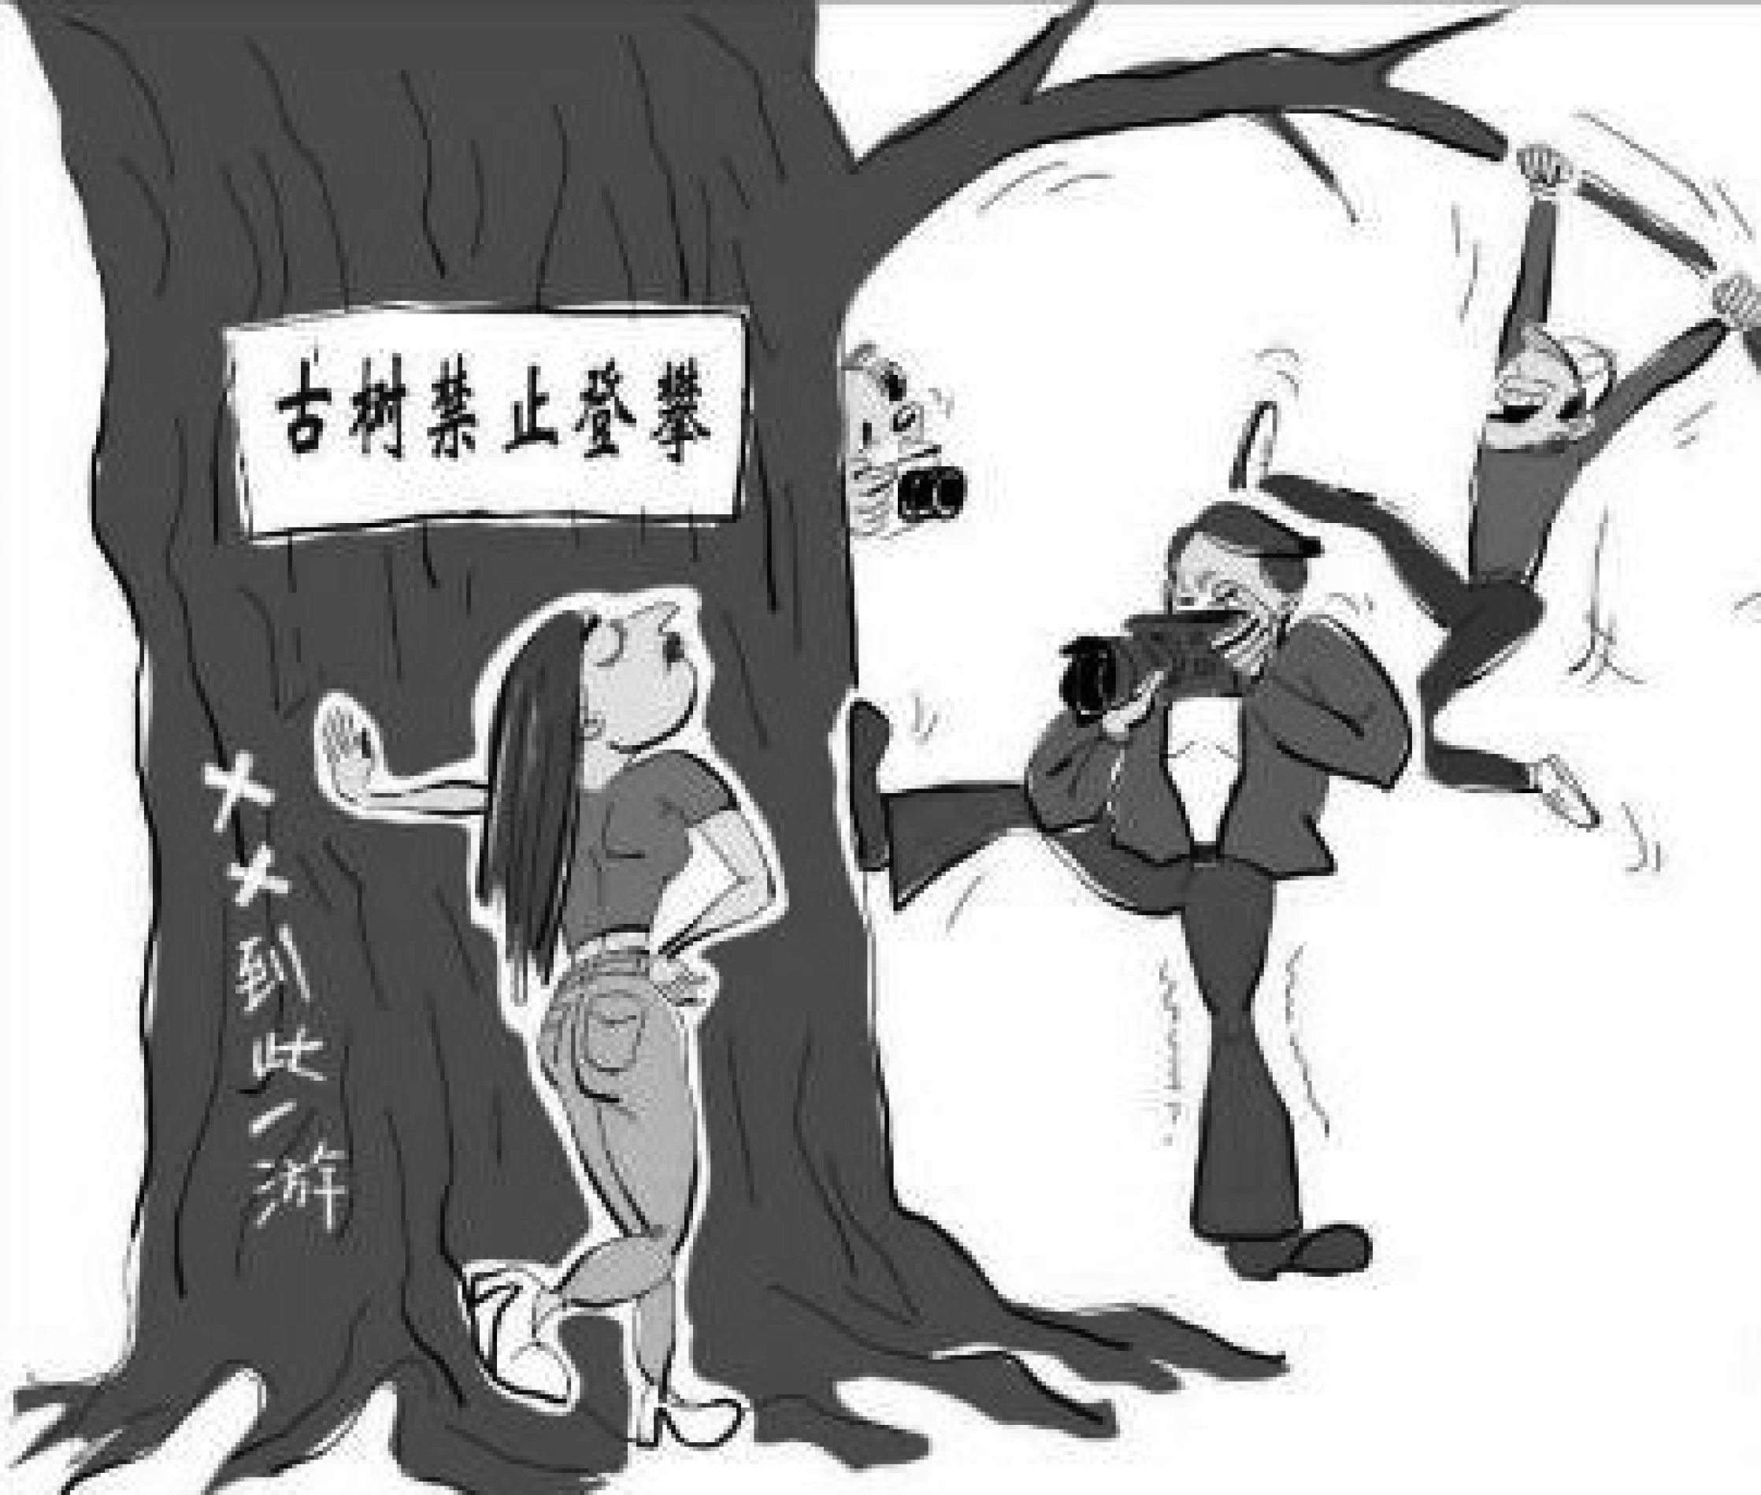

(考生准备时间４５秒)

Whenyouhearthebeep,pleasestarttospeak．

(考生A 和B 同时回答,时间１分钟)

Task４ PairWork

Inthistask,youwilltalkwithyourpartneraboutaplanoftravel．Supposeyouhave threedaystogosightseeingtogether．Talkwitheachotherand makeaplanforyourtrip． Yourplanmayinclude:

* place(s)tovisit
* schedule
* meansoftransportation

Youwillhaveoneminutetoprepareandthreeminutestotalk．Remember,thisisapair activityandyouneedtointeractwitheachother．Yourperformancewillbejudgedaccording toyourcontributiontothepairwork．Nowpleasestarttoprepare．

样卷

１６５

(屏幕上显示以下文字)

Yourplanmayinclude:

* place(s)tovisit
* schedule
* meansoftransportation

(考生准备时间１分钟)

Whenyouhearthebeep,pleasestarttospeak．

(考生A 和B 讨论,时间３分钟)

Thankyou．Thatistheendofthetest．

１６６

## ３．全国大学英语六级考试(笔试)样卷

PartI

Writing

(３０minutes)

Directions:Forthispart,youareallowed３０ minutestowriteanessaycommentingon thesaying “Ifyoucannotdogreatthings,dosmallthingsinagreatway．”Youcan citeexamplestoillustrateyourpointofview．Youshouldwriteatleast１５０wordsbut nomorethan２００words．WriteyouressayonAnswerSheet１．

PartII

ListeningComprehension

(３０minutes)

SectionA

Directions:Inthissection,you willheartwolongconversations．Attheendofeach conversation,you willhearfourquestions．Boththeconversation andthequestions willbespokenonlyonce．Afteryouhearaquestion,you mustchoosethebestanswer fromthefourchoicesmarkedA),B),C)andD)．Then markthecorrespondingletter onAnswerSheet１withasinglelinethroughthecentre．

Questions１to４arebasedontheconversationyouhavejustheard．

１．A)Heinventedtherefrigerator． B)Hepatentedhisfirstinvention． C)Hewasadmittedtoauniversity． D)HegotadegreeinMathematics．

２．A)Hestartedtoworkonrefrigeration． B)HebecameaprofessorofMathematics． C)HefellinlovewithNatashaWilloughby． D)Hedistinguishedhimselfinlowtemperaturephysics．

３．A)Discoveringthetruenatureofsubatomicparticles． B)Theirexplanationofthelawsofcauseandeffect． C)Theirworkonveryhighfrequencyradiowaves． D)Layingthefoundationsofmodernmathematics．

４．A)TohaveathreeＧweekholiday． C)Topatenthisinventions． B)Tospendhisremainingyears． D)Toteachatauniversity．

样卷

１６７

Questions５to８arebasedontheconversationyouhavejustheard．

５．A)Theinjuryofsomestudents． B)Aschoolbuscrashontheway． C)Thecollapseofaschoolbuilding． D)Afirethatbrokeoutonaschoolcampus．

６．A)Teaching． C)Havinglunch． B)Onvacation． D)Holdingameeting．

７．A)A malfunctioningstove． C)Violationoftrafficrules． B)Cigarettesbuttsleftbyworkers． D)Negligenceinschoolmaintenance．

８．A)Sentastorytothelocalnewspaper． B)ThrewasmallThanksgivingparty． C)Bakedsomecookiesasapresent． D)Wroteapersonalletterofthanks．

SectionB Directions:Inthissection,youwillheartwopassages．Attheendofeachpassage,you willhearthreeorfourquestions．Boththepassageandthequestionswillbespokenonly once．Afteryouhearaquestion,you mustchoosethebestanswerfromthefourchoices markedA),B),C)andD)．Then markthecorrespondingletteron AnswerSheet１ withasinglelinethroughthecentre．

１６８

Questions９to１１arebasedonthepassageyouhavejustheard．

９．A)Itisatraitofagenerouscharacter． B)ItisareflectionofselfＧesteem． C)Itisanindicatorofhighintelligence． D)Itisasignofhappinessandconfidence．

１０．A)ItwasselfＧdefeating． C)Itwastheessenceofcomedy． B)Itwasaggressive． D)Itwassomethingadmirable．

１１．A)ItisadoubleＧedgedsword． C)Itisauniquegiftofhumanbeings． B)Itisafeatureofagivenculture． D)Itisaresultofbothnatureandnurture．

Questions１２to１５arebasedonthepassageyouhavejustheard．

１２．A)Sheisatouristguide． C)Sheisadomesticservant． B)Sheisaninterpreter． D)Sheisfromtheroyalfamily．

１３．A)Itissituatedatthefootofabeautifulmountain． B)Itwasusedbythefamilytoholddinnerparties． C)Itwasfrequentlyvisitedbyheadsofstate． D)Itisfurnishedlikeoneinaroyalpalace．

１４．A)Itiselaboratelydecorated． B)Ithassurvivedsome２,０００years． C)Itisverybig,withonlysixslimlegs． D)ItisshapedlikeanancientSpanishboat．

１５．A)Theyareinterestingtolookat． B)Theyhavelostsomeoftheirlegs． C)Theydonotmatchtheovaltableatall． D)Theyareuncomfortabletositinforlong．

SectionC Directions:Inthissection,you willhearthreerecordingsoflecturesortalksfollowed bythreeorfourquestions．Therecordingswillbeplayedonlyonce．Afteryouheara question,you mustchoosethebestanswerfrom thefourchoices markedA),B),C) andD)．Then markthecorrespondingletteron AnswerSheet１ with asingleline throughthecentre．

Questions１６to１９arebasedontherecordingyouhavejustheard．

１６．A)TheyinvestigatetheretirementhomesinAmerica． B)TheyareonissuesfacingseniorcitizensinAmerica． C)Theydescribethegreatpleasuresofthegoldenyears． D)Theyarefilledwithfondmemoriesofhisgrandparents．

１７．A)Thelossoftheabilitytotakecareofhimself． B)Thefeelingofnotbeingimportantanymore． C)Beingunabletofindagoodretirementhome． D)Leavingthehomehehadlivedinfor６０years．

１８．A)ThelossofidentityandselfＧworth． B)Fearofbeingreplacedordiscarded． C)Freedomfrompressureandworldlycares． D)Thepossessionofwealthandhighrespect．

１９．A)Theurgencyofpensionreform．

样卷

１６９

B)Medicalcareforseniorcitizens． C)Findingmeaningfulrolesfortheelderlyinsociety． D)Thedevelopmentofpublicfacilitiesforseniorcitizens．

Questions２０to２２arebasedontherecordingyouhavejustheard．

２０．A)Itseriouslyimpactstheirphysicalandmentaldevelopment． B)Ithasbecomeaproblemaffectingglobaleconomicgrowth． C)Itisacommonproblemfoundinunderdevelopedcountries． D)Itisanissueoftenoverlookedbyparentsinmanycountries．

２１．A)Theywilllivelonger． C)Theygetalongwellwithpeople．

B)Theygetbetterpay． D)TheydevelopmuchhigherIQs．

２２．A)AppropriatedfundstopromoteresearchofnutrientＧrichfoods． B)Encouragedbreastfeedingforthefirstsixmonthsofachildslife． C)Recruitedvolunteerstoteachruralpeopleabouthealthandnutrition． D)TargetedhungerＧreliefprogramsatpregnantwomenandyoungchildren．

Questions２３to２５arebasedontherecordingyouhavejustheard．

２３．A)Theguaranteedqualityofitsgoods． B)Thehugevolumeofitsannualsales． C)Theserviceitprovidesforitscustomers． D)ThehighvalueＧtoＧweightratioofitsgoods．

２４．A)Thosehavingatasteorsmellcomponent． B)Productspotentiallyembarrassingtobuy． C)Thosethatrequireverycarefulhandling． D)Servicesinvolvingapersonalelement．

２５．A)Thosewholiveinthevirtualworld． B)Thosewhohavetoworklonghours． C)Thosewhoareusedtoonlinetransactions． D)Thosewhodontmindpayingalittlemore．

PartIII

ReadingComprehension

(４０minutes)

１７０

SectionA Directions:Inthissection,thereisapassagewithtenblanks．Youarerequiredtoselect

onewordforeachblankfrom alistofchoicesgivenin a wordbankfollowingthe passage．Readthepassagethroughcarefullybeforemakingyourchoices．Eachchoicein thebankisidentifiedbyaletter．Pleasemarkthecorrespondingletterforeachitemon AnswerSheet２withasinglelinethroughthecentre．You maynotuseanyofthewords inthebank morethanonce．

Travelwebsiteshavebeenaroundsincethe１９９０s,when Expedia,Travelocity,and otherholidaybookingsiteswerelaunched,allowingtravelerstocompareflightandhotel priceswiththeclickofa mouse．Withinformationnolonger ２６ bytravelagentsor hiddeninbusinessnetworks,thetravelindustrywasrevolutionized,asgreatertransparency helped ２７ prices．

Today,theindustryisgoingthroughanewrevolution—thistimetransformingservice

quality．Onlineratingplatforms— ２８ inhotels,restaurants,apartments,andtaxis —

allowtravelerstoexchangereviewsandexperiencesforalltosee．

Hospitality businesses are now ranked,analyzed,and compared not by industry

２９ ,butbytheverypeopleforwhomtheserviceisintended — thecustomer．Thishas

３０ anewrelationshipbetweenbuyerandseller．Customershavealwaysvotedwiththeir feet;theycannowexplaintheirdecisiontoanyonewhoisinterested．Asaresult,businesses aremuch more ３１ ,ofteninveryspecific ways,whichcreatespowerful ３２ to improveservice．

Althoughsomereadersmightnotcareforgossipyreportsofunfriendlybellboys (行李

员)in Berlin or malfunctioning hotelhairdryersin Houston,thetrue powerofonline reviewsliesnotjustintheindividualstories,butinthewebsites ３３ toaggregatea largevolumeofratings．

Theimpactcannotbe ３４ ．Businessesthatattracttopratingscan enjoyrapid growth,asnew customersareattractedbygoodreviewsand ３５ provideyet more positivefeedback．Sogreatistheinfluenceofonlineratingsthatmanycompaniesnowhire digitalreputationmanagerstoensureafavorableonlineidentity．

样卷

I)persisting J)pessimistic K)professionals L)slash M)specializing N)spectators

O)subsequently

A)accountable B)capacity C)controlled D)entail E)forged F)incentives G)occasionally

H)overstated

１７１

SectionB Directions:Inthissection,youaregoingtoreadapassagewithtenstatementsattached toit．Eachstatementcontainsinformationgiveninoneoftheparagraphs．Identifythe paragraphfrom whichtheinformationisderived．You maychooseaparagraph more thanonce．Eachparagraphismarkedwithaletter．Answerthequestionsby marking thecorrespondingletteronAnswerSheet２．

１７２

PlasticSurgery

Abettercreditcardisthesolutiontoeverlargerhackattacks

1. A thin magnetic stripe (magstripe)is allthatstands between your creditＧcard informationandthebadguys．Andtheyvebeen workinghardtobreakin．Thatswhy ２０１４isshaping up asa majorshowdown:banks,law enforcementandtechnology companiesarealltryingtostopanetworkofhackers whoaresucceedinginstealing accountnumbers,names,emailaddressesandothercrucialdatausedinidentitytheft． Morethan１００ millionaccountsatTarget,Neiman Marcusand Michaelsstores were affectedinsomewayduringthemostrecentattacks,startinglastNovember．
2. Swipeistheoperative word:cardsareincreasinglyvulnerabletoattackswhenyou

makepurchasesinastore．Inseveralrecentincidents,hackershavebeenabletoobtain

massiveinformationofcreditＧ,debitＧ(借记)orprepaidＧcardnumbersusingmalware,i． e．malicioussoftware,inserted secretlyintotheretailerspointＧofＧsale system—the checkoutregisters．Hackersthensoldthedatatoasecondgroupofcriminalsoperatingin shadowycornersoftheweb．Notlongafter,thestolendatawasshowinguponfakecards andbeingusedforonlinepurchases．

1. Thesolutioncouldcostaslittleas＄２extraforeverypieceofplasticissued．Thefixis

asecuritytechnologyusedheavilyoutsidetheU．S．WhileAmericancreditcardsusethe ４０ＧyearＧoldmagstripetechnologytoprocesstransactions,muchoftherestoftheworld usessmartercardswithatechnologycalledEMV (shortforEuropay,MasterCard,Visa) thatemploysachipembeddedinthecardplusacustomerPIN (personalidentification number)toauthenticate (验证)everytransactiononthespot．Ifapurchaserfailsto punchin the correct PIN atthe checkout,the transaction gets rejected．(Online purchasescanbemadebysettingupaseparatetransactioncode．)

1. Whyhaventbigbanksadoptedthemoresecuretechnology? Whenitcomestomailing

outnewcreditcards,itsallaboutrelativecosts,saysDavidRobertson,whorunsthe NilsonReport,anindustrynewsletter:“Thecostofthecard,puttingthestickeronit, codingthe account number and expiration date,embossing (凸 印 )it,the small envelope—allputtogether,youreinthedollarrange．”AchipＧandＧPINcardcurrently costscloserto ＄３,saysRobertson,becauseofthepriceofchips．(Oncelargeissuers converttogether,thechipcostsshoulddrop．)

1. Multiply ＄３bythemorethan５billionmagstripecreditandprepaidcardsincirculation intheU．S．Thenconsiderthattheresanestimated＄１２．４billionincardfraudonaglobal basis,saysRobertson．With４４％ ofthatintheU．S．,AmericancreditＧcardfraudamounts toabout ＄５．５billionannually．Cardissuershavesofarcalculatedthatabsorbingthe liabilityforevenbighackslikethe Targetoneisstillcheaperthanreplacingallthat plastic．
2. Thatleaves American retailers pretty much alonethe world overin relying on

magstripetechnology to charge purchases—and leaves consumers vulnerable．Each magstripehasthreetracksofinformation,explainspaymentssecurityexpertJeremy Gumbley,thechieftechnologyofficerofCreditCall,anelectronicpaymentscompany． Thefirstandthirdareusedbythebankorcardissuer．Yourvitalaccountinformation livesonthesecondtrack,whichhackerstrytocapture．“Malwareisscanningthrough thememoryinrealtimeandlookingfordata,”hesays．“Itcreatesatextfilethatgets stolen．”

1. ChipＧandＧPINcards,bycontrast,makefakecardsorskimmingimpossiblebecausethe

informationthatgetsscannedisencrypted (加密)．ThehistoricalreasontheU．S．has stuckwithmagstripe,ironicallyenough,isoncesuperiortechnology．Ourcheap,ultraＧ reliablewirednetworks madecreditＧcardauthenticationoverthephonefrictionless．In France,cardcompaniescreated EMVinpartbecausethetelephone monopoly wasso maddeninglyinefficientandexpensive．The EMV solution allowedtransactionstobe verifiedlocallyandsecurely．

1. Somebigbanks,likeWellsFargo,arenowofferingtoconvertyourmagstripecardtoa

chipＧandＧPIN model．(Itsactuallyahybridthatwillstillhaveamagstripe,sincemostU． S．merchantsdonthaveEMVterminals．)Shouldyoutakethem uponit? Ifyoutravel internationally,theanswerisyes．

1. Keepinmind,too,thatcreditcardstypicallyhavebetterliabilityprotectionthandebit

cards．Ifsomeoneusesyourcreditcardfraudulently,itstheissueror merchant,not you,thattakesthehit．Debitcardshavedifferentliabilitylimitsdependingonthebank andtheeventssurroundinganyfraud．“Ifitsavailable,thelogicalthingistogetachipＧ andＧPINcardfromyourbank,”saysEricAdamowsky,acoＧfounderofCreditCardInsider． com．“Iwouldusecreditcardsoverdebitcardsbecauseofliabilityissues．”Cashstill worksprettywelltoo．

1. RetailersandbanksstandtobenefitfromthelowerfraudlevelsofchipＧandＧPINcards

buthavebeenreluctantforyearstoinvestinthenewinfrastructureneededforthe technology,especiallyifconsumers dont have accesstoit．Its a chickenＧandＧegg problem:noonewantstospendthe moneyonupgradedpointＧofＧsalesystemsthatcan readthe chip cards if shoppers arent carrying them—yet theres little pointin consumerscarryingthefancyplasticifstoresarentequippedtousethem．(Anearlier effortbyTargettomovetochipandPINnevergainedprogress．)AccordingtoGumbley,

样卷

１７３

theresa“youＧfirstmentality．Thelogjam (僵局)hastobebroken．”

1. JPMorganChaseCEOJamieDimonrecentlyexpressedhiswillingnesstodoso,noting thatbanksandmerchantshavespentthepastdecadesuingeachotheroverinterchange fees—thepercentage ofthetransaction pricethey keep—ratherthan deal withthe growinghacking problem．ChaseoffersachipＧenabledcard underitsown brandand severalothersfortravelＧrelatedcompaniessuchasBritishAirwaysandRitzＧCarlton．
2. TheTargetandNeimanhackshavealsochangedthecostcalculation:althoughretailers

havebeenreluctanttospendthe＄６．７５billionthatCapgeminiconsultantsestimateitwill taketoconvertalltheirregisterstobechipＧandＧPINＧcompatible,thepotentialliability theynowfaceisdramaticallygreater．Targethasbeenhitwithclassactionsfromhacked consumers．“Itstheultimatenightmare,”aretailexecutivefrom a wellＧknownchain admittedtoTIME．

1. ThecardＧpaymentcompanies MasterCardandVisaarepushinghardforchange．The

twofirmshavewarnedallpartiesinthetransactionchain—merchant,network,bank— thatifthey dontbecome EMVＧcompliantby October２０１５,the partythatisleast compliantwillbearthefraudrisk．

1. Inthemeantime,appＧequippedsmartphonesanddigitalwallets—allofwhichcanuse

EMVtechnology—arebeginningtomakeinroads (侵袭)oncardsandcash．PayPal,for instance,istestinganappthatletsyouuseyourmobilephonetopayontheflyatlocal merchants—withoutsurrenderinganycardinformationtothem．Andfurtherdownthe roadisbiometricauthentication,whichcouldbeencryptedwith,say,afingerprint．

1. Creditanddebitcards,though,aregoingtobewithusfortheforeseeablefuture,and

soarehackers,ifwestick with magstripetechnology．“Itseemscrazyto me,”says Gumbley,whoisEnglish,“thatacuttingＧedgeＧtechnologycountryisdependingona４０Ｇ yearＧoldtechnology．”Thatswhyitmaybeuptoconsumerstomovetheneedleonchip andPIN．SaysRobertson:“Whenyougettheconsumerintoapositionofworryand inconvenience,thatswheretherubberhitstheroad．”

３６．ItisbesttouseanEMVcardforinternationaltravel．

３７．Personalinformationoncreditanddebitcardsisincreasinglyvulnerabletohacking． ３８．The French card companies adopted EMV technology partly because ofinefficient

telephoneservice．

３９．While manycountriesusethesmarter EMV cards,the U．S．stillclingstoitsold magstripetechnology．

１７４

４０．Attemptsarebeingmadetopreventhackersfromcarryingoutidentitytheft．

４１．Creditcardsaremuchsafertousethandebitcards．

４２．Bigbankshavebeenreluctanttoswitchtomoresecuretechnologybecauseofthehigher costsinvolved．

４３．Thepotentialliabilityforretailersusing magstripeisfar morecostlythanupgrading theirregisters．

４４．TheuseofmagstripecardsbyAmericanretailersleavesconsumersexposedtotherisks oflosingaccountinformation．

４５．Consumers willbe a drivingforce behindthe conversion from magstripeto EMV technology．

SectionC

Directions:Thereare２ passagesin thissection．Each passageisfollowed bysome questionsorunfinishedstatements．ForeachofthemtherearefourchoicesmarkedA), B),C)andD)．Youshoulddecideonthebestchoiceandmarkthecorrespondingletter onAnswerSheet２withasinglelinethroughthecentre．

PassageOne

IlladmitIveneverquiteunderstoodtheobsessionsurroundinggenetically modified (GM)crops．Toenvironmentalistopponents,GMfoodsaresimplyevil,anunderstudied, possiblyharmfultoolusedbybigagriculturalbusinessestocontrolglobalseedmarketsand crushlocalfarmers．TheyarguethatGM foodshaveneverdeliveredontheirsupposed promise,thatmoneyspentonGMcropswouldbebetterchanneledtoorganicfarmingand thatconsumersshould be protected with warninglabels on any productsthatcontain geneticallymodifiedingredients．Tosupporters,GM cropsareakeypartoftheeffortto sustainablyprovidefoodtomeetagrowingglobalpopulation．Butmorethanthat,supporters seetheGMoppositionofmanyenvironmentalistsasfundamentallyantiＧscience,nodifferent thanthosewhoquestionthebasicsofmanＧmadeclimatechange．

Forbothsides,GMfoodsseemtoactasasymbol:youreproＧagriculturalbusinessor

antiＧscience．ButscienceisexactlywhatweneedmoreofwhenitcomestoGMfoods,which iswhyI washappytosee Nature devoteaspecialseriesofarticlestothe GM food controversy．Theconclusion:whileGMcropshaventyetrealizedtheirinitialpromiseand havebeendominatedbyagriculturalbusinesses,thereisreasontocontinuetouseand developthemtohelpmeettheenormouschallengeofsustainablyfeedingagrowingplanet． Thatdoesnt mean GM crops are perfect,or a oneＧsizeＧfitsＧallsolution to global

样卷

１７５

agricultureproblems．Butanythingthatcanincreasefarming efficiency—theamountof cropswecanproduceperacreofland—willbeextremelyuseful．GMcropscanandalmost certainlywillbepartofthatsuiteoftools,butsowilltraditionalplantbreeding,improved soilandcropmanagement—andperhapsmostimportantofall,betterstorageandtransport infrastructure,especiallyinthedevelopingworld．(Itdoesntdomuchgoodforfarmersin placeslike subＧSaharan Africa to produce more food ifthey cant getit to hungry consumers．)IdliketoseemorenonＧindustryresearchdoneonGMcrops—notjustbecause wedworrylessaboutbias,butalsobecauseseedcompanieslike MonsantoandPioneer shouldntbetheonlyentitiesworkingtoharnessgenetic modification．IdliketoseeGM researchonlesscommercialcrops,likecorn．IdontthinkitsvitaltolabelGMingredients infood,butIalso wouldntbeagainstit—andindustry wouldbesmarttogoalong with labeling,justasawayofremovingfearsaboutthetechnology．

Mostofall,though,IwishatenthoftheenergythatsspentendlesslydebatingGM

cropswasfocusedonthosemorepressingchallengesforglobalagriculture．Therearemuch biggerbattlestofight．

４６．Howdoenvironmentalistopponentsview GMfoodsaccordingtothepassage?

A)Theywilleventuallyruinagricultureandtheenvironment． B)Theyareusedbybigbusinessestomonopolizeagriculture． C)Theyhaveprovedpotentiallyharmfultoconsumershealth． D)Theyposeatremendousthreattocurrentfarmingpractice．

１７６

４７．Whatdoestheauthorsayisvitaltosolvingthecontroversybetweenthetwosidesofthe debate?

A)BreakingtheGMfoodmonopoly． B)Morefriendlyexchangeofideas． C)RegulatingGMfoodproduction． D)MorescientificresearchonGMcrops．

４８．WhatisthemainpointoftheNaturearticles?

A)FeedingthegrowingpopulationmakesitimperativetodevelopGMcrops． B)PopularizingGMtechnologywillhelpittoliveuptoitsinitialpromises． C)MeasuresshouldbetakentoensurethesafetyofGMfoods． D)Bothsupportersandopponentsshouldmakecompromises．

４９．Whatistheauthorsviewonthesolutiontoagriculturalproblems?

A)IthastodependmoreandmoreonGMtechnology． B)Itisvitaltothesustainabledevelopmentofhumansociety． C)GMcropsshouldbealloweduntilbetteralternativesarefound．

D)Whateverisusefultoboostfarmingefficiencyshouldbeencouraged．

５０．WhatdoestheauthorthinkoftheongoingdebatearoundGMcrops? A)Itarisesoutofignoranceofandprejudiceagainstnewscience． B)Itdistractsthepublicattentionfromotherkeyissuesoftheworld． C)Effortsspentonitshouldbeturnedtomoreurgentissuesofagriculture． D)Neithersideislikelytogiveinuntilmoreconvincingevidenceisfound．

PassageTwo

Whentherightpersonisholdingtherightjobattheright moment,thatpersons influenceisgreatlyexpanded．ThatisthepositioninwhichJanetYellen,whoisexpectedto beconfirmedasthenextchairoftheFederalReserveBank (Fed)inJanuary,nowfinds herself．Ifyoubelieve,asmanydo,thatunemploymentisthe majoreconomicandsocial concernofourday,thenitisnostretchtothinkYellenisthemostpowerfulpersoninthe worldrightnow．

Throughoutthe２００８financialcrisisandtherecessionandrecoverythatfollowed,

centralbankshavetakenontheroleofstimulatorsoflastresort,holdinguptheglobal economywithvastamountsofmoneyintheformofassetbuying．Yellen,previouslyaFed vicechair,wasoneoftheprincipalarchitectsoftheFeds＄３．８trillionmoneydump．Astar economistknownforhergroundbreaking workonlabor markets,Yellen wasakindof prophetessearly onin the crisisfor her warningsaboutthe subprime (次 级 债 的 ) meltdown．NowitwillbeherjobtogettheFedandthemarketsoutofthebiggestandmost unconventionalmonetaryprograminhistorywithoutderailingthefragilerecovery．

ThegoodnewsisthatYellen,６７,isparticularlywellsuitedtomeetthesechallenges．

Shehasakeenunderstandingoffinancialmarkets,anappreciationfortheirimperfections andastrongbeliefthathumansufferingismorerelatedtounemploymentthananythingelse． SomeexpertsworrythatYellenwillbeinclinedtochaseunemploymenttotheneglectof inflation．Butwithwagesstillrelativelyflatandtheeconomyincreasinglydividedbetween the wellＧoff and the longＧterm unemployed, more people worry about the opposite,

deflation (通货紧缩)thatwouldaggravatetheeconomysproblems．

Eitherway,theincomingFedchiefwillhavetowalkafinelineinslowlyendingthe stimulus．Itmustbesteadyenoughtodeflatebubbles (去泡沫)andbring marketsback downtoearthbutnotsoquickthatitcreatesanothercreditcrisis．

UnlikemanypastFedleaders,Yellenisnotonetobuyintothefinanceindustrys

argumentthatitshouldbeleftalonetoregulateitself．SheknowsallalongtheFedhasbeen tooslackonregulationoffinance．

Yellenislikelytoaddresstheissuerightaftershepushesunemploymentbelow６％,

stabilizes marketsand makessurethatthe recoveryis moreinclusive and robust．As PrincetonProfessorAlanBlindersays,“Shessmartasawhip,deeplylogical,willingto

样卷

１７７

arguebutalsoagoodlistener．Shecanpersuadewithoutcreatinghostility．”Allthosetraits willbe usefulasthe globaleconomys new power playertakes onits mostannoying problems．

５１．WhatdomanypeoplethinkisthebiggestproblemfacingJanetYellen?

A)Lackofmoney． C)Unemployment．

B)Subprimecrisis． D)Socialinstability．

５２．WhatdidYellenhelptheFeddototacklethe２００８financialcrisis?

A)Takeeffectivemeasurestocurbinflation． B)DeflatethebubblesintheAmericaneconomy． C)Formulatepoliciestohelpfinancialinstitutions． D)Pourmoneyintothemarketthroughassetbuying．

５３．Whatisagreaterconcernofthegeneralpublic?

A)Recession． C)Inequality．

B)Deflation． D)Income．

５４．WhatisYellenlikelytodoinherpositionastheFedchief?

A)Reformthecreditsystem． C)Tightenfinancialregulation． B)Restorepublicconfidence． D)Developanew monetaryprogram．

５５．HowdoesAlanBlinderportrayYellen?

A)Shepossessesstrongpersuasivepower． B)Shehasconfidenceinwhatsheisdoing． C)Sheisoneoftheworldsgreatesteconomists． D)SheisthemostpowerfulFedchiefinhistory．

PartIV

Translation

(３０minutes)

Directions:Forthispart,you areallowed３０ minutestotranslatea passagefrom ChineseintoEnglish．YoushouldwriteyouransweronAnswerSheet２．

中国传统的待客之道要求饭菜丰富多样,让客人吃不完.中国宴席上典型的菜单包括开席的一套凉菜及其后的热菜,例如肉类、鸡鸭、蔬菜等.大多数宴席上,全鱼被认为是必不 可少的,除非已经上过各式海鲜. 如今,中国人喜欢把西方特色菜与传统中式菜肴融于一席,因此牛排上桌也不少见.沙拉也已流行起来,尽管传统上中国人一般不吃任何未经烹饪 的菜肴.宴席通常至少有一道汤,可以最先或最后上桌.甜点和水果通常标志宴席的结束.

１７８

### 【听力文字稿】

SectionA

Directions:Inthissection,you willheartwolongconversations．Attheendofeach conversation,you willhearfourquestions．Boththeconversation andthequestions willbespokenonlyonce．Afteryouhearaquestion,you mustchoosethebestanswer fromthefourchoicesmarkedA),B),C)andD)．Then markthecorrespondingletter onAnswerSheet１withasinglelinethroughthecentre．

ConversationOne

W:Hello． M:Hello,isthatthereferencelibrary? W:Yes．CanIhelpyou?

M:Ihopeso．Irangearlierandaskedforsomeinformationabout Denys Hawtin,the

scientist．Youaskedmetoringback． W:Oh,yes．Ihavefoundsomething． M:Good．Ivegotapencilandpaper．Perhapsyoucouldreadoutwhatitsays． W:Certainly．Hawtin,Denys．Born:Darlington１８３６;diedNewYork１９２０． M:Yes．Gotthat．

W:Inventorandphysicist．Thesonofafarm worker,hewasadmittedtotheUniversityof

Londonattheageoffifteen． M:Yes．

W:Hegraduatedatseventeen withafirstclassdegreein Physicsand Mathematics．All right?

M:Yes,allright．

W:He made hisfirstnotableachievementattheageofeighteen．It wasa methodof refrigeration which arose from his work in low temperature physics．He became professorof Mathematicsatthe Universityof ManchesterattwentyＧfour,wherehe remainedfortwelveyears．Duringthattimehe marriedoneofhisstudents,Natasha Willoughby．

M:Yes．Goon．

W:Later,workingtogetherin London,theylaidthefoundationof modern Physicsby showingthatnormallawsofcauseandeffectdonotapplyatthelevelofsubatomic particles．ForthisheandhiswifereceivedtheNobelPrizeforPhysicsin１９１０,anddid soagainin１９１２fortheir workonveryhighfrequencyradio waves．Inhislifetime Hawtinpatented２４４inventions．Doyouwantanymore?

M:Yes．WhendidhegotoAmerica?

W:Letmesee．In１９２０hewenttoteachinNew York,anddiedtheresuddenlyafteronly threeweeks．Still,hewasagoodage．

样卷

１７９

M:Yes．Isupposeso．Well,thanks．

Questions１to４arebasedontheconversationyouhavejustheard．

１．WhatdowelearnaboutDenysHawtinwhenhewas１５? ２．WhatdidDenysHawtindoattheageof２４?

３．ForwhatwereDenysHawtinandhiswifeawardedtheNobelPrizeasecondtime?

４．WhydidDenysHawtingotoNewYork?

ConversationTwo

W:ThisisLisa Meyerinthe WBZnewsroom,talking with MikeBassichis,whoisthe directorofthe GiffordSchool,aboutthecleanupfromlastweeksfireand whatthe possiblecauseofthatblazemayhavebeen．

M:Were getting ready for our entire staffto return early from vacation tomorrow

whereuponwearegoingto moveintotemporaryclassrooms．Andtheotherbuildings thatdidnotburnarebeingdeＧsmoked．Astothecauseofthefire,allweknowisthatwe werehavingtroublewiththepilotlightssinceweboughtthestoveinJulyandithad beenservicedthreetimes．Well,asamatteroffact,wethinkitwasamalfunctioning stovethatmayhavecausedthefire．Nothingdefiniteyethasbeendetermined．

W:Haveyouheardfromotherschoolsorotherinstitutionalusersofthisstovethathavehad

thesameproblem?

M:No．Iwouldntknowanything moreaboutthestoveitself．AllIknowisthatthisfire wentupsoquicklythattheresbeenasuspicionaboutwhyitwentupsoquickly．Andit maybethattherewasagasblast．But,again,thishasnotbeendeterminedofficiallyby anybody．

W:Igotyou．Whendokidscomebacktoschool?

M:NextMonday,andwewillbereadyforthem．MondayJanuary４．Werejustextremely thrilledthatnoonewashurtandthatsbecauseofthefirefightersthatwerehere,nine ofthem．Theyrewonderful．

W:AndImsureyousendyourthanksouttothem,uh?

M:Well,weresendingoutthankstotheminaletterorinanyotherwaywecan．Ihearda storytodaywhereoneofourkidsactuallybakedsomecookiesandistakingittothefire department,togiveittothem．

Questions５to８arebasedontheconversationyouhavejustheard．

５．Whatwerethespeakerstalkingabout? ６．Whatweretheschoolstaffdoingatthetimeoftheaccident? ７．Whatwassupposedtobethecauseoftheaccident?

８．Whatdidoneofthekidsdotoshowgratitude?

１８０

SectionB Directions:Inthissection,youwillheartwopassages．Attheendofeachpassage,you willhearthreeorfourquestions．Boththepassageandthequestionswillbespokenonly once．Afteryouhearaquestion,you mustchoosethebestanswerfromthefourchoices markedA),B),C)andD)．Then markthecorrespondingletteron AnswerSheet１ withasinglelinethroughthecentre．

PassageOne

Intodayspersonalitystakes,nothingismorehighlyvaluedthanasenseofhumor．We seekitoutinothersandareproudtoclaimitinourselves,perhapseven morethangood looksorintelligence．Ifsomeonehasagreatsenseofhumor,wereason,itmeansthatthey arehappy,sociallyconfidentandhaveahealthyperspectiveonlife．

Thisattitude would havesurprisedtheancient Greeks,whobelieved humortobe

essentiallyaggressive．Andinfact,ouradmirationforthecomicallygiftedisrelativelynew, andnotvery wellＧfounded,saysRod Martin,apsychologistattheUniversityof Western Ontario．BeingfunnyisntnecessarilyanindicatorofgoodsocialskillsandwellＧbeing,his researchhasshown．Itmayjustaslikelybeasignofpersonalityflaws．

HehasfoundthathumorisadoubleＧedgedsword．Itcanforgebetterrelationshipsand helpyoucope withlife,oritcanbecorrosive,eatingawayatselfＧesteem andirritating others．“Itsaform ofcommunication,likespeech,and wealluseitdifferently,”says Martin．Weusebondinghumortoenhanceoursocialconnections,butwealsomayemployit asawayofexcludingorrejectinganoutsider．

Thoughhumorisessentiallysocial,howyouuseitsaysalotaboutyoursenseofself．

ThosewhouseselfＧdefeatinghumor,makingfunofthemselvesfortheenjoymentofothers, tendtomaintainthathostilitytowardthemselvesevenwhenalone．Similarly,thosewhoare abletoview the world withamusedtoleranceareoften equallyforgiving oftheirown shortcomings．

Questions９to１１arebasedonthepassageyouhavejustheard． ９．Howdopeopletodayviewhumoraccordingtothespeaker? １０．WhatdidtheancientGreeksthinkofhumor?

１１．WhathaspsychologistRodMartinfoundabouthumor?

PassageTwo

Andnow,ifyoullwalkthisway,ladiesandgentlemen,thenextroom weregoingto seeistheroom in whichthefamily usedto holdtheirformaldinnerpartiesandeven occasionallyentertainheadsofstateandroyalty．However,theymanagedtokeepthisroom friendlyandintimateandIthinkyoullagreeithasaveryinformalatmosphere,quiteunlike somegrandhousesyouvisit．Thecurtainswereneverdrawn,evenatnight,soguestsgota

样卷

１８１

viewofthelakeandfountainsoutside,whichwerelitupatnight．Averyattractivesight． Asyoucansee,ladiesandgentlemen,theguestswereseatedveryinformallyaround thisovaltable,which wouldaddtotherelaxedatmosphere．Thetable datesfrom the eighteenthcenturyandis madeofSpanishoak．Itsratherremarkableforthefactthat althoughitisextremelybig,itssupportedbyjustsixratherslimlegs．However,itseemsto havesurvivedlikethatfortwohundredyears,soitsprobablygoingtolastabitlonger．The chairswhichgowiththetablearenotacompleteset—there wereoriginallysixofthem． Theyareinterestingforthefactthattheyareveryplainandundecoratedforthetime,with onlyone plain centralpanelatthe back and no armＧrests．I myselffindthem rather uncomfortabletositinforverylong,butpeoplewereusedtomorediscomfortinthepast．

Andnow,ladiesandgentlemen,ifyoudliketofollow meintotheGreatHall．．．

Questions１２to１５arebasedonthepassageyouhavejustheard．

１２．Whatdowelearnaboutthespeaker? １３．Whatdoesthespeakersayabouttheroomtheyarevisiting? １４．Whatissaidabouttheovaltableintheroom?

１５．Whatdoesthespeakersayaboutthechairs?

SectionC Directions:Inthissection,you willhearthreerecordingsoflecturesortalksfollowed bythreeorfourquestions．Therecordingswillbeplayedonlyonce．Afteryouheara question,you mustchoosethebestanswerfrom thefourchoices markedA),B),C) andD)．Then markthecorrespondingletteron AnswerSheet１ with asingleline throughthecentre．

１８２

RecordingOne

Moderator:

HelloLadiesand Gentleman,itgives me greatpleasuretointroduce our keynote speakerfortodayssession,Dr．Howard Miller．Dr．Miller,ProfessorofSociology at WashingtonUniversity,haswrittennumerousarticlesandbooksontheissuesfacingolder Americansinourgrayingsocietyforthepast１５years．Dr．Miller:

Dr．Miller:

Thankyouforthatintroduction．Today,Idliketopreface myremarkswithastory from myownlifewhichIfeelhighlightsthecommonconcernsthatbringusheretogether． Severalyearsagowhenmygrandparentswerewellintotheireighties,theywerefacedwith therealityofnolongerbeingabletoadequatelycareforthemselves．Mygrandfatherspoke ofhisgreatestfear,thatofleavingtheonlyhometheyhadknownforthepast６０years． Fightingbackthetears,hespokeproudlyofthefactthathehadbuilttheirhomefromthe

groundup,andthathehadpoundedeverynailandlaideverybrickintheprocess．The prospectofhavingtoselltheirhomeandgiveuptheirindependence,and moveintoa retirementhomewasanextremelypainfulexperienceforthem．Itwas,inmygrandfathers ownwords,likehavingalimbcutoff．Heexclaimedinaforcefulmannerthathefelthe wasntimportantanymore．

ForthemandsomeolderAmericans,theirsoＧcalled “goldenyears”areattimesnotso

pleasant,forthisperiodcanmeanthedeclineofnotonlyoneshealthbutthelossofidentity andselfＧworth．Inmanysocieties,thisselfＧidentityiscloselyrelatedwithoursocialstatus, occupation,materialpossessions,orindependence．Furthermore,weoftenliveinsocieties thatvaluewhatis“new”orinfashion,andourownusageofwordsintheEnglishlanguage isoftenasignofbadnewsforolderAmericans．Imeanhow wouldyourfamilyreactifyou camehometonightexclaiming,“Hey,cometothelivingroomandseetheOLDblackand whiteTVIbrought!”Unfortunately,theword “old”callsto mindimagesoftheneedto replaceordiscard．

Now,manyofthelecturesgivenatthisconferencehavefocusedontheissuesof

pensionreform,medicalcare,andthedevelopmentofpublicfacilitiesforseniorcitizens． Andwhilethesearevitalissuesthatmustbeaddressed,Idliketofocusmycommentsonan importantissuethatwillaffecttheoverallsuccessoftheotherprogramsmentioned．Thishas todowithchangingourperspectivesonwhatitmeanstobeapartofthisgroup,andfinding meaningfulrolestheelderlycanplayandshouldplayinoursocieties．

Firstofall,Idliketotalkabout．．．

Questions１６to１９arebasedontherecordingyouhavejustheard． １６．WhatdoestheintroductionsayaboutDr．HowardMillersarticlesandbooks? １７．WhatisthegreatestfearofDr．Millersgrandfather?

１８．WhatdoesDr．Millersaythe “goldenyears”canoftenmean?

１９．WhatisthefocusofDr．Millersspeech?

RecordingTwo

The２０１０ GlobalHungerIndexreportwasreleasedtodaybytheInternationalFood PolicyResearchInstitute (IFPRI)．Itnotesthat,inrecentyears,expertshavecometothe conclusionthatundernourishmentbetweenconceptionandachildssecondbirthdaycanhave seriousandlongＧlastingimpacts．

Undernourishmentduringthisapproximately１,０００Ｇdaywindowcanseriouslycheckthe

growthanddevelopmentofchildrenandrenderthem morelikelytogetsickanddiethan wellＧfedchildren．Preventinghungerallowschildrentodevelopbothphysicallyandmentally． SaysIFPRIsMarieRuel,“They willbe morelikelytoperform wellinschool．They willstayinschoollonger．Andtheninadulthood,IFPRIhasactuallydemonstratedthat childrenwhowerebetternourishedhavehigherwages,byaprettylarge margin,by４６

样卷

１８３

percent．”

Ruelsaysthatmeanstheproductivityofanationsfuturegenerationsdependsinalarge partonthefirst１,０００daysoflife．

“Thisiswhywereallonboardinfocusingonthosethousanddaystoimprovenutrition．

Afterthat,thedamageisdoneandishighlyirreversible．”

Thedataonnutritionandchildhooddevelopmenthasbeenslowlycomingtogetherfor decades．ButRuelsaysscientificconsensusalonewillnotsolvetheproblem．

“Itsnotenoughthatnutritionistsknowyouhavetointervenethen,ifwedonthave

thepoliticiansonboard,andalsothe．．．peoplethatimplementprogramsinthefield．”

Ruelsaysthereareencouragingsignsthatpoliticiansandimplementersarebeginningto geton board．Many major donors and the United Nations are targeting hungerＧrelief programsatpregnantwomenandyoungchildren．Theyfocusonimprovingdietsorproviding microＧfoodsupplements．TheyimproveaccesstopreＧbirthcareandencourageexclusive breastfeedingforthefirstsixmonthsofachildslife．

Ruelsaysinthe１９８０sThailandwasabletoreducechildundernourishmentbyrecruiting

alargenumberofvolunteerstotravelthecountrysideteachingabouthealthandnutrition． “Theyreallydidveryactivepromotionofdiversityinthedietandgoodeatinghabits．So theywereprovidingmorefoodtopeople,butalsoeducatingpeopleonhowtousethem,and

alsoeducatingpeopleonhowtofeedtheiryoungchildren．”

Ruelsayscountriesmaytakedifferentapproachestoreducingchildundernutrition．But shesaysnationswillnotmakeprogressfightinghungerandpovertyuntiltheybegintofocus onthosecriticalfirstthousanddays．

Questions２０to２２arebasedontherecordingyouhavejustheard．

２０．Whatistheexpertsconclusionregardingchildrensundernourishmentintheirearliest daysoflife?

２１．WhatdoesIFPRIsMarieRuelsayaboutwellＧfedchildrenintheiradultlife?

２２．WhatdidThailanddotoreducechildundernourishmentinthe１９８０s?

１８４

RecordingThree

IdliketolookatavitalaspectofeＧcommerce,andthatisthenatureoftheproductor service．Therearecertainproductsandservicesthatareverysuitableforsellingonline,and othersthatsimplydontwork．

SuitableproductsgenerallyhaveahighvalueＧtoＧweightratio．ItemssuchasCDsand DVDsareobviousexamples．Books,althoughheavierandso moreexpensivetopost,still haveahighenoughvalueＧtoＧweightratio,asthesuccessofAmazon,whichstartedoff sellingonlybooks,shows．Laptopcomputersareanothergoodproductforsellingonline．

Digitalproducts,suchassoftware,filmsand music,canbesoldinapurelyvirtual

environment．Thegoodsarepaidforbyonlinetransactions,andthendownloadedontothe

buyerscomputer．Therearenopostageordeliverycosts,sopricescanbekeptlow． Many successful virtual companies provide digital services, such as financial

transactions,inthecaseofPaypal,ormeansofcommunication,asSkypedoes．Thekeyto

successhereisprovidinganeasyＧtoＧuse,reliableservice．Dothisandyoucaneasilybecome themarketleader,asSkypehasproved．

Products which are potentially embarrassing to buy also do wellin the virtual environment．Someofthe mostprofitableeＧcommercecompaniesarethosesellingsexＧ relatedproductsorservices．Forasimilarreason,onlinegamblingishighlypopular．

Productswhichareusuallyconsideredunsuitableforsellingonlineincludethosethat haveatasteorsmellcomponent．Food,especiallyfreshfood,fallsintothiscategory,along withperfume．Clothesandotheritemsthatneedtobetriedonsuchasdiamondringsand goldnecklacesaregenerallynotsuitedtovirtualretailing,and,ofcourse,itemswithalow valueＧtoＧweightratio．

Thereareexceptions,though．Onlinegroceryshoppinghasreallytakenoff,withmost

majorsupermarketsofferingtheservice．Theinconvenienceofnotbeingabletoseethefood youare buyingisoutweighed bythetimesaved andconvenience ofhavingthe goods delivered．Typicalusersofonlinesupermarketsincludetheelderly,peoplewhoworklong hoursandthosewithouttheirowntransport．

Questions２３to２５arebasedontherecordingyouhavejustheard．

２３．Whatisimportanttothesuccessofanonlinestore? ２４．Whatproductsareunsuitableforsellingonline?

２５．Whoaremorelikelytobuygroceriesonline?

### 【参考答案】

PartI ListeningComprehension SectionA

１．C ２．B ３．C ４．D ５．D

６．B ７．A ８．C

SectionB

９．D １０．B １１．A １２．A １３．B

１４．C １５．D

SectionC

１６．B １７．D １８．A １９．C ２０．A

２１．B ２２．C ２３．D ２４．A ２５．B

样卷

１８５

PartII ReadingComprehension SectionA

２６．C ２７．L ２８．M ２９．K ３０．E

３１．A ３２．F ３３．B ３４．H ３５．O

SectionB

３６．H ３７．B ３８．G ３９．C ４０．A

４１．I ４２．D ４３．L ４４．F ４５．O

SectionC

４６．B ４７．D ４８．A ４９．D ５０．C

５１．C ５２．D ５３．B ５４．C ５５．A

PartIV Translation

TraditionalChinesehospitalityrequiresthatguestsbeofferedarichvarietyofdishes whicharemorethantheycouldpossiblyfinish．TypicalmenusinaChinesebanquetincludea setofcolddishestobeginwith,followedbyhotdishes,suchasmeats,chicken,duck,and vegetables．A wholefishisconsideredessentialformostbanquetsunlessvariousseafoods havealready been served．Nowadaysthe Chineseliketo mix Western specialties with traditionalChinesedishes,soitsnotunusualtoseebeefsteaksserved．Saladshavealso comeintofashioneventhoughtraditionallyChinesetendtorefuseanythinguncooked．A banquetusuallyincludesatleastonesoup,whichislikelytobeservedasthefirstorthelast course．Dessertsandfruitsgeneralysignaltheendofabanquet．

１８６

## ４．全国大学英语六级考试(口试)样卷

TopicArea:SocialIssues Topic:Stress

Hello,welcometotheCETSpokenEnglishTest—BandSix．Nowletsstartbyintroducing yourselves．CandidateA,wouldyoupleasegofirst? (倒计时２０秒)

Thankyou．CandidateB,nowitsyourturn．(倒计时２０秒)

Thankyou．OK,nowthatweknoweachother,letsmoveon．First,Idliketoaskyoua question．

Q:Doyouthinkcollegelifeischallenging? Whydoyousayso?

(两位考生同步回答问题,倒计时３０秒)

Nowletsmoveontosomethingmorespecific．Thetopicforourdiscussiontodayis“Stress”． Eachofyouwillseeacardwithinstructionsforyourpresentation．Youllhaveoneminuteto prepare,andeachofyouwillhaveoneandahalfminutestogiveyourpresentation．Now

lookatyourcard．(考生屏幕上只显示各人自己的卡片,倒计时６０秒)

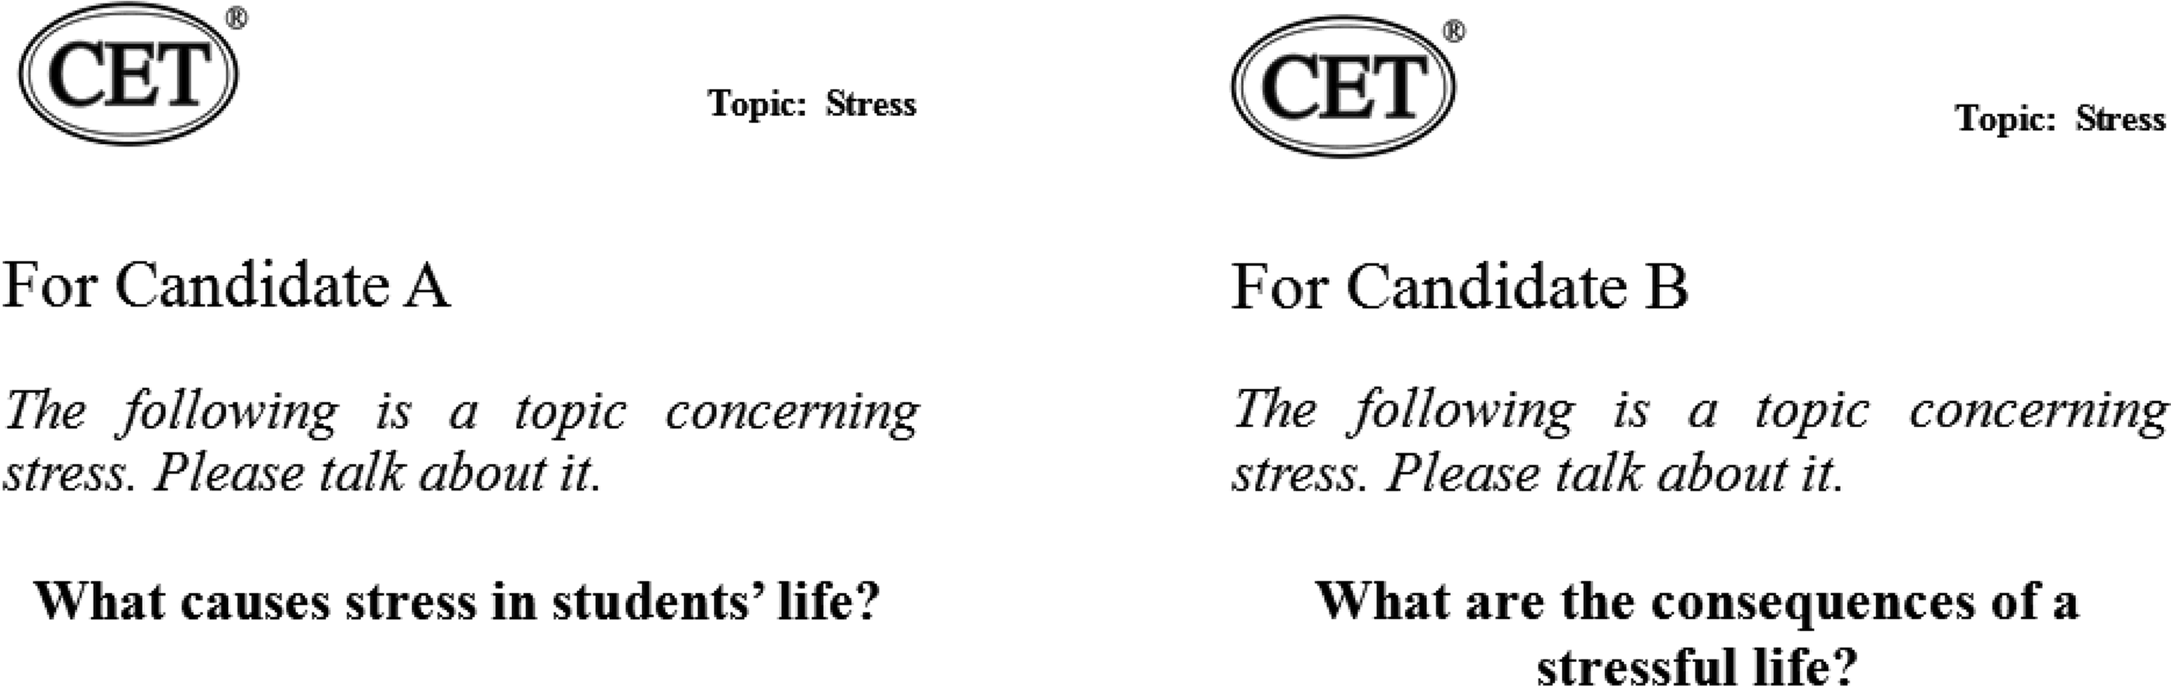

NowCandidateA,pleasebegin．(倒计时１分３０秒)

CandidateB,nowitsyourturn．(倒计时１分３０秒)

两位考生依次根据图片或卡片作陈述

Right．Nowthatwevetalkedbrieflyaboutstress,Idlikeyoutodevelopthistopicfurther andhaveadiscussionforaboutthreeminutes．Duringthediscussionyoumayargueandask eachotherquestions．Ourdiscussionisaboutthebestwaytomanagestress．(屏幕上显示The bestwaytomanagestress)

样卷

１８７

Remember,thisisapairactivityandyouneedtointeractwitheachother．Sodontkeep

talkingwithoutgivingtheotherachance．Nowletsbegin．(倒计时３分)

Allright,thatstheendofthediscussion．

NowIdliketoaskyoujustonelastquestiononthetopicof“Stress”． Q:Whenareyoumostlikelytoexperiencestress? Pleasesaysomethingaboutit．

(两位考生同步回答问题,倒计时４５秒)

OK,thatstheendofthetest．Thankyou．

１８８

## ５．全国大学英语四级考试答题卡

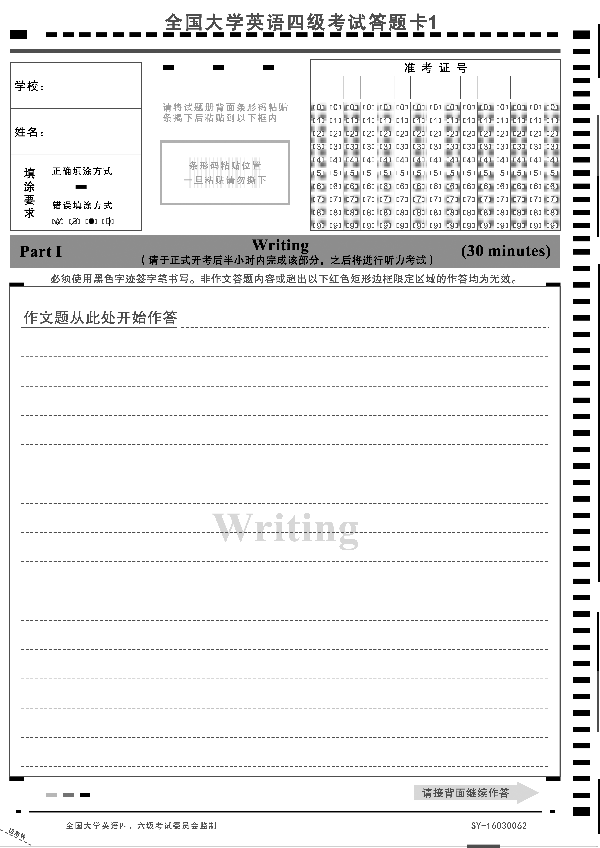

样卷

１８９

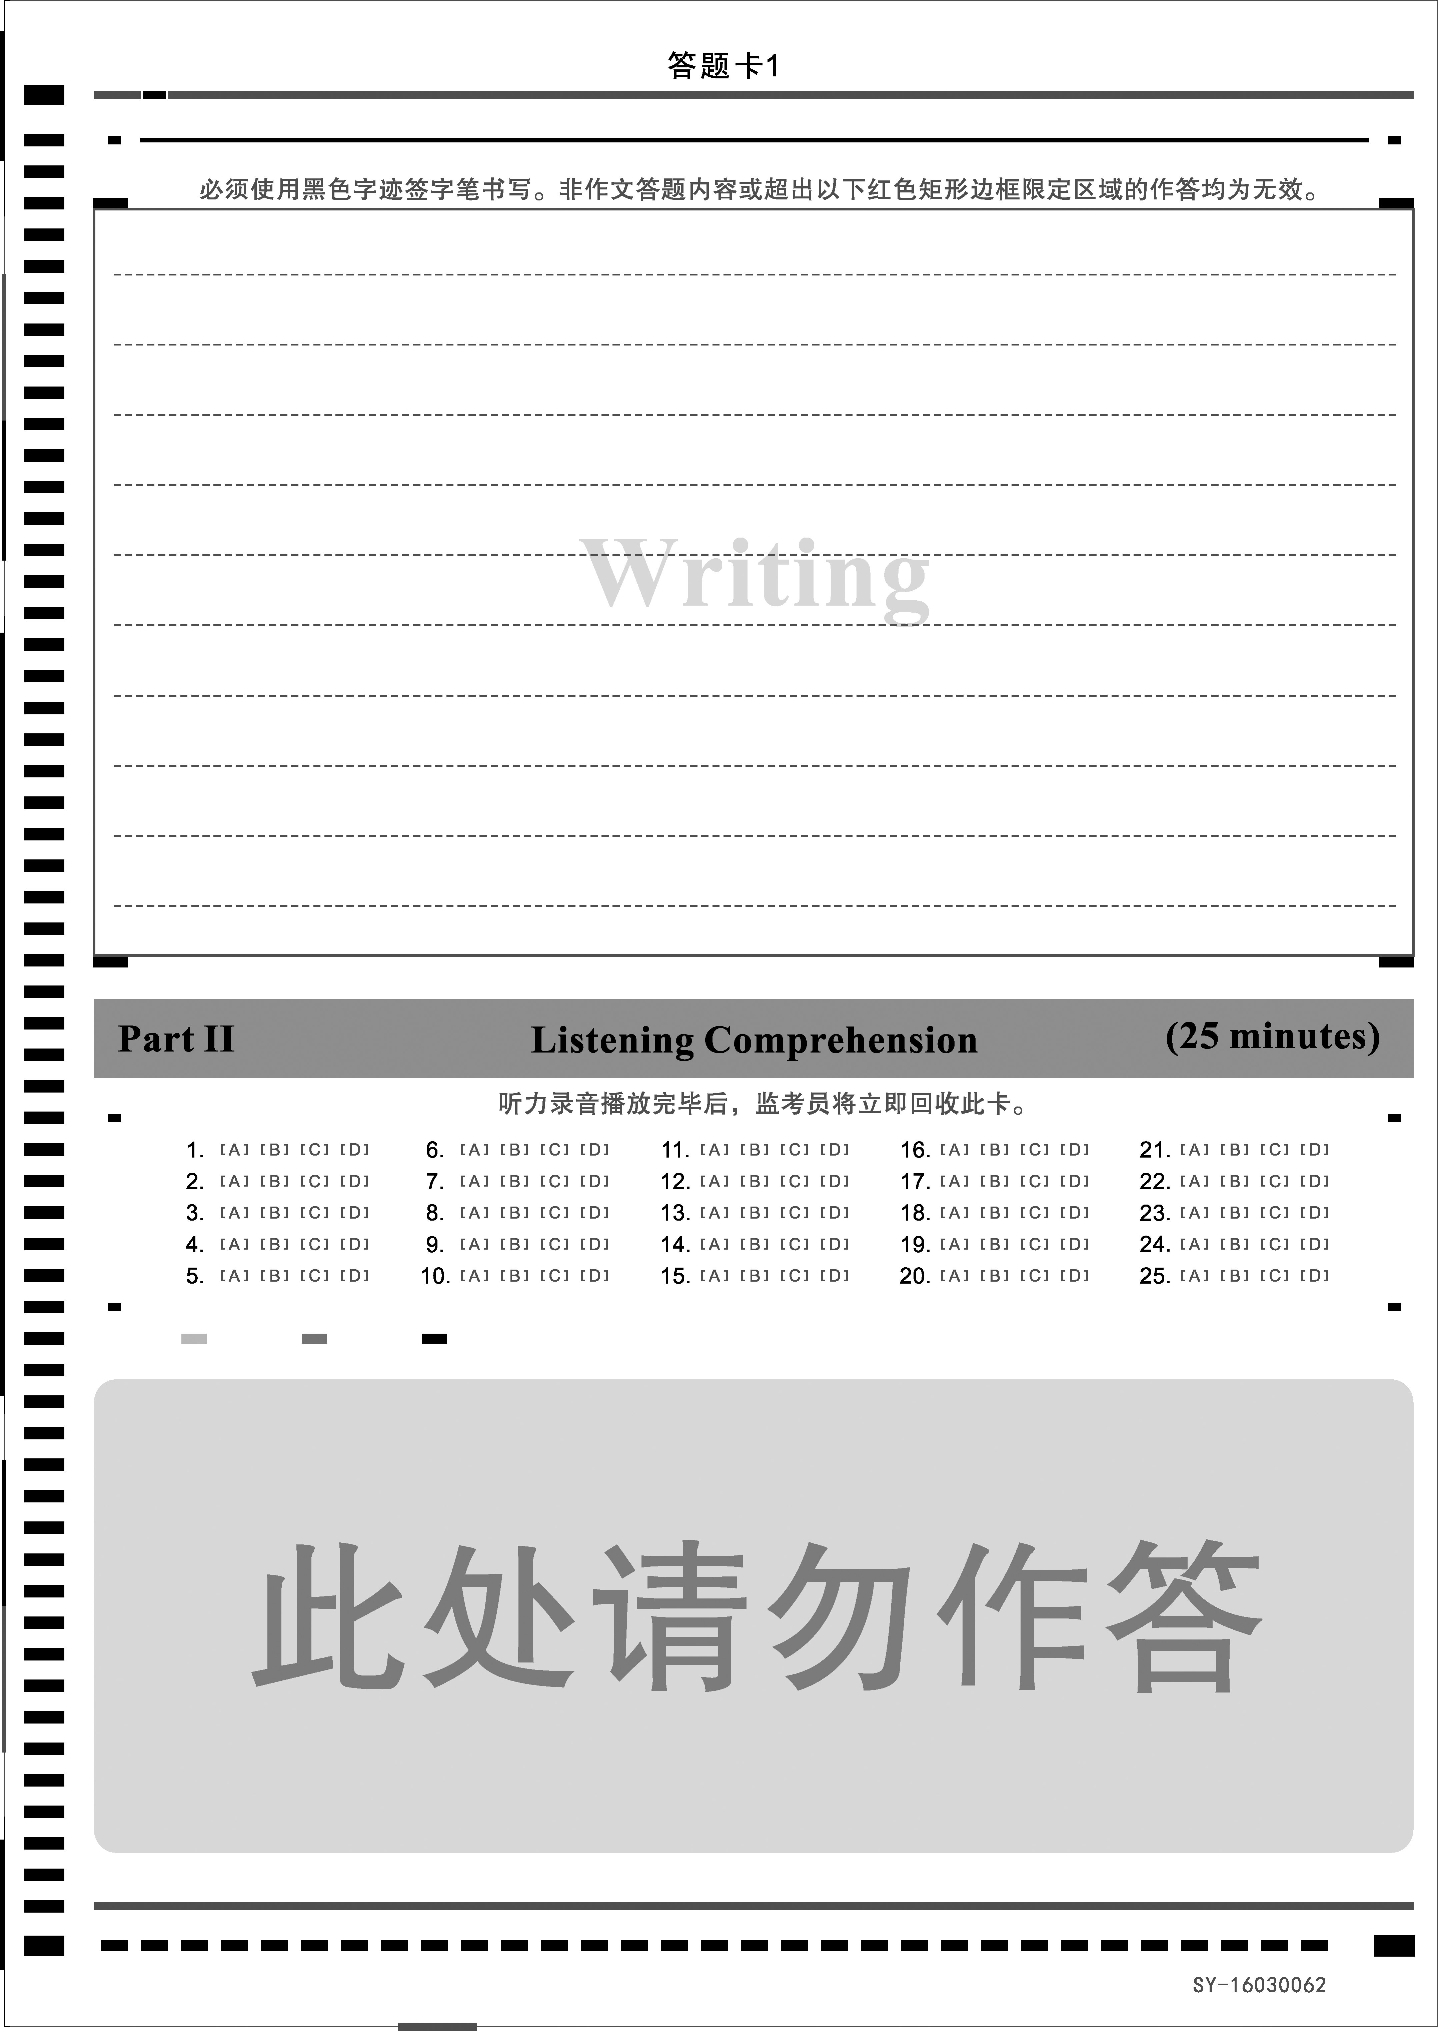

１９０

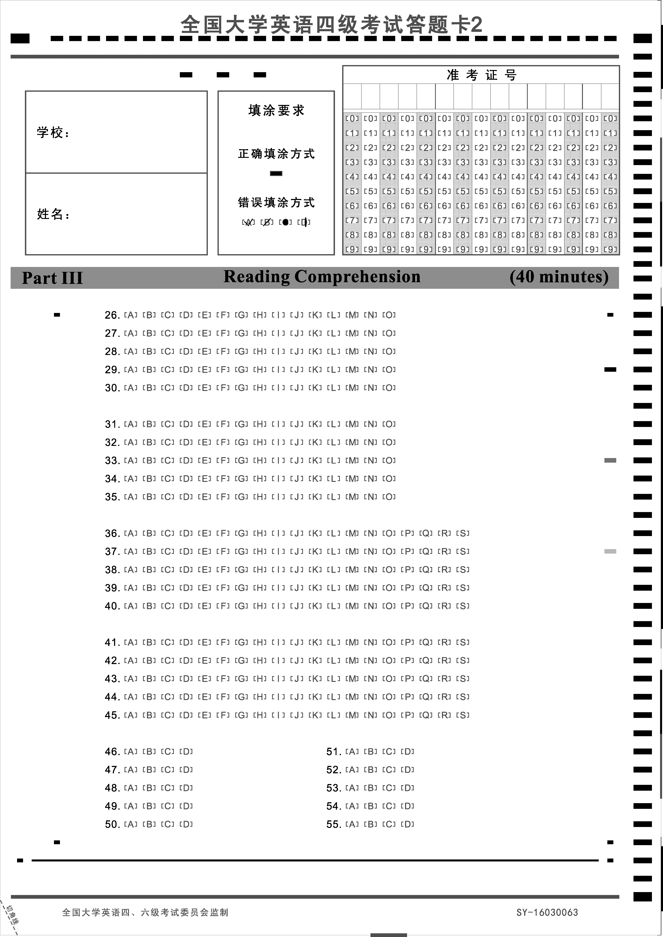

样卷

１９１



１９２

## ６．全国大学英语六级考试答题卡

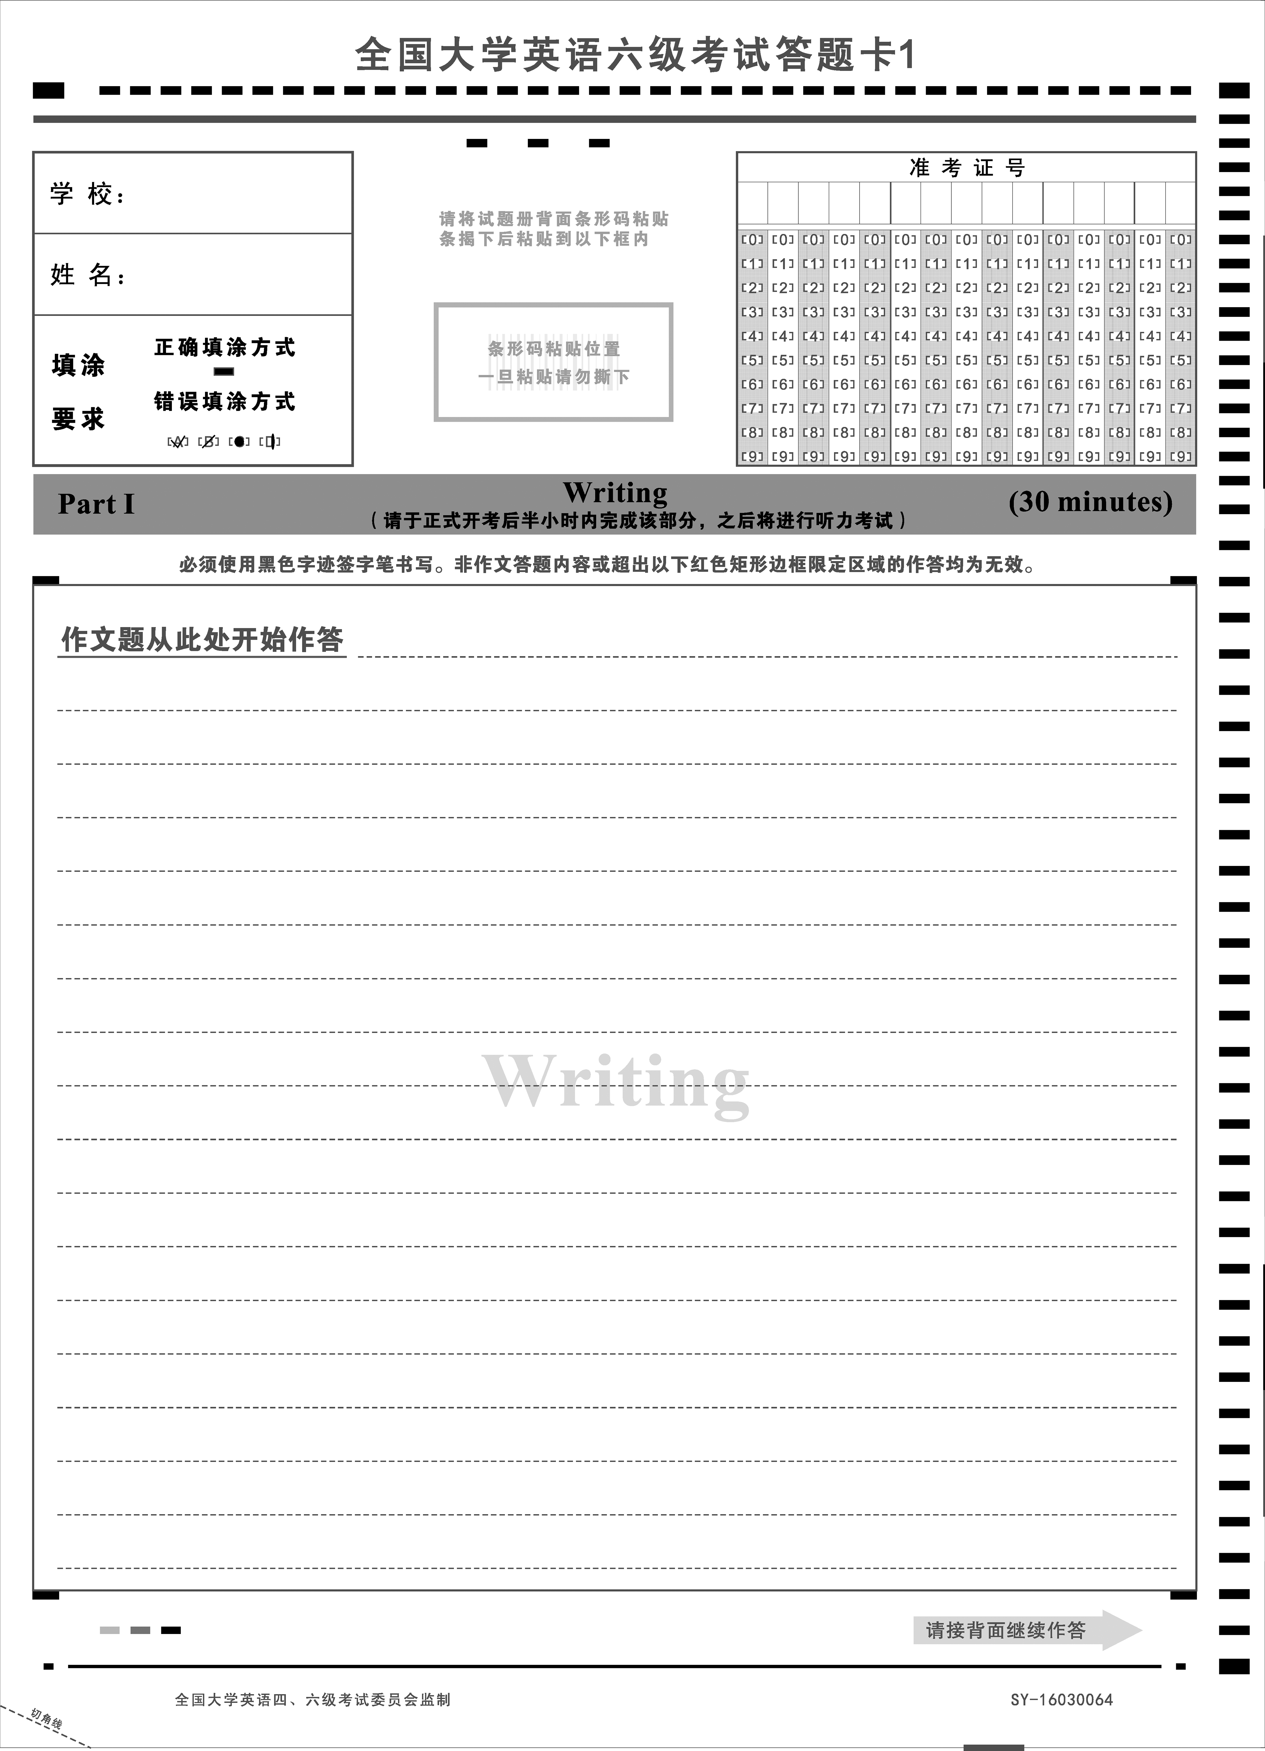

样卷

１９３

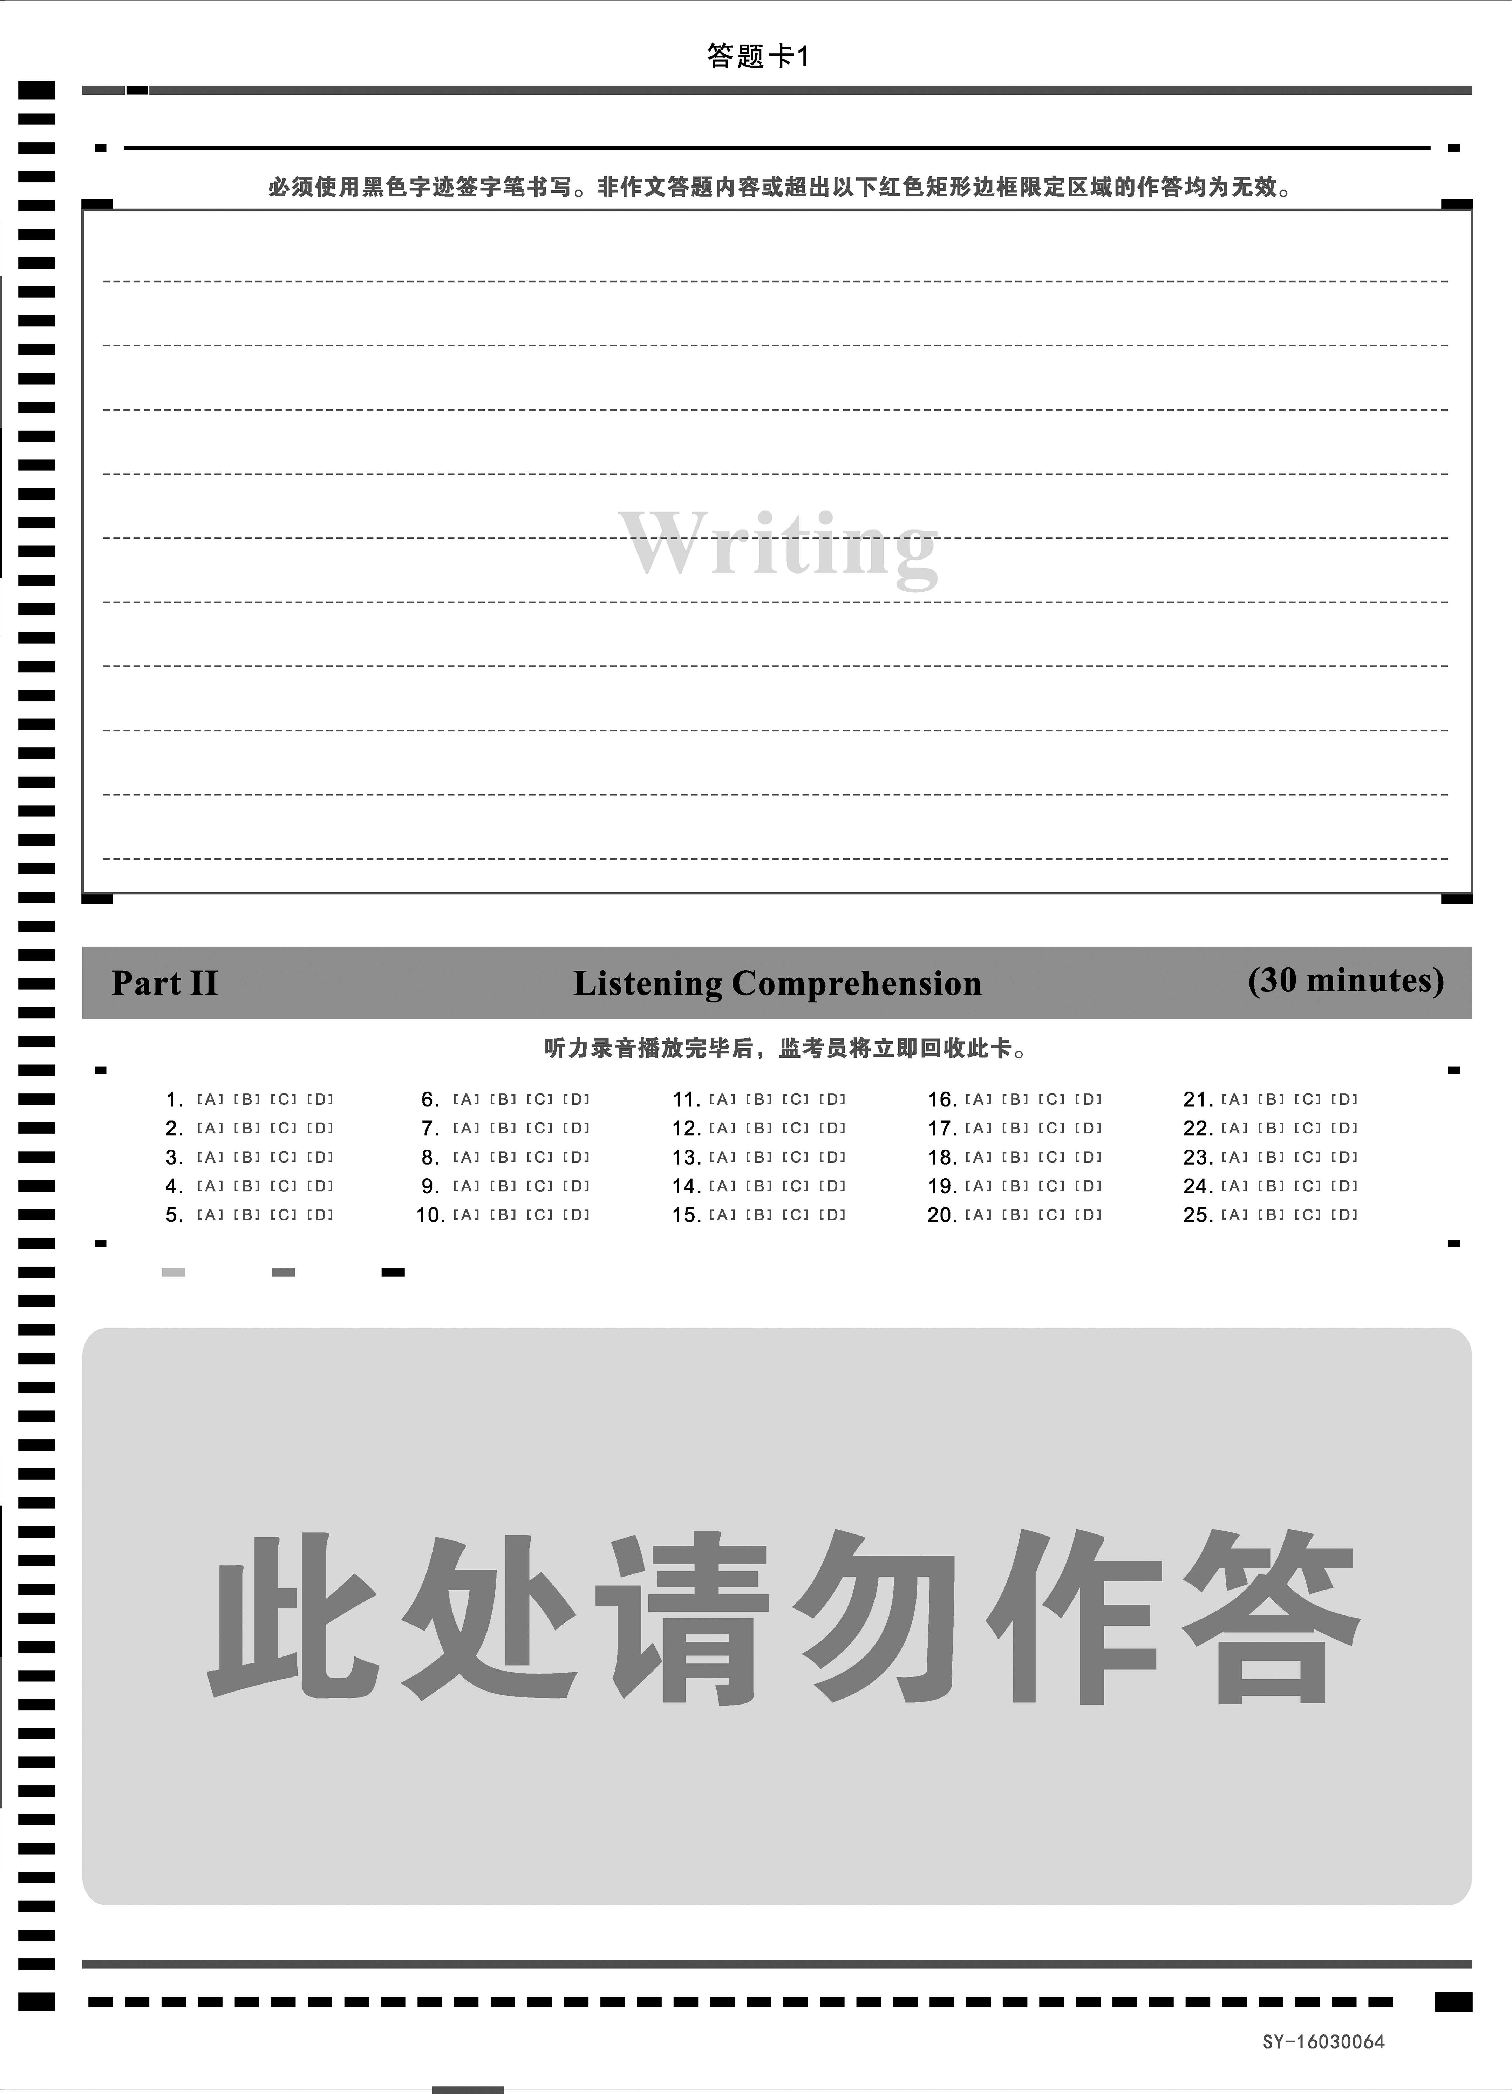

１９４

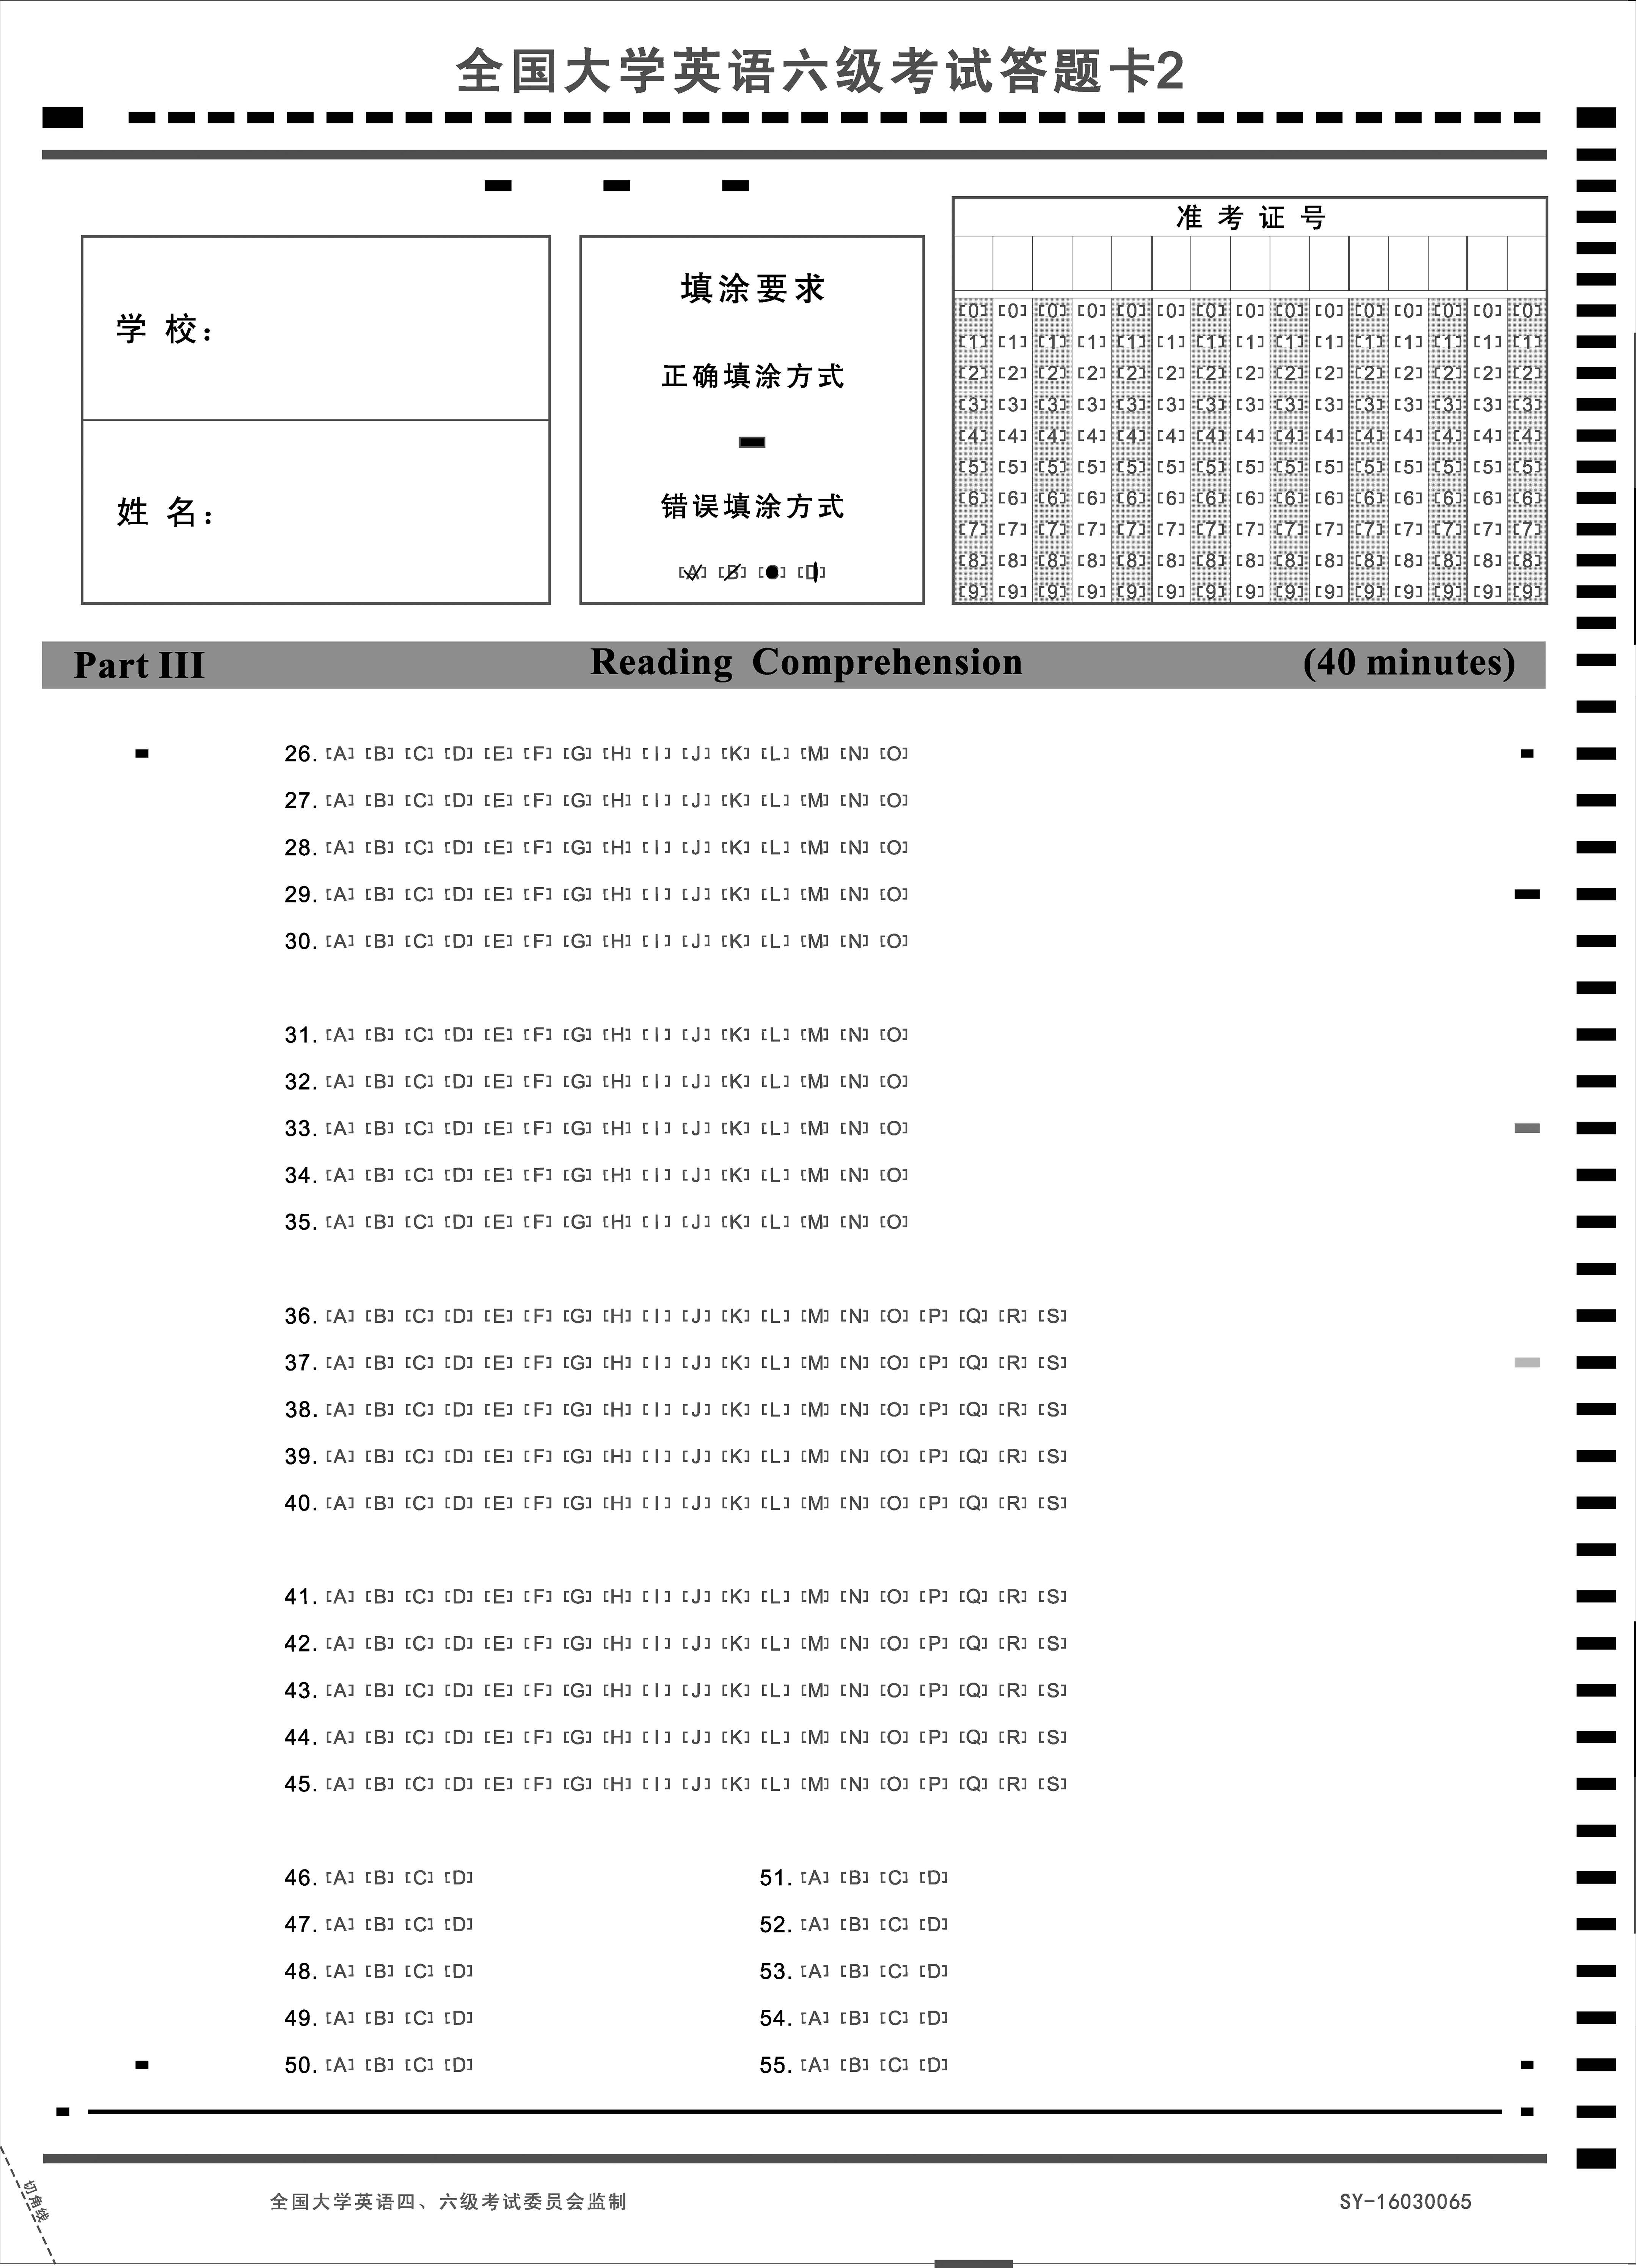

样卷

１９５



１９６

## ７．全国大学英语四级考试作文评分样卷

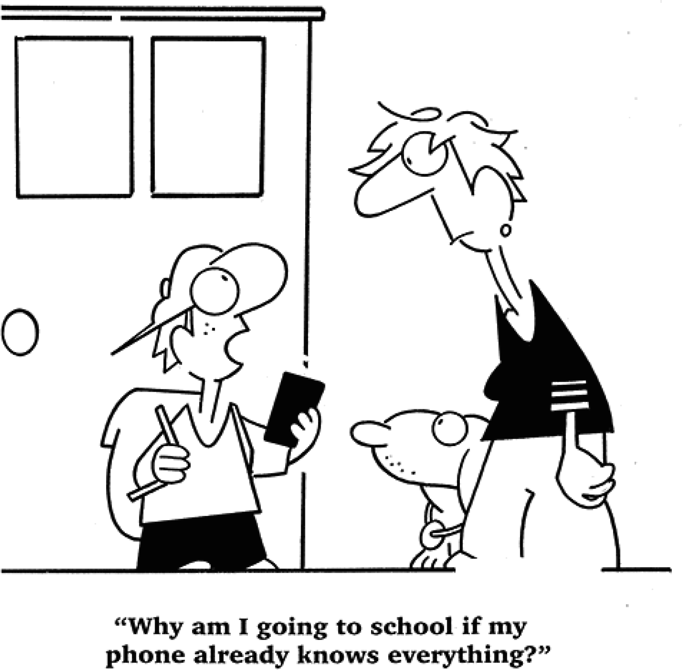Directions:Forthispart,youareallowed３０ minutestowriteanessaybasedonthe picturebelow．Youshouldstartyouressaywithabriefdescriptionofthepictureand commentonthekidsunderstandingofgoingtoschool．Youshould writeatleast１２０ wordsbutnomorethan１８０words．WriteyouressayonAnswerSheet１．

１４points

Asisdemonstratedinthepicture,despitehismothersangryface,thekidisunwilling togotoschool,arguingthatsincehecangeteverythinghe wantstoknowthroughhis phone,theresnoneedgoingtoschoolandacquiringtheminclass．Itsnotuncommonto hearsuchargumentamongyoungstudentsnowadays．

However,thiskidsunderstandingofgoingtoschoolcanbepotentiallyharmfulfor

followingreasons．First,morethanmerelyacquiringknowledge,goingtoschoolisalsoan acttogetinvolvedinsociety．Welllearnhowtobuildfriendshipanddevelopinterpersonal skills,whichisvaluableexperienceinourlifethatcannotbelearntfrom phones．Besides, schoolalsoteachesushowtothink,howtopursueknowledgeactively,whichcannotbe replacedbycellphonesbecausewecanonlygainknowledgepassivelyfromcellphones．

Forreasonsabove,itshightimethatyoungstudentsrealizedthevalueofschool．Put

downtheirphonesandinteractwithothers,andabiggerworldiswaitingforustoexplore．

１１points

Thispicturedescribesaconversationbetweenachildandhismother．Thechildthinksit

样卷

１９７

１９８

isnotnecessarytoattendschoolbecausealmostallinformationcanbeobtainedfrom cell phone withInternet．Thatseems makesense,whereas,in my perspective,itisstill essentialforustogotoschool．

Weliveinaninformationagewhenbooksandarticlesareavailabletoeveryoneonthe Internet．Knowledgebecomespublic．Ifwewanttolearnsomethingsuchasmathematics, wecan easily find some related books online．However,knowledge onlineisnt your knowledge．Youwillneedtolearnitandturnittoyourownknowledge．Schools,ormaybe teachers,canconductyouhowtolearnwell．Actually,theydevelopyourstudyhabitsand tellyousomemethodswhendealingwithnewdifficultproblems．Howtolearnisabsolutely moreimportantthanwhattolearn．Althoughtherearehugeamountsofknowledgeonline, westillneedtoknowhowtomasterit．Thatswhywegotoschool．

８points

Thecartonrevealsayoungboywhotakesaphoneandshowhisdoubting,andaman withadogislisteninghisquestion,“WhyamIgoingtoschoolifmyphonealreadyknows everything?”Nowaday,agreatamountofstudentsuseelectronicslike mobilephone．It seemswecanacknowledgeallinformationthroughinternet,butsomethingweignored．

Firstofall,ifwehavealreadygotaphoneanddontneedtogotoschool,sohowabout

improveourcommunicationskills? Thereisnoplatformforstudentstoknoweachother． Secondly,how tocreateateam work? We only know ourselves,and dontknow

sharing,dontknowhelpothers,dontknow１＋１morethan２．

Lastbutnotleast,wecanlearnnotonlyknowledge,butalso music,computer,and language．

Allreasonsshow why weshould gotoschool．Althoughitisconvenientforusto acknowledgeinformationthroughphone,butlosthappinessoflearningandexploringwith otherswhichisthemostimportant．

５points

Inourdailylife,moreand more morden methodcanstart．Justlikethepicturesaid “whyamIgoingtoschoolifmyphonealreadyknowseverything?”Asweknowns,wecan startfromourphones．ButIthinkthereisamisunderstandingsaidaboutthis．Thereasons areaboveof．

Goingtoschool,wecanstartallsubjects,example,Chinese,Math,Musicandsoon．

Whenwenotunderstand,wecanaskforteachers．Wecanreceiveallkindsofknowledge fromtheschool． Goingtoschool,wehavecommunicatewithteacherandclassmate,these canhelpusimprovingourcommunicateskills,whichcanhelpwewhenwegotosociate．If youhavethiscommunicaterelationship,wewillhavegoodjob．

Inall,learningfromthephonecannotsteadyoflearningfromschool．Inourlife,the phoneknowledgeislimit．Inourlimitededucationcondition,goingtoschoolwilllearnmore knowledge．Itcantakeusallknowledge,communicationskills,peoplesrelationship．

２points

WhyIgoingtoschoolif myphonealreadyknowseverything? Butyouphonecant teacheryouhowleaning．

Forsomereason,inweareachild,wemustgoingtoschool,tostudy,toleaning,to

player．ButifthisITtime,thisBigdatetime,myphonecanknowseverything．Hecan teacheryou,caneasycalleverone,cangivingyouhappyingfromsomethinggame．

Because,theschoolcangive more．First,letyougoingtoschool,isingovernment

idea,inverylongtimeisawayinthey．Two,youfatherandmother,hewanttoyougoing toschool,because,inhim wearechild,inhim webegoingtoschool．So,whereyouphone canalreadyknowseverything．Butthisisjustphonehecantchang weareschool．For somethingreason,schoolawayisschool,wheverITtime,Bigdatetime,schoolisnobody caneasychang．Because,thisisschool,bylearn,byfuning,givingyoufriendtheschool．

样卷

１９９

## ８．全国大学英语六级考试作文评分样卷

Directions:Forthispart,youareallowed３０ minutestowriteanessaycommentingon thesaying “Ifyoucannotdogreatthings,dosmallthingsinagreatway．”Youcan citeexamplestoillustrateyourpointofview．Youshouldwriteatleast１５０wordsbut nomorethan２００words．WriteyouressayonAnswerSheet１．

２００

１４points

WeallrememberatimewhenwespokeproudlyaboutbecomingthenextBillGates,or StephenHawking,anditsnever wrongtodream big．Astimepassesby,wegradually realizethat mostofusareboundtostayordinary．Yettheresstilla wayofachieving excellency．Asthesaying goes, “Ifyou cannotdo greatthings,dosmallthingsin a greatway．”

Aperfectlifedoesnthavetobesogloriousorsparklingasgrandplaysperformedin

theatres．Thetrue valueliesin our attitude towardstiny dailyissues,of which the repairmanworkinginourcommunityisanidealexample．BicycleＧrepairingiscertainlynot thebrightestorbestＧpaidprofessiontomany,butthismanputshisheartandsoulintoitand viewsitashiswayofservingforpeopleinthecommunity,whichiswhyheearnshigh reputation．

Asagenerationabouttostepintothefiercelycompetitivesociety,wearehauntedby

thefeelingofworryandhelplessness．Ifwestriveforaccomplishingremarkablesuccessand becomingworldＧrenowned,wellprobablyfeelfrustratedanddisappointed．Onlybyrealizing “Excellencyderivesfromsmallmatters”canwesurviveandthrive．

１１points

“Ifyoucannotdogreatthings,dosmallthingsinagreatway”isthegreatestsaying Iveeverheard．Iadmiremanypeople．Someofthemareheroeswhodogreatthings,but someofthemareordinarypeople．Theydosmallthingswhichseemssimpleandboring．

Toillustrateit,Ishowanexamplefirst．MyChineseteacher,MissChen,isanordinary

seniorhighschoolteacher．Sheteacheseveryday．However,in myeyes,shesagreat teacher．Shereallylovesherstudentsandhercoursesare wonderful．She willspendher sparetimetoprepareagoodclass．Shesalwayswillingtohelpstudents．Asaresult,shesa verypopularteacherinourschool．

MissChendoesntdogreatthings,butshetriesto makeherjobgreat．Whenyoudo

thingswholeheartedly,youaregreatperson．Obviously,noteveryonehasthechancetobea hero,butwhenwedooursmallthingsingreatway,wesucceed．

Thisisanamazingquality．Soweshouldntcomplainthatwecantdogreatthings．Lets

dosmallthingsinagreatwaytobeourownhero．

８points

Asuccessfulgreatmansaid:“asoldierwhodontwanttobeageneralisnotagood soldier”．Wecanfindthatmostofmenwanttobecomegreatman,anddogreatthings! But anarmyhasonlyonegeneral,mostofsoldierscanonlybeanormalsoldier．Soshouldthe soldiersallgobackhome,justbecausetheycantbecomeageneral? Ofcoursenot!

Everyonehashisvalueinhisposition．Anarmycantwinbattleifhasonlyageneralbut

nosoldiers．Ifyouareasoldier,justdoyourbest,stayinyourpositionandeveryonewill respectyouincludethegeneral．Asmyfather,althoughhesworkinginthegovernmentasa normalpublicservantnotanofficer,buthedidhisbestinwork．Hesolvedlotsofquestions forhisdepartment,andservedforhundredsofpeopleaweektohelpthem,hefeelsthat hessuccessfulbecausehisleaderandallthepeopleheservedsaidtohim:“youareagreat man”．

Sowejustdoourbestinourwork,domorefortheothers! Weareallthegreatman!

５points

Asshowinthissaying,Recentally manypeople,especiallyyoungperson,thinkitis certainlydogoodtodogreatthings,ratherthansmallthings．Moreover,theyoftenthinkdo smallthingshasnovalueandboring．

Thesayingabovetriestocriticizethephenomenonthat mostpeople wantdogreat thingsratherthansmallthings．Itsreallyawrongviews．Aftercarefullyconsideration,I havestatethatthesayingismorebiased．Itgivenfollowingreasons．Firstly,Therenotonly greatthingsbutalsosmallthingsineveryproject．Besides,thesmallthingscandovery excellenttoo,ifyoucanmakeyourmindstodoit．Further,Ifyoucantdoasmallthings well,neithergreatthings．

From whatdiscussedabove,weconcludethatquestionquitedependsonchoice．Inmy

owneyes,nomatterwhatabilitywehave,howexcellentweare．Becauseifyouwantwalk thousandsmiles,youhavetodoeverystepinyoufoot．Onlyifdosmallthingswell,dogreat thingsinthesametime．

２points

Nowadays,everybodywantdogreatthings,suchasstudentwewouldrathertoelect thehotofsauceratherthanstudytheusefulteknologe．But,asshowintheeassythatit saying “Ifyoucannotdogreatthings,dosmallthingsinagreatway”．

Therearesomereasons weshoulddosomesmallthings．Tobegin with,nothingis

样卷

２０１

distinguishbygreatthingsandsmallthings．Tosum upthesmallthing．Itisalsoagreat thing．Andthegreatthingisowntopeoplesopinion．Then,ifwanttobesuccess,thesmall thingswillhelptoyou．Furthermore,themostofallfamouspeopleisgrowninsmallthings． Finally,thethingsmustsaidtoyourself．Ifyouunabletodo,youshouldgiveupquickly．

Inshort,itistimetodosomethingsnomatterhowgreatthingsorsmallthings．When

wegrowingup,wearegetbenefitedfromthosesmallthings．Everyisimportant．Every thingsisbenefittoyourfuture．Onlybythiswaywecansuccessfulandmorehappy．

２０２

## ９．全国大学英语四级考试翻译评分样卷

据报道,今年中国快递服务(courierservices)将递送大约１２０亿件包裹.这将使中国有可能超越美国成为世界上最大的快递市场.大多数包裹里装着网上订购的物品.中国给数百万在线零售商以极具竞争力的价格销售商品的机会.仅在１１ 月１１ 日,中国消费者就从国内最大的购物平台购买了价值９０亿美元的商品.中国有不少这样的特殊购物日.因此,快递业在中国扩展就不足为奇了.

【参考译文】

ItisreportedthatChinesecourierserviceswilldeliverabout１２billionparcelsthisyear． ThiswillenableChinatoovertaketheUSandbecometheworldsbiggestdeliverymarket． Themajorityofcourierpackagescontainitemsorderedonline．Chinagivesmillionsofonline retailerstheopportunitytosellgoodsathighlycompetitiveprices．On１１Novemberalone, Chineseconsumersbought ＄９billion worthofproductsonthecountrysbiggestshopping platform．Chinahasmanyspecialshoppingholidayslikethis．So,itsnosurprisethecourier industryisexpandinginChina．

１４points

ItisreportedthatthecourierservicesinChinawilldeliverabout１２billionpiecesof package,whichindicatesthatChinamaysurpasstheU．S．tobecomethelargestmarketfor courierservices．Mostpackagescontain productsorderedfrom theInternet．China has providedmillionsofonlineretailerswithopportunitiestoselltheirproductsatanextremely competitiveprice．OnNovember１１thalone,Chineseconsumershavepurchasedproductsthat valuedupto９billiondollarsfromthelargestshoppingplatforminthecountry．Sincethere arequiteafew specialshoppingfestivalsin China,itisnotparticularlysurprisingthat courierserviceshaveexpandedrapidlyinChina．

１１points

ItisreportedthatChinesecourierserviceswillsendabout１２billionpackagesthisyear, whichmay make Chinabecomethebiggestcourier marketinthe worldintheplaceof America．MostofthepackagescarrytheitemsboughtontheInternet．Chinagivesmillions ofretailersonlinetheopportunitiestosellproductsinextremelycompetitiveprices．Onlyon November１１th,Chineseconsumersboughtproductsvalued９billiondollarsfromthebiggest shoppingplatforminChina．TherearemanyspecialshoppingdaysinChina．Therefore,itis notstrangethatcourierserviceshavebeendevelopingfastinChina．

样卷

２０３

８points

ItisreportedthatthecourierservicesinChinawilldeliverabout１２billionpackages thisyearwhichmayshowthatChinawouldbeattheUSAtobethebiggestcouriermarketin theworld．Mostpackagescoverstheproducts whichareboughtonＧline,forChinagives millionsofcompaniesonlineopportunitiestosellproductsincompetitiveprices．Justin November１１th,thecosumersinChinaboughtmorethan９billionpricesproductsfromthe largestbusinessfloor．Chinahasmanyotheruniquecosumingdaylikethis,therefore,its notsurprisingthecourierservicesexpandinChina．

５points

Accordingtothereport,thisyearcourierservicesinChinawillsendabout１２billion packets．ItwillmakeChinaoverAmericatobecomethebiggestcouriermarketintheworld． MostofpacketsarethethingswhichbuyfromtheInternet．Chinagivestheopportunitiesto themillionsofsalesmentousethecompetivepricesellingthings．JustonNov．１１th,Chinese comastersbought９billiondollarsthingsfromthebiggestshoppingmarkets．Chinahasmany specialshoppingdayslikethis．Soitisnotsurprisethatthecourierservicescanextend quicklyinChina．

２points

Fromthereport,Chinacourierserviceswilldeliveyabout１２０ millionpackagesinthis year．China willbeyond Americabecome mostbiggestcourieralloverthe world．Most packagesaregoodsofonlineshop．Chinaofferforbillionsofdetialshopsthatpriceof competitivesalethegoodsforachance．On November１１st,theChinesecomsumerwho bought９０ million dollars goods on biggest China shop platform．China have many extraordinaryshoppingday．Eventhough,couriesserviceswillexpandthatnotextrordinary inChina．

２０４

## １０．全国大学英语六级考试翻译评分样卷

中国传统的待客之道要求饭菜丰富多样,让客人吃不完.中国宴席上典型的菜单包括开席的一套凉菜及其后的热菜,例如肉类、鸡鸭、蔬菜等.大多数宴席上,全鱼被认为是必不 可少的,除非已经上过各式海鲜. 如今,中国人喜欢把西方特色菜与传统中式菜肴融于一席,因此牛排上桌也不少见.沙拉也已流行起来,尽管传统上中国人一般不吃任何未经烹饪 的菜肴.宴席通常至少有一道汤,可以最先或最后上桌.甜点和水果通常标志宴席的结束.

【参考译文】

TraditionalChinesehospitalityrequiresthatguestsbeofferedarichvarietyofdishes whicharemorethantheycouldpossiblyfinish．TypicalmenusinaChinesebanquetincludea setofcolddishestobeginwith,followedbyhotdishes,suchasmeats,chicken,duck,and vegetables．A wholefishisconsideredessentialformostbanquetsunlessvariousseafoods havealready been served．Nowadaysthe Chineseliketo mix Western specialties with traditionalChinesedishes,soitsnotunusualtoseebeefsteaksserved．Saladshavealso comeintofashioneventhoughtraditionallyChinesetendtorefuseanythinguncooked．A banquetusuallyincludesatleastonesoup,whichislikelytobeservedasthefirstorthelast course．Dessertsandfruitsgenerallysignaltheendofabanquet．

１４points

ThetraditionalChinesewayoftreatingguestsrequireshoststoprepareabundantand variousdishes,and maketheguestsunabletofinishthem all．Thetypical menufora Chinesefeastconsistsofasetofcolddishes,whichareservedatthebeginningandsomehot dishesafterthat,suchasmeat,chicken,ducksandvegetables．Inmostfeasts,acomplete fishisconsiderednecessaryunlessvariouskindsofseafoodhavebeenserved．Nowadays, Chinesepeopleliketo mixwesternspecialdisheswithtraditionalChinesecuisine,soitis notraretofindsteakonthetable．Inaddition,saladhasgaineditspopularityconstantly, eventhough Chinese peopleare notlikelytoeatdishesthathave notbeen cookedin tradition．Thereisgenerallyasoupinafeast,whichcanbeservedatthebeginningorthe endofthemeal．Besides,dessertsandfruitsoftenmarktheendofafeast．

１１points

ThetraditionalChinesewaytotreatguestsdemandsavarietyoffoodwhichwontbe eatenup．AtypicalmenuofChinesedinnercontainsaseriesofcolddishesatthebeginning andcookedfoodlater,suchasmeat,chicken,duckandvegetables．Fishisthoughttobe necessaryin mostformal dinners unless different kinds of seafood has been served．

样卷

２０５

Nowadays,Chinese peoplelike to combine specialfood from Western countries with traditionalChinesefood．Asaresult,beefisnotrareatChinesedinner．Saladhasbeenmore andmorepopular,althoughChinesedonteatanyuncookedfoodtraditionally．Therewillbe atleastonesoupatdinner,whichcanbeservedatfirstoratlast．Dessertsandfruitsare usuallyasignoftheendofdinner．

８points

TheChinesetraditionalwayoftreatingguestsrequiresthatthefoodinadinnershould bevariousand morethan whatguestscouldeatup．A typicallistofa Chinesedinner includingasetofcolddishesatthebeginning,followedbyhotdishessuchasmeat,chicken, vegetablesandsoon．Inmostdinners,itisthoughtthatanentirefishisunlackableexcept thatallkindsofseafoodhavebeenprovided．Nowadays,Chinesepeopleprefertocombine westerntypicalfoodwithtraditionalChinesefoodinadinner．Soitsnotraretoseesteak being provided．Saladisbeginningto become popularas well,eventhoughtraditional Chinesepeopledonteatanythinguncooked．Thereshouldusuallybeakindofsoupatleast, whichcanbeservedatthebeginningorattheendofadinner．Desertsandfruitsusually marktheendofdinner．

２０６

５points

ThetraditionofChinesetreatmenttoguestsisthatthefoodmustbemuchenoughtolet guestsbeunabletofinish．ThetraditionalfoodinChinaincludesthebeginningcoolfoodand hotfoodnext,suchasmeat,chicken,vegetablesandetc．Inmostparties,fishisconsidered tobeimportant,exceptthattheseafoodhasbeengiven．Nowadays,Chineseliketo mix WesternfoodandtraditionalChinesefoodtogether,thusthepearlcanbeseenfrequentlyon thetable．Salahasalsogaineditspopularity,eventhoughtraditionally,Chinesepeopledont eatanyfoodwithoutbeingfired．Theresatleastonekindofsouponthetable．Itcanbe takenintothetablefirstlyorlastly．Dessertsandfruitsoftenmarktheendingoftheparty．

２points

InthewayofChinesetraditionaltreat,thefoodshouldbemanyandtoomuchtoeat． ClassicalChinesetreatincludessomecolddishesinthebeginning,andthansomehotdishes, likemeat,vegetableandchiken．Often,thefishismustprovided,expecttherearemanysea foods,now,ChineselikemixsomewestdishesinaChinesetraditionaltreat．So,beefisa oftendish．Saladalsostarttobepopular．AlthoughChinesedonteatanyfoodnotbecooked． Usually,thereisatleastasoup,inthestartorthelast．Dessertorfruitusuallysymblesthat treatwillbeover．

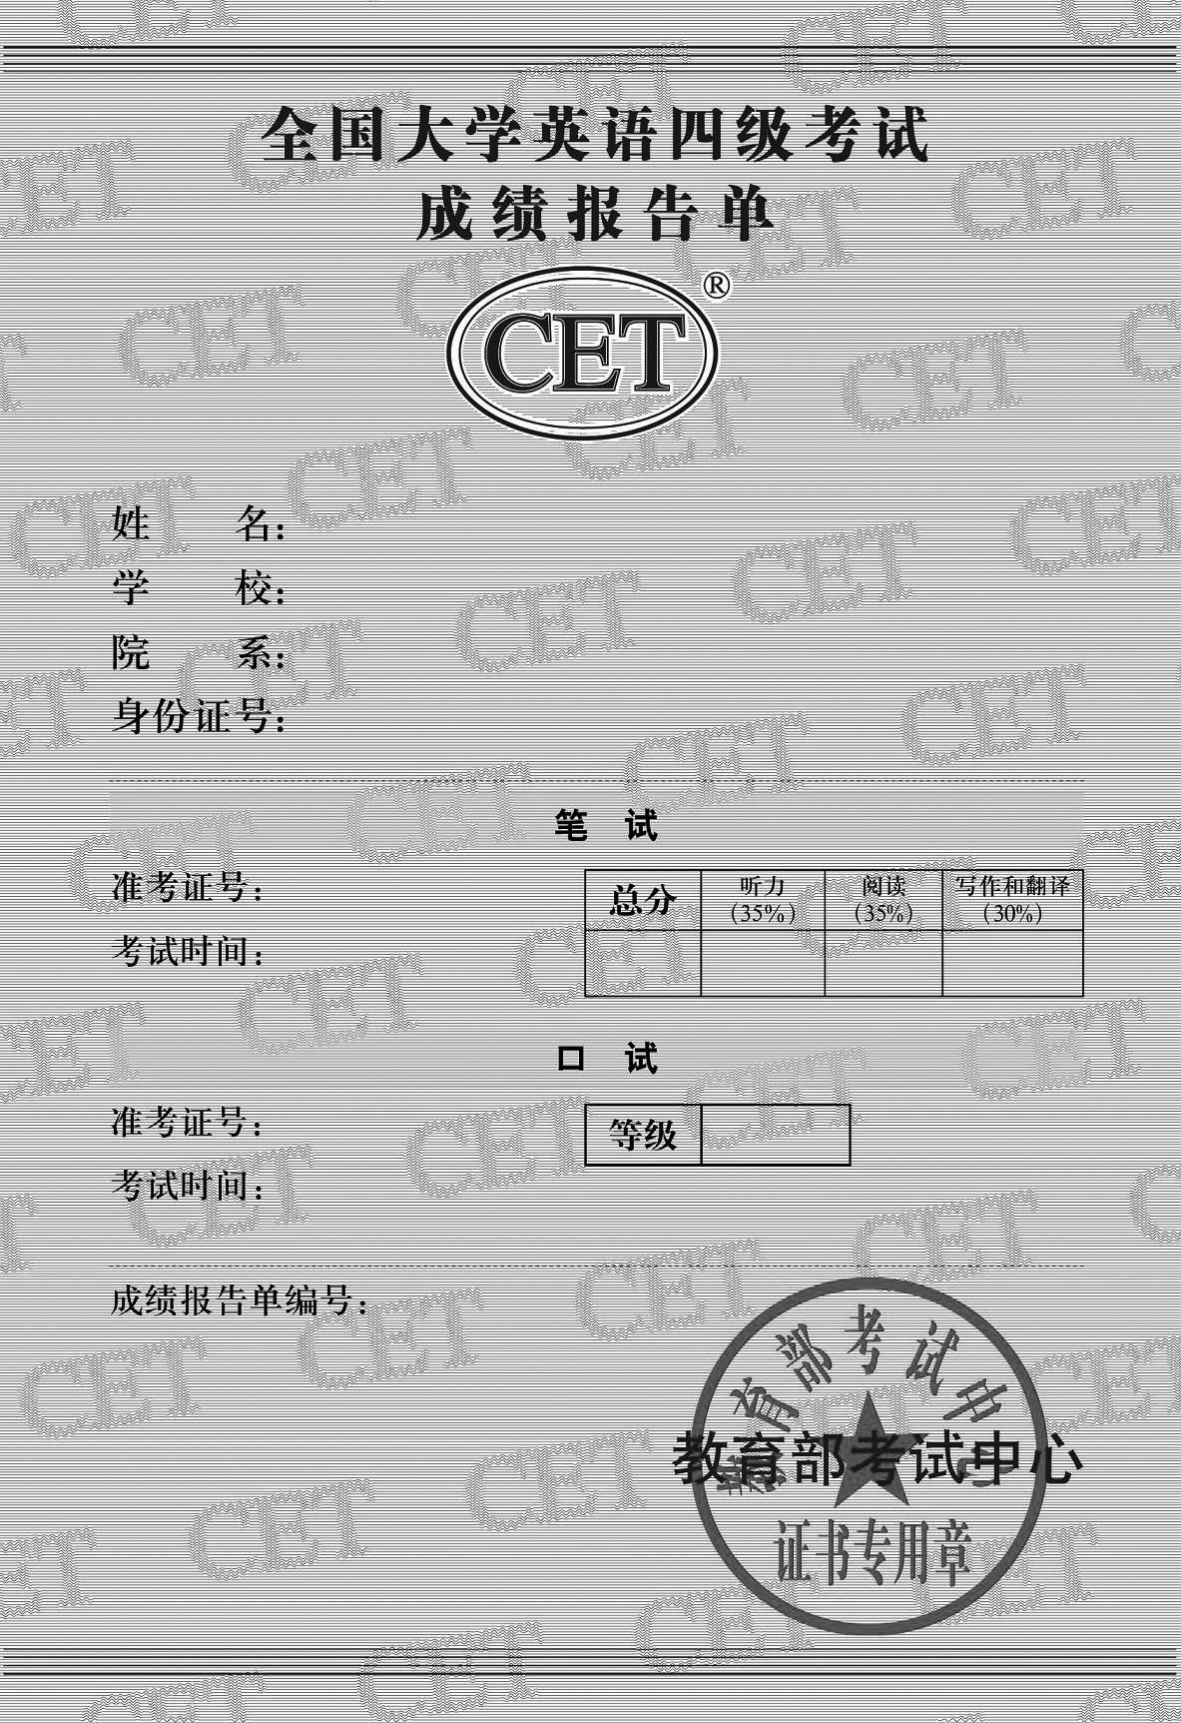

样卷

２０７

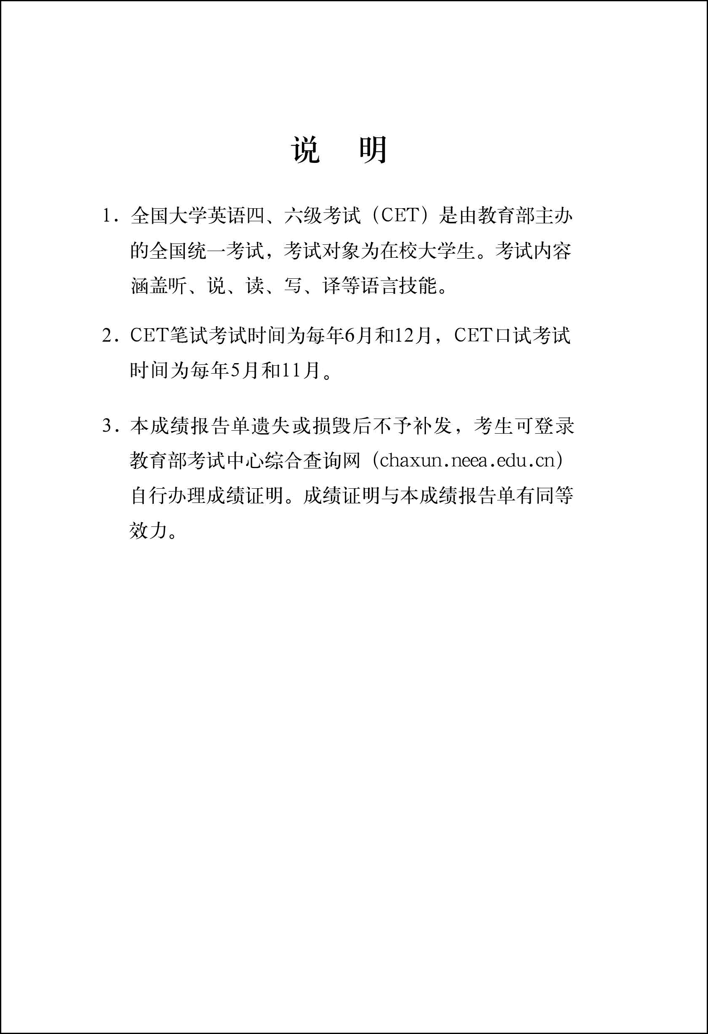

２０８

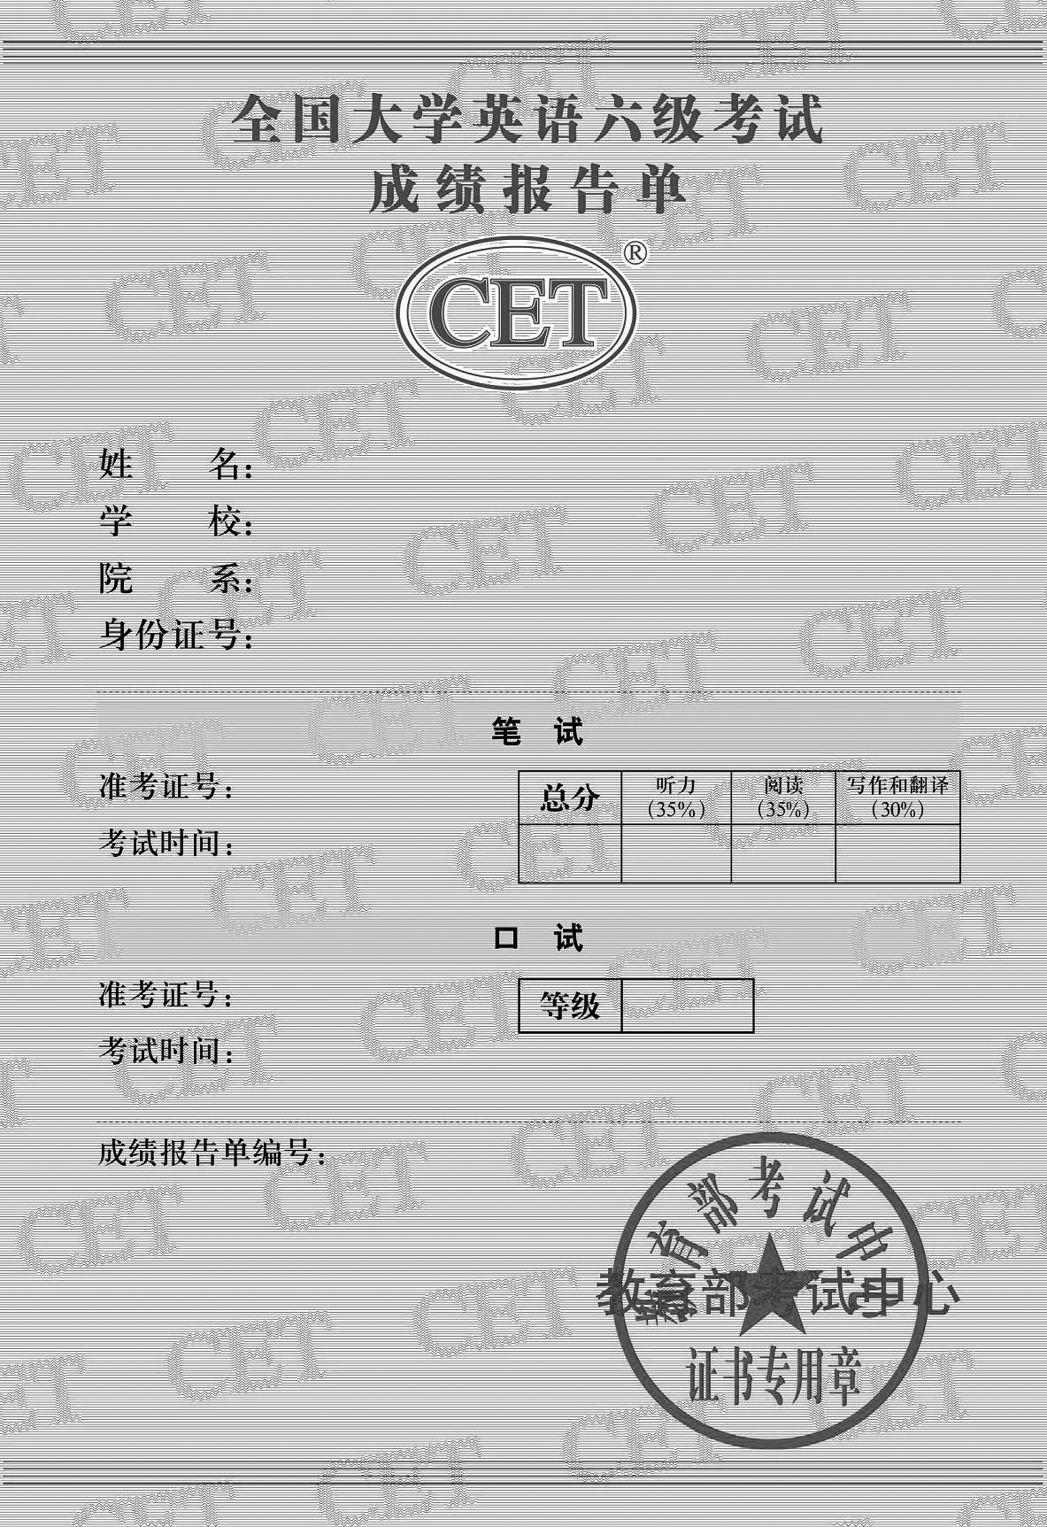

样卷

２０９

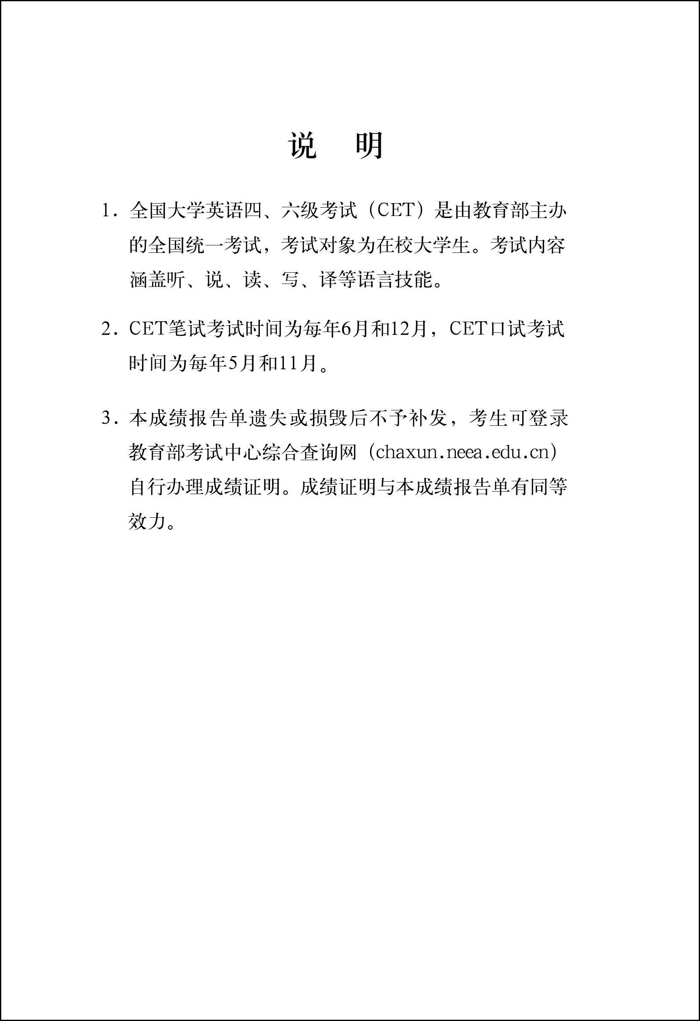

２１０